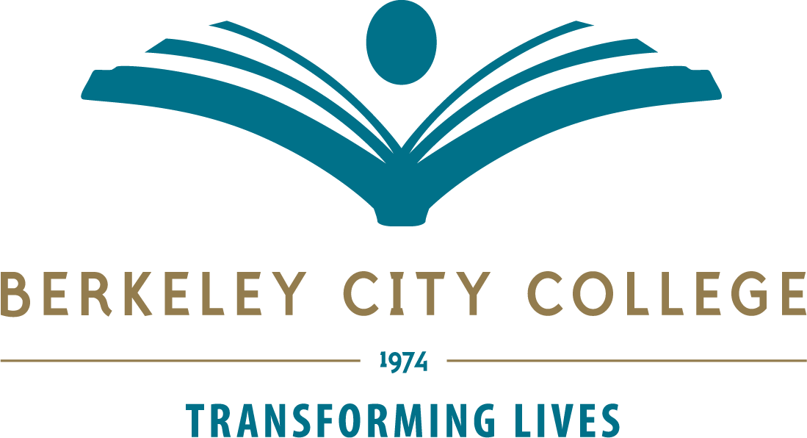

Technology Committee Agenda – September 19, 2019
Location: 451A Time: 12:20p.m.-1:20p.m.
Co-Chairs: R. Tomaneng, President and Mary Clarke-Miller

Mission: Berkeley City College’s mission is to promote student success, to provide our diverse community with educational opportunities, and to transform lives. The College achieves its mission through instruction, student support and learning resources which enable its enrolled students to earn associate degrees and certificates, and to attain college competency, careers, transfer, and skills for lifelong success.

TIME | AGENDA TOPIC | LEADER | DESIRED OUTCOME
12:20p-12:25p | Review Agenda | R. Tomaneng | - Approve Agenda
12:25p-12:40p | Orientation to Technology Committee | R. Tomaneng | - Review description and purpose of committee
12:40p-12:50p | Program Review & Technology  Resources Prioritization Timeline | P. Sayavong  R. Tomaneng  M. Clarke-Miller | - Share Information
12:50p-1:10p | Accreditation, ISER Timeline, Standard III | R. Tomaneng | - Share Information
1:10-1:20p | Campus and District Updates | K. Pernell  V. Koo  Joe Bay | - Share Information
1:20p | Adjourn Meeting | M. Clarke-Miller
Next meeting: October 17, 2019

Tech Committee Members:
Rowena Tomaneng, Mary Clarke-Miller, Kelly Pernell, Christopher Bernard, John Pang, Barbara Godoy, Felicia Bridges, Phoumy Sayavong, Joe Bay, Vincent Koo, Jeejun Bertuso, Siraj Omar, Joshua Boatright, Elissa Jaw

Vision: Berkeley City College is a premier, diverse, student-centered learning community, dedicated to academic excellence, collaboration, innovation and transformation.

Tech Committee meetings are open to the college community.

