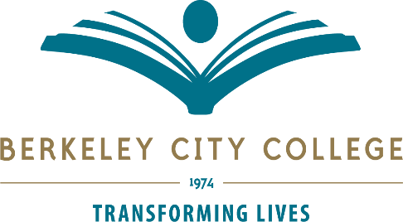

2018-2019 Program Review Process
January 25, 2019 (revised 1-29-19 spring semester 2019)

February 8 PR submission to Dean

January 29 Validation tool development and summary development

February 11 – 14 Validation (Integrated Planning Committee)

February 14 – 21 Summary development (Researcher)

February 21 Send out summary to BCC participatory governance committee

February 21 – March 20 All prioritized list of needs from each participatory governance committee
Back to Integrated Planning Committee

March 21 Prioritized lists to be sent to Roundtable members for review

March 25 BCC Roundtable (approval)

March 27 BCC sends prioritized list to PBC/PGC

March 29 PBC/PGC review (special meeting added as of 1-25-19 for PR review)

