Summer 2020 Enrollment
As of May 5, 2020, BCC’s summer enrollment (aka census) is 2,071. The unique headcount to students is 1,590.
On the same day in summer 2019 (M19), our enrollment was 1,976 with a headcount of 1,622.
BCC has gained 242.5 resident FTES, reaching 74.6% of our summer target.
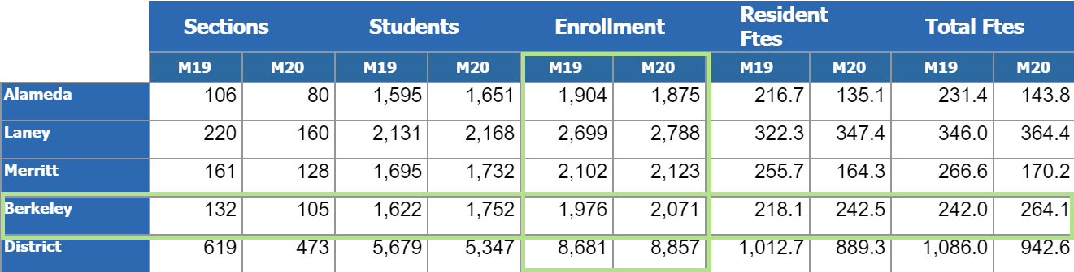
TERM | SECT | Headcount | CENSUS |  | FTES_TOTL | FTES_RESD | FTES_NONR | PROD
Summer 2015 | 149 | 3,403 | 4,390 |  | 705.8 | 634.6 | 71.2 | 20.5
Summer 2016 | 140 | 3,184 | 3,982 |  | 538.1 | 481.0 | 57.1 | 17.0
Summer 2017 | 130 | 2,883 | 3,559 |  | 463.8 | 415.0 | 48.8 | 15.1
Summer 2018 | 124 | 2,850 | 3,405 |  | 454.2 | 408.3 | 45.9 | 15.1
Summer 2019 | 126 | 2,903 | 3,558 |  | 456.1 | 411.0 | 45.1 | 15.4
Summer 2020 | 105 | 1,590 | 2,071 |  | 264.1 | 242.5 | 21.6 | 10.6
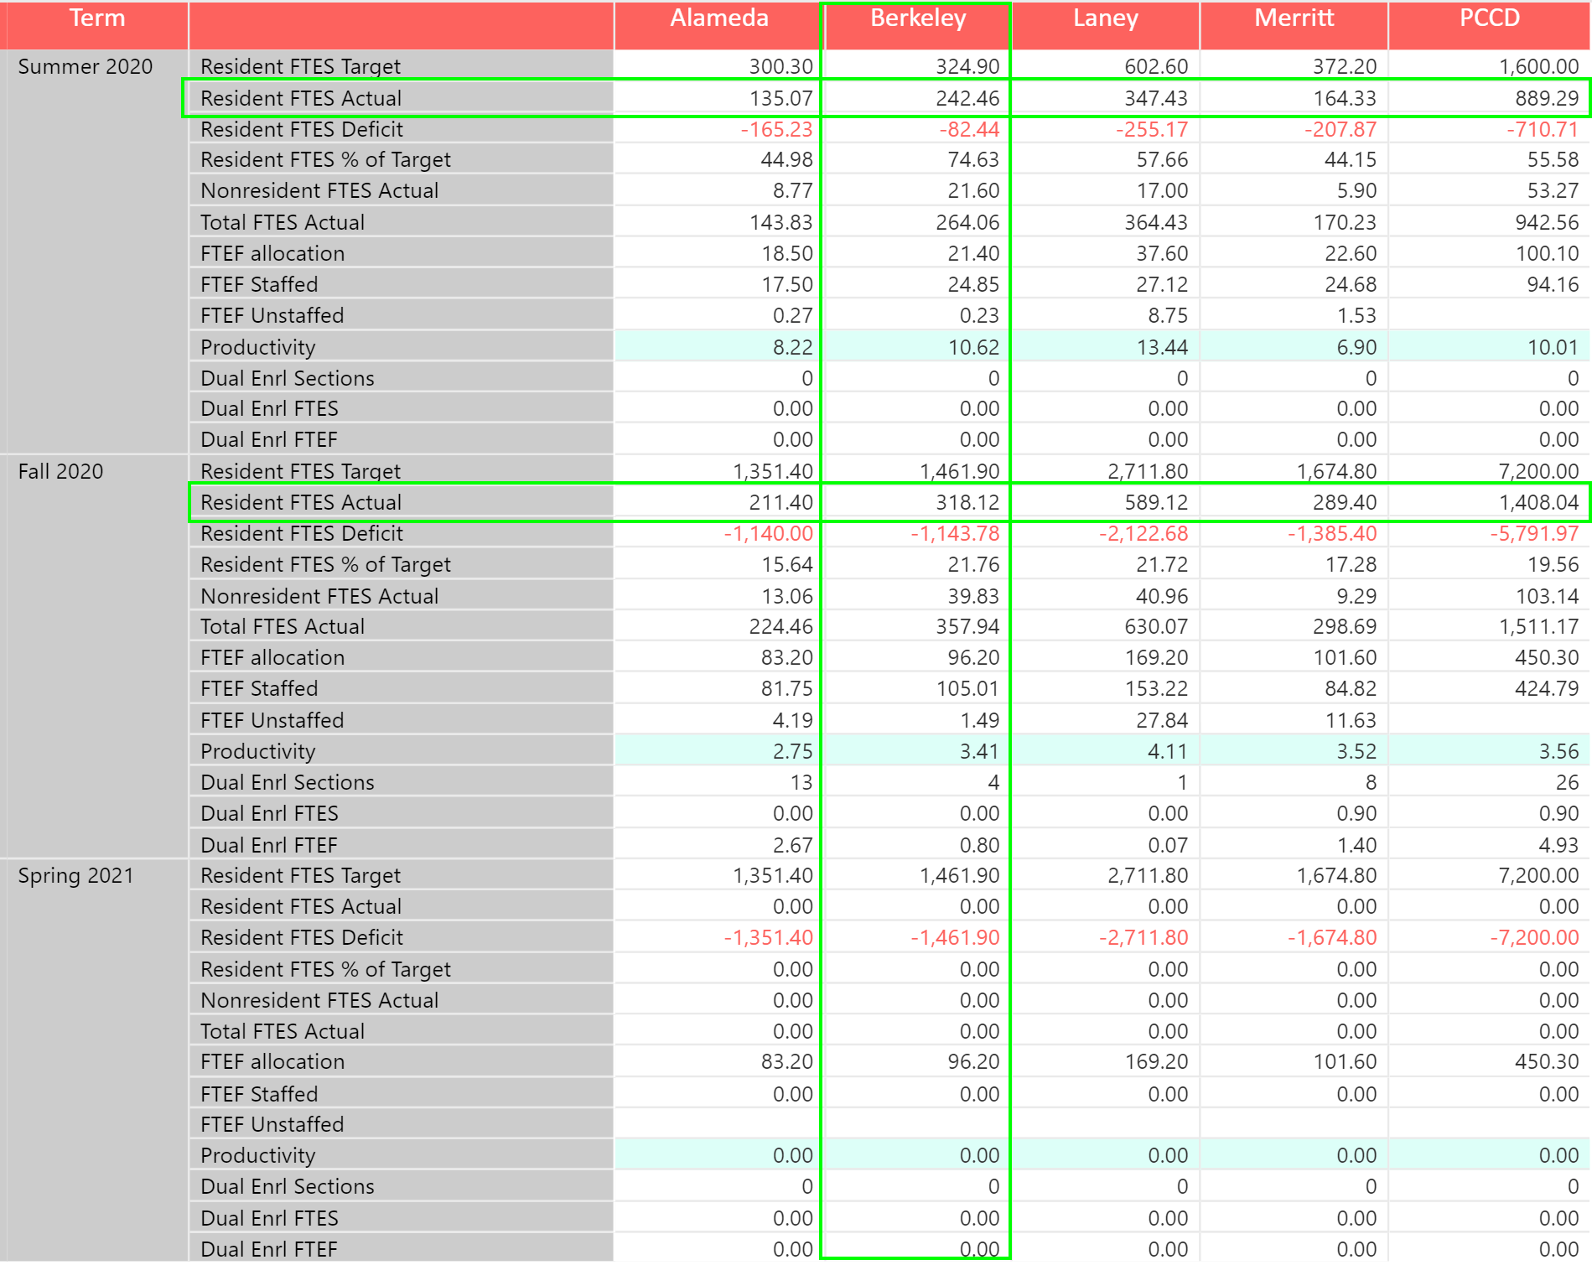
Section Withdrawals (Drops)
Section Withdrawals (Drops):
- Unduplicated Headcount of students who withdrew from class with a W or EW = 1,780
- Number of standard dropped classes (W) = 567
- Number of excused dropped classes (EW) = 1,293
- Combined W+EW dropped classes = 1,860

 | Berkeley City College |  | College of Alameda |  | Laney College |  | Merritt College |  | PCCD
GRADE | #Students | %Students | #Students | %Students | #Students | %Students | #Students | %Students | #Students | %Students
A | 8 | 0% | 88 | 1% | 210 | 2% | 148 | 2% | 454 | 1%
B | 8 | 0% | 53 | 1% | 66 | 1% | 73 | 1% | 200 | 1%
C | 2 | 0% | 16 | 0% | 24 | 0% | 20 | 0% | 62 | 0%
D | 1 | 0% |  | 0% | 4 | 0% | 4 | 0% | 9 | 0%
F | 4 | 0% | 1 | 0% | 4 | 0% | 12 | 0% | 21 | 0%
I |  | 0% | 1 | 0% |  | 0% | 2 | 0% | 3 | 0%
NG |  | 0% | 467 | 7% | 111 | 1% | 659 | 8% | 1237 | 3%
NP | 34 | 0% | 2 | 0% | 9 | 0% | 29 | 0% | 74 | 0%
P | 17 | 0% | 45 | 1% | 75 | 1% | 21 | 0% | 158 | 0%
SP | 2 | 0% | 5 | 0% | 37 | 0% | 24 | 0% | 68 | 0%
W | 567 | 7% | 392 | 5% | 716 | 6% | 510 | 6% | 2185 | 6%
EW | 1293 | 17% | 982 | 14% | 2052 | 17% | 1305 | 15% | 5632 | 16%
XX | 5634 | 74% | 5088 | 71% | 8828 | 73% | 5855 | 68% | 25405 | 72%
Grand Total | 7570 | 100% | 7140 | 100% | 12136 | 100% | 8662 | 100% | 35508 | 100%
W+EW | 1,860 | 25% | 1,374 | 19% | 2,768 | 23% | 1,815 | 21% | 7,817 | 22%

Number of drops by subject
Most of the drops were in English and Math classes, accounting to 16% and 15%, respectively. For many subjects, the number of excused drops (EW) drops account for more than double the standard drops (W).
Subject | EW | W |  | Grand Total | % of Total
ENGL | 325 | 84 |  | 409 | 16%
MATH | 292 | 96 |  | 388 | 15%
ART | 99 | 43 |  | 142 | 5%
SOC | 84 | 34 |  | 118 | 5%
MMART | 81 | 32 |  | 113 | 4%
SPAN | 62 | 33 |  | 95 | 4%
PSYCH | 60 | 29 |  | 89 | 3%
BUS | 67 | 19 |  | 86 | 3%
HIST | 65 | 20 |  | 85 | 3%
CIS | 57 | 27 |  | 84 | 3%
HUMAN | 48 | 25 |  | 73 | 3%
COMM | 46 | 22 |  | 68 | 3%
ANTHR | 41 | 27 |  | 68 | 3%
ASL | 50 | 10 |  | 60 | 2%
POSCI | 43 | 16 |  | 59 | 2%
MM/VI | 39 | 19 |  | 58 | 2%
COUN | 29 | 25 |  | 54 | 2%
MM/AN | 41 | 12 |  | 53 | 2%
BIOL | 30 | 21 |  | 51 | 2%
CHEM | 32 | 19 |  | 51 | 2%
ESOL | 42 | 9 |  | 51 | 2%
MUSIC | 38 | 11 |  | 49 | 2%
PHIL | 32 | 15 |  | 47 | 2%
MM/DI | 27 | 7 |  | 34 | 1%
ECON | 22 | 4 |  | 26 | 1%
HUSV | 18 | 3 |  | 21 | 1%
MM/MW | 4 | 15 |  | 19 | 1%
EDUC | 11 | 8 |  | 19 | 1%
FREN | 9 | 9 |  | 18 | 1%
ETHST | 14 | 2 |  | 16 | 1%
GEOG | 8 | 7 |  | 15 | 1%
SOCSC | 10 | 3 |  | 13 | 0%
PHYS | 9 | 3 |  | 12 | 0%
GEOL | 6 | 5 |  | 11 | 0%
CHDEV | 9 | 1 |  | 10 | 0%
ARAB | 5 | 2 |  | 7 | 0%
HLTED | 4 | 1 |  | 5 | 0%
PHYSC | 2 | 2 |  | 4 | 0%
CHIN | 4 |  |  | 4 | 0%
AFRAM | 2 | 1 |  | 3 | 0%
WS | 1 | 1 |  | 2 | 0%
ASTR | 1 | 1 |  | 2 | 0%
LIS | 1 |  |  | 1 | 0%
Grand Total | 1870 | 723 |  | 2593 | 100%

Demographics of Students Who Withdrew in Spring 2020
ETHNICITY | Student headcount | %Students
American Indian | 6 | 0%
Asian | 287 | 16%
Black / African American | 304 | 17%
Hispanic / Latino | 533 | 30%
Pacific Islander | 7 | 0%
Two or More | 139 | 8%
Unknown / NR | 93 | 5%
White | 411 | 23%
Grand Total | 1780 | 100%

GENDER | Student headcount | %Students
F | 967 | 54%
M | 753 | 42%
X | 60 | 3%
Grand Total | 1780 | 100%

AGE RANGE | Student headcount | %Students
16-18 | 138 | 8%
19-24 | 911 | 51%
25-29 | 285 | 16%
30-34 | 155 | 9%
35-54 | 183 | 10%
55-64 | 51 | 3%
65 & Above | 45 | 3%
Under 16 | 12 | 1%
Grand Total | 1780 | 100%

RESIDENCY | Student headcount | %Students
International | 65 | 4%
In State | 1638 | 92%
Out of State | 77 | 4%
Grand Total | 1780 | 100%

