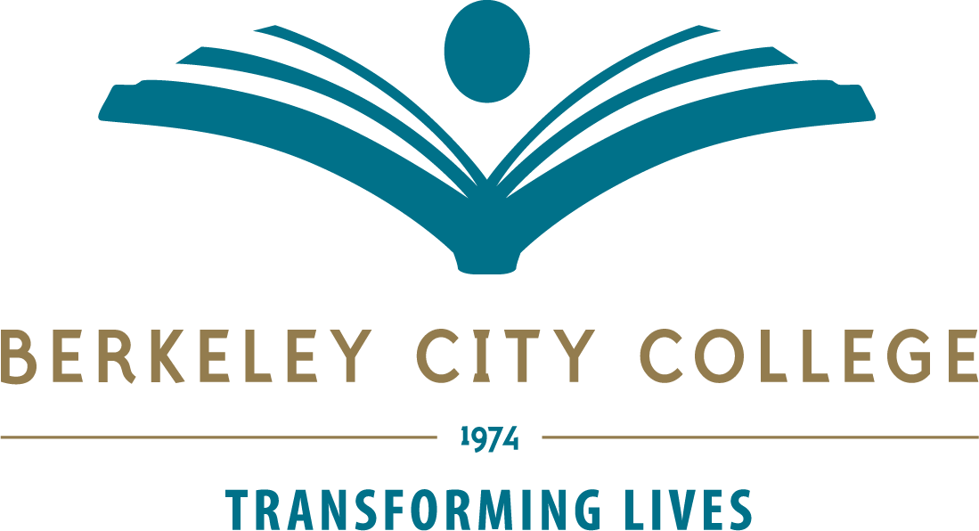
Office of Instruction
Service Area Outcomes
November 2019

Overview:
Berkeley City College Office of Instruction encourages and supports our college Mission-Vision-Values where student success for our diverse student population is at its core. The primary purpose of the Office of Instruction is to support student success in learning and completion by providing quality academic and career education programs and learning support services that ensure students in achieving their educational and career goals.
BCC provides a comprehensive learning environment that provides educational pathways to careers, transfer to four-year institutions and focused skill-building opportunities through a variety of certificate and degree programs.
The last comprehensive and Annual Program Reviews that occurred for the Office of Instruction was in spring 2018 (spring 2013, prior to 2018). 2018-2019 Program Review addressed renewed set of Mission, Goals, and Service Area Outcomes. This was vetted through the college’s Roundtable for Planning and Budget in the spring 2019 semester.
Since the last Accreditation Self-Study in spring 2015, there have been multiple vacancies on the College’s executive level. The College experienced a vacancy in President till July 2016 where three interim Presidents have been identified prior to that time. The new President’s arrival in 2016-2017 provided a much needed stability, continuity and grounding that the college deserved. On the Vice President’s level; however, there was a vacancy in much of fall 2017 until the new Vice President of Instruction arrived in spring 2018. In 2019-2020 year, the President entered into her fourth year and VP of Instruction, 2 years, and a new VPSS began in mid-December 2018.
In October 2019, there was a sudden departure of the Dean of Business, Science, Applied Technology and Multimedia which created a hole in the Office of Instruction. New Chancellor, Dr. Regina Stanback-Stroud began her tenure at PCCD on October 21, 2019.
Finally, BCC (PCCD) began engaging in the preparation for the Accreditation comprehensive visit for spring 2021 this semester.
Library, Teaching and Learning Center, Freshman Experience Learning Community programs submitted separate Program Review for their areas.

SERVICE AREA OUTCOME1:
Ensure the development of quality curriculum that are in alignment with the guided pathway framework for Career and Transfer programs for student success and equity.
MEASURES: Curriculum Committee agenda and minutes, College Catalog, Schedule, Classes,
Guided Pathway self-assessment, work plan, GP related activities and associated materials and notes (Flex Day GP activities in spring 2018, Fall 2018, Design Team Kick off agenda, PP, and notes, Fall 2018, Design team agenda and notes), BCC Integrated Strategic Enrollment Management Plan 2018-2021), Department Chairs meeting agenda and minutes, CE meeting agenda and minutes.)
Progress since 18-19 Comprehensive Program Review (CPR):
The GP Design team met on a regular basis since its inception. During this process, much discussion and reflection were made and a decision was made to identify a faculty GP coordinator (0.4 FTE per semester) supported by VPI and VPSS and Design team remains as originally established. This is in progress as of fall 2019. Consultation with the Academic Senate and Roundtable occurred.
During 19-20, BCC GP will focus on the development of meta majors or clustering of programs to ensure that the quality pathways curriculum are to be created which will lead to a strategic course offerings for the students.
SERVICE AREA OUTCOME 2:
Provide support and leadership for the college community on Program Review and Resource Allocation process and Assessment (SLO, PLO, and ILO) to ensure that the college meets the Accreditation standards.
MEASURES:
Planning for Institution Committee (PIE) agenda and minutes, Task Stream evidence (2015-2018), 2018-2019 Assessment Planning schedule per department, CurirrcNet Meta tool for Assessment. Program Review evidence from 2013 or 2015, 2018-2019 BCC Program Review documents including timeline, validation process by Integrated Planning Committee, summary review by participatory governance groups (Technology, Facility and safety, Classified Senate, Professional Development, and 2019-2020 Faculty prioritization documents and results by the Department chairs and Academic Senate, and Roundtable for budgeting and planning).
Progress since 18-19 Comprehensive Program Review (CPR):
PIE Committee has enjoyed consistent participation by the division liaisons during 18-19 and it is continuing. Leveraging this engagement, individual and group workshops have been provided and it is ongoing. This year, the committee will collaborate with an active TLC committee.
PIE committee made a decision to revise their name to “Assessment” committee that represent clearly what the committee is in charge of. This was brought to the review by the Academic Senate and Roundtable.
19-20 APU process was prepared in a timely fashion: the timeline was shared with the college community via key participatory governance committees at the very beginning of fall 2019, tools for validation was created and reviewed by the IPC committee. Participatory governance groups (identified above) were made aware of the timeline and their role of prioritization of the resources early part of the semester. Overall, much clarify in the process was made for 19-20.
SERVICE AREA OUTCOME 3:
Provide transparent and accurate communication with the college community and public regarding instructional and academic matters through college catalog, schedule of classes, website and other communication mechanisms.
MEASURES:
VPI communication with faculty and staff regarding academic, instructional, and Accreditation related matters, VPI communication with participatory governance groups regarding new legislation, initiatives, major changes in process and procedures (presentations, reports, etc.).
Schedule of courses, College catalog, and publication material regarding academic and career programs for external community.
Progress since 18-19 Comprehensive Program Review (CPR):
Catalog 2019-2020 was published in July 2019 in time for the 2020-2019 academic year and an addendum is to be published during the week of October 28, 2019.
In consultation with the Curriculum Committee, 2020-2021 catalog development timeline has been set.
ACCJC BCC ISER 2021 process began in fall 2019 led by the ALO, VPI Hay and Faculty ALO, Charlotte Lee. ISER Steering Committee is fully established by mid October 2019 and detailed information and direction for them and the college community have been communicated re:
• Timeline and process of developing ISER.
• Regularly scheduled Steering Committee
• Regularly scheduled Standard Team
• Criteria for response and recommended evidence list for the production of bullet point in fall 2019 and evidence collection.

SERVICE AREA OUTCOME 4:
Provide effective and innovative academic support services for the college to ensure student success and equity.
MEASURES:
Learning Resource Center, Library, Math Tutorial program, Embedded Tutoring, English Writing center, Faculty Advising.
Progress since 18-19 Comprehensive Program Review (CPR):
Completion of the Basic Skills grant, BCC faced a new challenge in identifying fiscal support to continue an effort to increase embedded tutoring particularly for the AB 705 Math and English courses. SEA funds support the current tutors.
Centuralized tutoring center development is ongoing.

