City of Berkeley
Work Session
Status Report on 2020 Vision Phase IV Work Plan September 27,2016

2020 Historical Background

On June 24, 2008, Council adopted a Resolution to authorize the City Manager to develop plans and models for internal and cross-jurisdictional collaboration to remove barriers to learning and to promote healthy development for all Berkeley children and youth (64,113-N.S.).
- To date the 2020 Vision has been in existence for 8 years. We have learned that a racial equity lens needs to be applied to the 2020 Vision efforts.

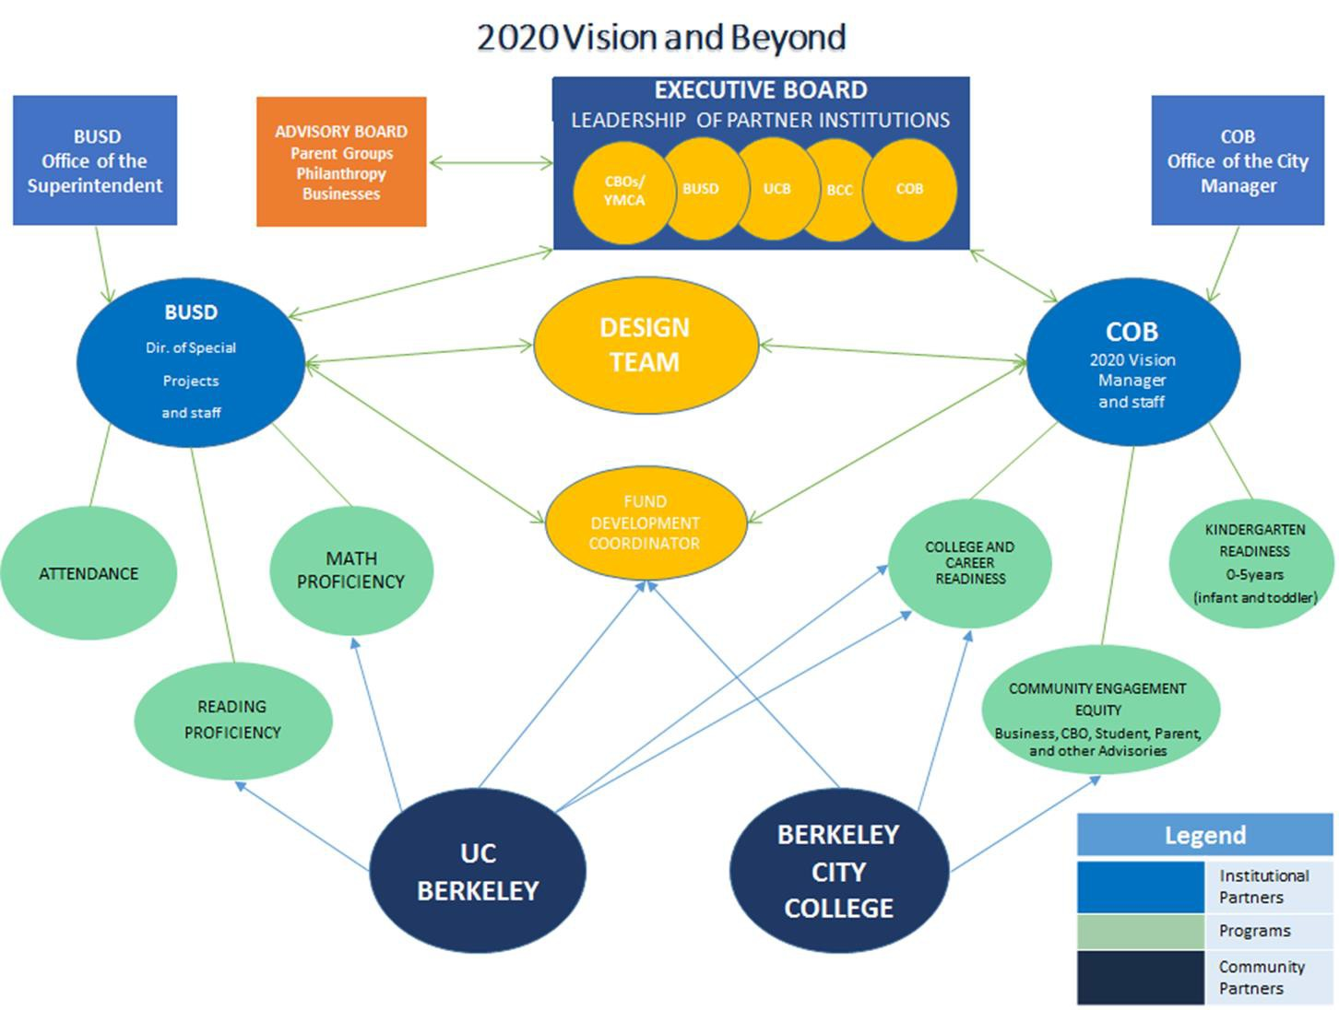
2020 Vision Sustainability

The Collective Impact of
Institutional Partnerships
- Alignment of the 2020 Vision goals and Mission;

UC Chancellor Grants
The Partnership Fund supports neighborhood improvement projects that utilize collaborative relationships between UC Berkeley and the community to address critical needs in the following thematic areas:
    - Arts and Culture
    - Community Safety
    - Economic Development
    - Education (Aligned with 2020 Vision)
    - Environmental Stewardship

BUSD-The Local Control & Accountability Plan (LCAP)
BUSD developed 5 strategic goals based on the LCAP guidelines that have since been aligned with the 2020 Vision Initiative.

Community Agency Contracts & 2020 Vision

Process for Community Agency Contracts for Youth
Serving Agencies (circa September 2012).
    - Align outcomes and service measures to support 2020 Vision Indicators (K-Ready, 3rd Grade Literacy, Math, Attendance, College and Career Readiness).
    - Utilize standardized evaluation tools for youth-serving
agencies (City Data Services).
    - Provide technical assistance, equity coaching, and other
support when needed.

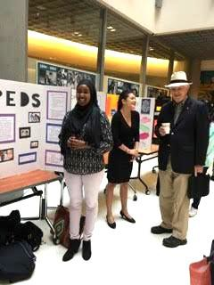
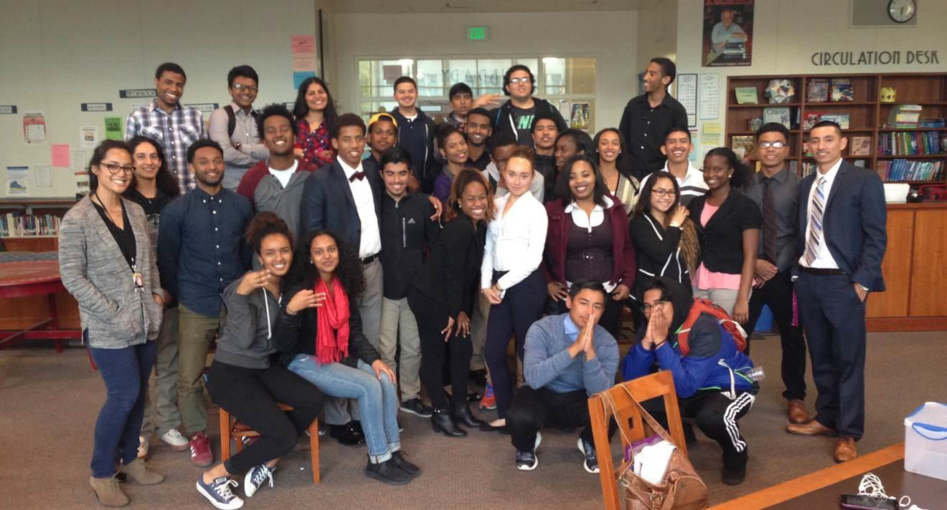
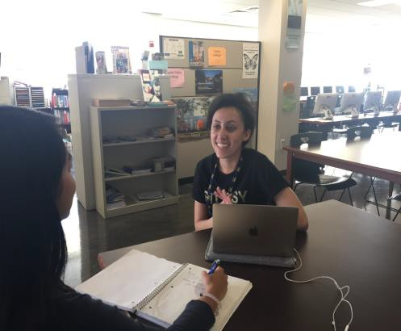
2020 Vision | College & Career Readiness

Concurrent Enrollment

College and Career Week
Transition Support Destination College Advising Corps

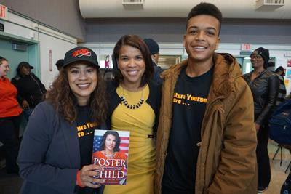
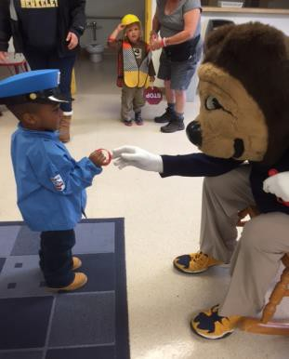
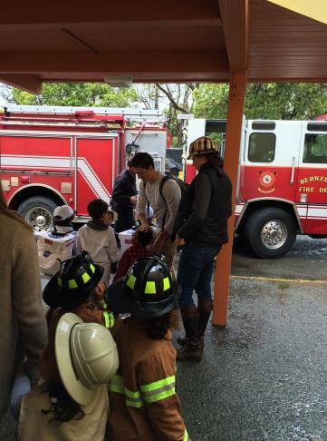
College & Career Week
(March 7-11, 2016)

Pre-K - 12th grade activities, speakers, workshops, youth panels, field trips
- Summer Opportunities/Career Fair - (Over 26 CBO’s & 1000 students)
- Main Summit (March 9th)
- Classroom visits
- Keynote Speakers
- Community College Fair
- Youth Panels
- HS youth to Longfellow AVID & Bridge students
- Teens Lead @ Work
- Biotech Partners

Future Actions
• Overarching 2020 Vision Programmatic Intervention; Trauma Informed Systems (TIS) Pilot in three BUSD schools: The 2020 Vision collaborative partners have proposed addressing some of the issues associated with student trauma and the achievement gap through becoming a Trauma Informed System (i.e. the school system).
• K-Ready Indicator; Environmental Scan: The City of Berkeley (COB) recognizes the growing need to promote health equity and wellness among children from Prenatal to age 5, with particular emphasis on Prenatal to 3. The purpose of Environmental Scan will be to focus on pre-natal through 3 years of age services, write a comprehensive report and analysis of findings from the scan, and provide guidance in the development of a Strategic Plan to improve the coordination of the early childhood-serving systems within the City of Berkeley.

Future Actions cont’d
• College and Career Readiness Indicator; Two primary strategies of the College and Career Readiness have been rolled into one program focus, "Completion Velocity". Completion Velocity (CV) refers to student empowerment as expressed through college credit attainment, self-advocacy within academic institutions, financial literacy and interpersonal communications.
• College and Career Readiness Indicator; STEM (Science, Technology, Engineering and Mathematics) Career Pathways: 2020 Vision is incubating a National Society of Black Engineers (NSBE) and the Society of Hispanic Professional Engineers (SHPE). This incubation of the two chapters is being created to increase multiple STEM pathways for students of color who have been left behind in the education and achievement opportunities that STEM careers represent.

The Berkeley Promise

is a college access and matriculation scholarship initiative that will support Berkeley Public school
low-income and/or first-generation-to-college graduates with degree and or certificate completion.

A 3-Tiered Approach:

Tier 1: High School
Component

Tier 2: The PROMISE
(Seniors only)

Tier 3: The PROMISE PLUS
(BCC Transfer students)
- Access to early college credit
- Access to online SAT & ACT prep
- College & Career Fairs
- Workforce Development/Internships
- FAFSA & Dream Act Completion
- Community service opportunities

- 1 FREE semester at BCC
- Financial Scholarship $1500/2 years ($500/yr1 $100/yr2)
- Access to one-on-one counseling & guidance
- Summer transition to college workshops
- Monthly group mentoring sessions
- Textbook Waivers/Support
- Transportation supports

- Access to scholarship for 4-yr college $8Kover 2yrs (4k/yr)
- 1:1 mentoring
- Guaranteed transfer to CSU w/ minimum 2.5 GPA
- UC transfer support

