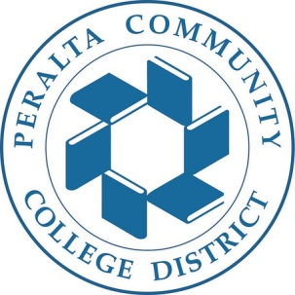
District CTE Committee

DATE: October 8, 2016
TO: District Education Committee
FROM: Mary Clarke-Miller, Co-Chair District CE Committee
CC: District CTE Committee, Mel King, Sui Song
RE: Strong Workforce College Allocations

On Friday October 7th, the District CTE committee reviewed information item # 3 Workforce Development Continuing Ed Unit, presented by the Workforce Development and Contract Education (WDCE) Unit. The item presented a proposal for the usage of the Strong Workforce funds to 1) centralize assessment and professional development efforts for the four colleges and 2) provide seed money to fund a new District Workforce Development and Contract Education Unit.

At the end of the presentation, the District CTE Committee made the following recommendations.

- It is recommended that the WDCE Unit proposal regarding use of the Strong Workforce funds go through the necessary college governance structures for vetting and action before any action is taken at the District PBC. College governance actions should be used to inform any action taken by the District PBC regarding the allocation of the Strong Workforce funds.
- It is also recommended that the Strong Workforce funds ($2,156,948 minus the District 4% for indirect) be initially allocated to the colleges using the existing District Budget Allocation Model (BAM) before any decisions regarding district allocations are made.

The above recommendations will enable the colleges to evaluate the needs of the college, along with the WDCE Unit proposal, to determine appropriate allocations to support the college CTE programs. In addition, it will ensure that the funds are accurately recorded and tracked at the college level to align with college reporting requirements. Lastly, this process will ensure transparency regarding allocations of college funds used towards District-wide efforts for the purpose of expanding the availability of quality career technical education and workforce development courses, programs, pathways, credentials, certificates, and degrees in accordance to AB 1602.

