Berkeley City College

Follow-Up Report

March 15, 2013

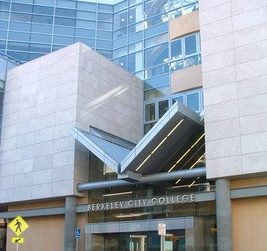

Submitted by:

President
Berkeley City College
2050 Center Street
Berkeley, CA 94704

To:
Accrediting Commission for Community and Junior Colleges
Western Association of Schools and Colleges
Peralta Community College District Board of Trustees
Cyril Gulassa, President, Board of Trustees
Dr. William “Bill” Riley, Vice President, Board of Trustees
Dr. Nicky Gonzalez Yuen, Trustee
Abel Guillen, Trustee
Linda Handy, Trustee
Marcie Hodge, Trustee
Edward W. Withrow, Trustee
Brian Cervantes, Student Trustee
Sharon Clegg, Student Trustee

Follow-Up Report – Certification Page

Date: March 15, 2013

This Follow-Up Report is submitted to the ACCJC for the purpose of assisting in the determination of the institution’s accreditation status.

We certify that there was broad participation by the campus community and believe that this report accurately reflects that nature and substance of this institution.

Signed

________________________________________
Dr. Deborah Budd, Berkeley City College President

________________________________________
Dr. José M. Ortiz, Ed.D., Peralta Community College District Chancellor

________________________________________
Cyril Gulassa, President, Peralta Board of Trustees

________________________________________
Dr. Linda Berry, Vice President of Instruction,
Accreditation Liaison Officer

________________________________________
Dr. May Kuangchi Chen, Vice President of Student Services

________________________________________
Dr. Cleavon Smith, Academic Senate President

________________________________________
Peralta Federation of Teachers Representative

________________________________________
Ramona Butler, Classified Senate President

PROPOSED OUTLINE FOR BCC’S RESPONSE
Recommendation #5 from the AACJC
- Introduction

College Overview

Mission, Vision and Values of BCC

- Institutional Effectiveness:

- Integration of Mission, Vision Values, Annual Goals and Strategic Plan.

- Demographic data of BCC student population and residents in the service areas

- Broad-based Planning and decision-making process (SLO, Program review, Annual Program Update

- Outcome Measures: success and persistence by ethnicity, closing the achievement gap, Participation rate, Transfers to UC and CSU, etc..

- ACCJC Institutional Planning Rubric and how we meet sustainability; tie in strategic planning;

- Tie in the 2012-2013 institutional goals and outcomes

- Address ACCJC Program Review Planning Rubric: completion of program review in Fall 2012 (where posted).

- Resource request summary: use of annual APUs; 9 new faculty members this year; Program Review and APUs ensure quality programs and services and contribute to the overall strategic planning of the college

- Provide institutional data and discussion of the data (persistence, retention, graduation rates, etc.)

- Shared Governance Manual

- Fiscal Capacity

- Budget Allocation Model and its value to fiscal decision making and budget development.

- College Infrastructure building evaluation

- Established shared gov planning processes

- What college has in classified salaries etc.

- Need to demonstrate that college is data driven and is addressing data issues such as low success rate and achievement gap among African Americans. Discuss persistence rates as a measure…

- Addressing completion rates with AA-Ts and AS-Ts

- Economic impact on student lives

- Dialogue and discussions in shared gov processes

- Have made cuts in instructional assistants and support services.

- Reduction in discretionary funds.

- 2007: year when planning and budgeting structure did not exist. When did the P&B structure come on line? Speak to that in Report. 2010-11 PCCD told there was a reserve and no need to worry about budget.

- Parcel Tax and Proposition 30– should these be mentioned here as well as in next section?

- Grant funding: Chart that depicts Federal, State and Local grants and details of amounts. Need narrative that speaks to the impact these funds have had on institutional effectiveness and student success.
[success rates do not speak to principles and practices – share stories of ESL and English and the program improvements based on data]

- Provide information on reduction in categorical funds and how college has overcome those reductions in providing services in innovative ways.

- Administrative Capacity

- Org Chart

- Oversight, meeting needs, Annex, UC Berkeley
This may be a short section, but to note the number of administrators and that all key functions of the college have administrative oversight and note the areas each administrator is responsible for.
Possibly put in organizational charts here.

- Instructional Services- Acceleration, contextualized, TAA, CAA, TRIO, Title III, Math Acceleration, English, etc. Various programs and their success. Multimedia, Bioscience, etc
Instructional Programs

- Again note the importance of program review and APUs to provide direction in Instructional Programs and lead into accomplishments of various programs which are responding to student needs.
- PERSIST
- English and the portfolio project
- ESL and the re-design of the curriculum
- Mathematics and the open entry-open exit course pattern in non-transfer mathematics to move students more quickly through classes; also note the Accelerated Algebra for Statistics
- MMART and the repacking of courses into various Certificate of Proficiency for work skills
- PACE and its continued value to students
- The new Stephanie Sanders Badt programs - Public Health and Human Services - and I would try to state this in a way to say it was a method of taking existing courses and packaging them as a program of study.
- AA-Ts and AS-Ts: Sociology, Psychology, Mathematics, and English currently approved and only needed one course added in Research Methods; currently working on Business Administration, Studio Art, Art History, History, Political Science, Elementary Teacher Education – which for the most part work with existing courses; looking forward to Computer Science, Anthropology, and Philosophy (to name a few) which are in process at the State (in this area also note that BCC has a major focus on transfer curriculum)
- Possible listing of grants and which instructional programs they are tied with.
- Learning Communities, such as in Global Studies
- Does anything need to be said about course scheduling and the process?
- Make a general assertion that BCC meets all of Standard IIA.

- Student Support Services: Successful online counseling, group counseling, how we are addressing the needs even with the increased “mandates”. Academic Advising, Effective Implementation.
Student Support Services Programs
- Will be hiring 2 new counselors
- Hired a new LD Specialist and now hiring a DSPS Counselor/Coordinator
- TRIO
- Online advising
- Group orientation, especially for graduating high school students
- Providing counseling presentations in select courses
- The Tabling for programs that includes counselors
- Some general statements about EOPS, DSPS, CARE, CalWORKS, even PACE counseling
- Concurrent enrollment and TAG agreements (may be able to get data from Tamara Harris Coleman)
- Make a general assertion that BCC meets all of Standard IIB

- Conclusion

Commission Recommendation 5—Evidence
…………………………………………………………………………………………………Page

APPENDICES

EXECUTIVE SUMMARY

Commission Recommendation 5:

While evidence identifies progress, the District/Colleges have not achieved compliance with Standard III.D and Eligibility Requirements #5 and #17. Specifically the District/Colleges do not demonstrate the fiscal capacity to adequately support quality student learning programs and services. Therefore, in order to meet Standards and Eligibility Requirements, the District/Colleges must evaluate the impact of financial decisions on the educational quality and implement actions to resolve any deficiencies.

In reviewing the reports, the Commission noted that the four colleges have not fully evaluated the impact of recent District financial decisions on the colleges’ ability to sustain educational programs and services. The District and Colleges reports did describe the principles and practices around fiscal decisions at the District and the colleges; yet, it was unclear to the Commission what specific impact the reductions or changes had and what the future impact of those reductions and changes would be at each college. The colleges’ responses in the upcoming Follow-Up Reports should include an analysis of staff sufficiency and the quality of educational programs and services before and after budget reductions with sufficient detail and evidence to evaluate the impact of these reductions on the overall educational quality of the colleges. The colleges should describe how they intend to deal with any resulting negative impact.

Introduction
In the following response to ACCJC Recommendation 5, Berkeley City College has undertaken an analysis of its fiscal and administrative capacity and the impact of budget reductions on the college’s ability to continue to provide quality educational and support services. In doing so, the college has reviewed Eligibility Requirements #5 and #17, and has consulted with all units in the college to determine the real impact of the state-mandated workload reduction and decreased budget allocations in academic years 2009-2010, 2010-2011, and 2011-2012.

The college has determined and can demonstrate that college resources have been and will continue to be sufficient to support quality student learning programs, services, and institutional effectiveness. This report will provide specific examples of ways in which the college assessed budget reductions and, using data on student outcomes, refashioned curricula and support services to not only maintain services but to improve them, despite fewer general fund dollars to do so. The report will underscore Berkeley City College’s reliance on its mission as well as data as it engages in discussions about principles to drive the mission and practices to implement the mission’s focus on student success. The college continues to make financial and educational decisions in a shared governance environment.

Mission
Berkeley City College embraces its mission, vision, and values to guide the work of the college with a focus on effective educational and learning programs and services for students. Its statement of mission defines the educational purpose of the college through its commitment to student learning and student success. Berkeley City College’s Mission, Vision and Values are as follows:
Mission
Berkeley City College’s mission is to promote student success, to provide our diverse community with
educational opportunities, and to transform lives.
Adopted by the Peralta Board of Trustees April 12, 2005

Vision
Berkeley City College is a premier, diverse, student-centered learning community, dedicated to academic
excellence, collaboration, innovation and transformation.

Values
Berkeley City College embraces values which allow all members of our college community to grow and
thrive. Our values include:

• A Focus on Academic Excellence and Student Learning. We value our students’ varied educational and experiential backgrounds and learning styles, as well as educational objectives.
• A Commitment to Multiculturalism and Diversity. We value diversity, which fosters appreciation of others, depth of understanding, insight, empathy, innovation and creativity, characteristics our institution seeks in its students, faculty and staff.
• A Commitment to Preparing Students for Citizenship in a Diverse and Complex Changing Global Society. We value the fact that students live and work in an increasingly complex society and world.
• A Commitment to a Quality and a Collegial Workplace. We value the high quality that characterizes everything we do.
• The Importance of Innovation and Flexibility. We value innovation because it encourages our students to question the typical and expand their thinking in a flexible manner that allows them to understand life’s dynamic potential.

Berkeley City College’s mission is central to planning and decision-making throughout the institution. For Program Review and Annual Program Updates, the college mission of promoting student success is at the forefront of program and unit planning and budgeting. The college prides itself in its intentional planning and reliance on data to inform decisions. In the era of decreased state funding, budgeting based on planning has been essential and will be even more critical in allocating Parcel Tax funding as well as Proposition 30 funding. The college can demonstrate that even during times of decreased state funding it has maintained institutional effectiveness through appropriate administrative and staffing capacity, has effectively augmented state funding through federal, state and local grants, and through planning and dialogue has maintained quality instructional and student services.

District and College Planning
The District’s five Strategic Goals arose from the district-wide Strategic Plan, implemented in 2006 and intended to provide a process whereby the colleges and district would assess and respond to the educational needs of its service areas. The district and colleges examined service area demographics, expected job growth rates, and enrollment trends. The Strategic Goals serve as a guiding framework for the district and its four colleges.

The colleges and district have been operating under a Planning and Budgeting Integration Model (PBIM) in a shared governance environment that clearly delineates roles and procedures. In August 2011, the annual “Planning and Budgeting Integration Handbook” was developed and disseminated to the PCCD stakeholders. This Handbook describes the central principles and features of the PCCD’s Planning and Budgeting Integration Model (PBIM). The PBIM is a key step in implementing the PCCD’s mission and decision making process. The model streamlines decision making among the colleges and the district service centers by providing a transparent process of collaboration and recommendations leading to decisions consistent with the District’s mission and aligns with the State of California Community Colleges core educational focus of basic skills, transfer, and career technical education pathways. Most importantly, the Planning and Budgeting Integration Model (PBIM) provides a proven model for assuring that the PCCD’s major resources are allocated and linked to college planning. The PBIM is designed to promote the highest levels of success for students as it provides for a supportive framework for the colleges and district-wide planning. The PBIM’s basic tenets provide for a documented process that consistently drives the planning process. Planning and Budgeting Integration Model documents can be found at the following website: http://web.peralta.edu/pbi/

Institutional Effectiveness
Through its shared governance process, BCC has fully integrated its mission, vision, annual goals and strategic plans, and budget allocation. Program review is conducted on a three-year cycle, and annual program updates are completed every October. Faculty and staff are provided data from the Peralta Office of Institutional Research on enrollment trends, student demographics, and student outcomes. The data are reviewed and interpreted to inform decisions on curriculum development, program revision, student support activities, and budget requests. Berkeley City College has reached the stage of “sustainable continuous quality improvement” in its program review processes in that program review is ongoing and systematic, and the results are used to continually refine and improve program practices in order to enhance student achievement and learning.
The college has a well-functioning shared governance process that provides opportunities to all college constituencies to voice their ideas and participate in the governance of the college (see Figure XX – Decision Making Flow Chart). Just recently, under the leadership of President Debbie Budd, the college reorganized its campus governance committees to reflect those of the district in order to clarify the planning and approval process. Thus, the college education, technology, and facilities committees meet monthly and all report to the Roundtable on Planning and Budget (see Appendix XX, College Shared Governance Manual). The college’s planning process meets ACCJC’s standard of sustainability and continuous quality improvement. All governance documents and recommendations are reviewed and discussed at Leadership Council and Roundtable. Integrated planning and budget allocation decisions are made at Roundtable, with full participation of all constituency groups, including student government.
Berkeley City College goals are established each fall through work of the Leadership Council, with recommendations made to the Roundtable. BCC’s Strategic Goals mirror the Peralta district goals below and delineate objectives under each overarching goal (see Appendix XX for BCC Goals and Accomplishments). (Should we add any other accomplishments in the text also?)
- Access, Success and Equity
- Building our community partners
- Enriching our programs of distinction
- Ensuring collaboration and innovation and
- Maintaining Fiscal Soundness
Below are described BCC objectives as they relate to the district and college goal of Access, Success and Equity (hereafter referred to as Goal One), with data on BCC’s achievement in addressing these objectives.

Planning and Budget Integration and Decision Making
[include flow chart]

Depiction of Planning and Budget Integration
and
Decision Making
Mission, Vision,
and Value
Board
Decision Making
Recommendation to the Chancellor
Program
Review
Planning and Budgeting Integration
Planning & Budgeting Council
Education Committee
Technology Committee
Facilities Committee
.
Recommendation to the President

BCC Roundtable
Plan methods
of assessment
Enhancement
Summarizing data
SLO Defined
(Redefined)
Dialogue
Conduct assessments
Academic Senate
Classified Senate
BCC Councils, Committees, Division Meeting
BCC
Leadership

One of BCC’s objectives for 2010-11 (I think this was 2008-09) was to increase access for underrepresented groups to at least match their proportions to the adult population in BCC’s service area. The chart below demonstrates that there are proportionally 73% more African Americans in the first-time college cohort than in the service area population. Additionally, the college has been closing the gap for the Caucasian and Asian populations; however, the college needs to identify programs and services to attract Latino students and ensure their academic success at Berkeley City College. Our goal will be to implement outreach and retention initiatives to increase enrollments of underrepresented student populations, primarily Latino/a students.
Berkeley City College demonstrates its commitment to Goal One - Access, Success and Equity- through college programs and initiatives. Below are a few examples of recent data that support statements of our intentionality to ensure that the college offers quality educational programs and services that will lead to student success.

First-time Students compared to Service Area Population
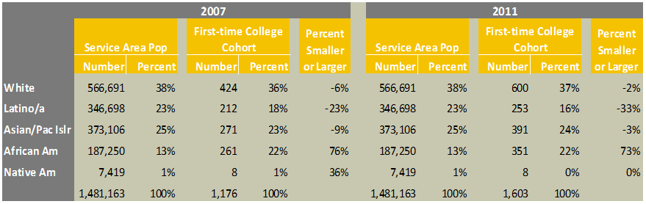
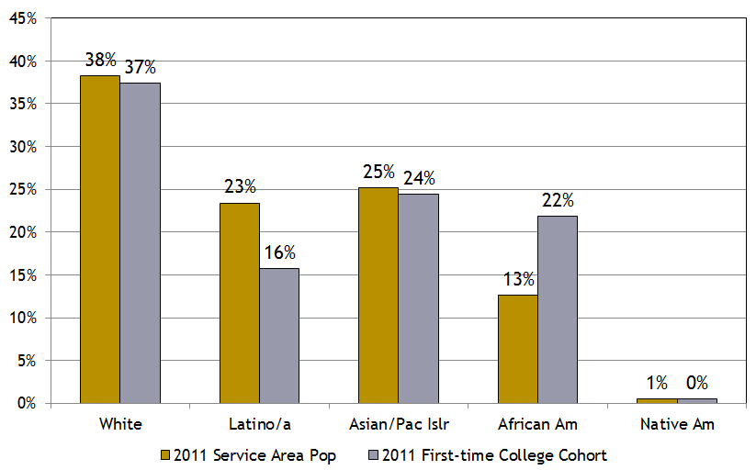

Course Success Rates
One of our objectives to address Goal One has been to increase the course success rate of all students and close the success gap among diverse student populations. As evidenced by the table below, the college has seen increases in student success among all ethnic groups.

Course success rates by Ethnicity
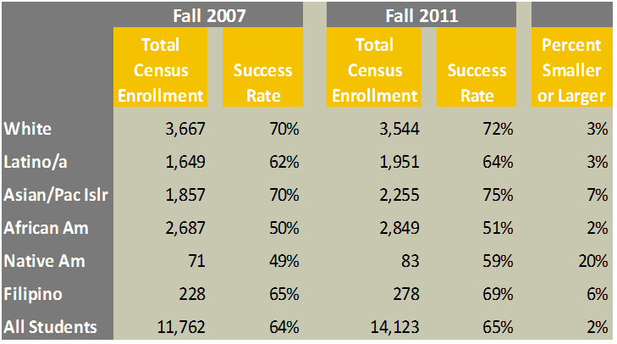
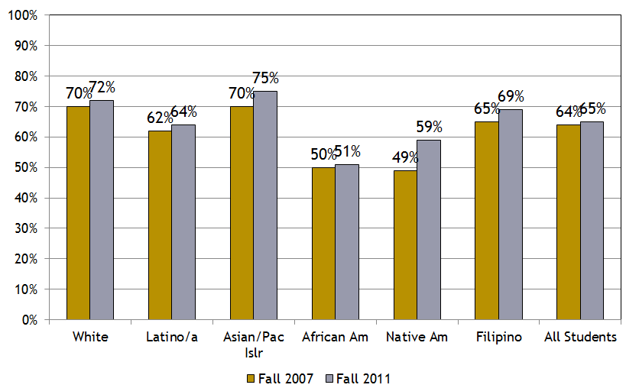
The course success rates increased for all ethnic groups by an average of 2% over the last five years. White and Latino/a success rates each increased by 3%. The African American success rate increased by 2%, while the Asian/Pacific Islander rate increased by 7%. Another objective is to increase the basic skills course success rates of all students and close the success gap among diverse student populations. The evidence below shows that BCC is achieving its objective.
English Basic Skills Course Success Rates by Ethnicity
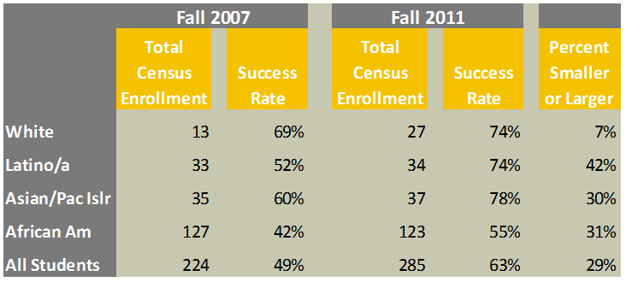
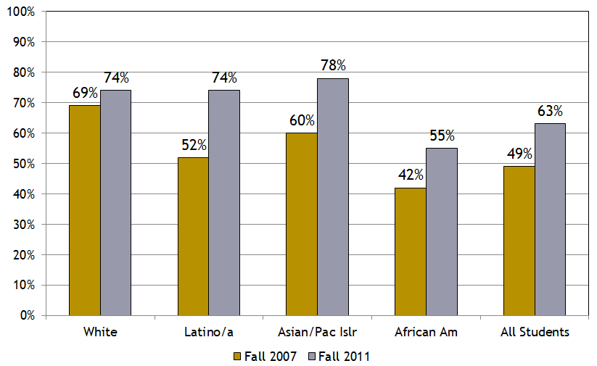

Mathematics Basic skills Course Success Rates by Ethnicity
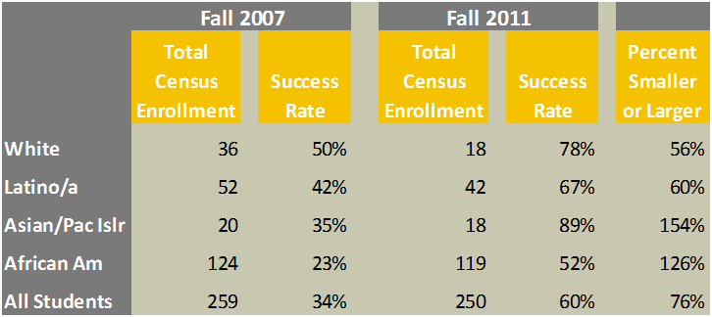

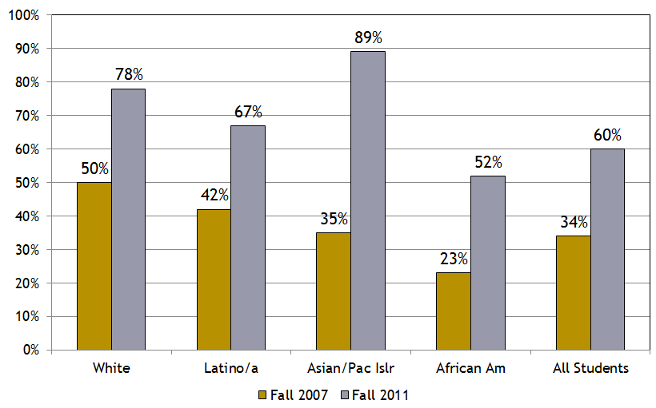

BCC’s overall Basic Skills course success rates increased significantly over the last 5 years, by 29% for English and 76% for mathematics. The college is committed to addressing the gap in African American success rates in both English and mathematics.

Degrees and Certificates
An additional college objective to address Goal One is to 1) increase the number and rates of students earning a degree or certificate, and 2) close success gaps among diverse student populations. As evidenced by the data below, BCC is on track to achieve this objective.

Certificates Earned by Ethnicity
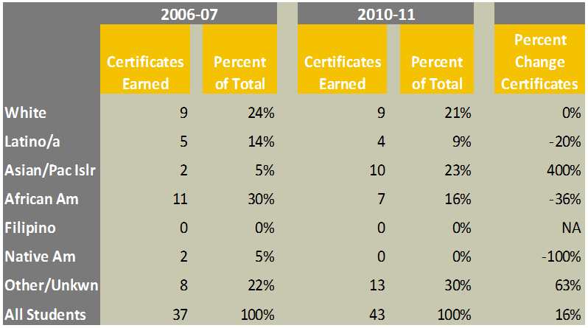
Associate Degrees Earned by Ethnicity
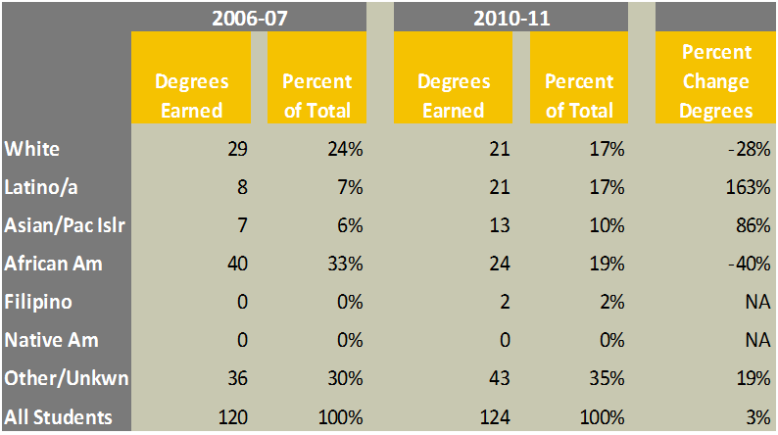
Certificates earned were up 16% while associate degrees earned were up 3%. In 2010-11, Asian/ Pacific Islanders earned 23% of certificates and 10% of degrees while making up 17% of all students. Latino/a earned 9% of certificates and 17% of degrees while making up 13% of all students. African Americans earned 16% of certificates and 19% of degrees while making up 20% of the student body. Berkeley City College has implemented four AA-T/AS-T degrees (with two pending approval) in order to increase the overall number of students earning associate degrees for transfer to CSU, and will implement strategies in spring 2013 to inform students of these new pathways to transfer.

Transfer
BCC has a defined objective to increase the number and rates of students transferring to a four-year university and to close any success gap among diverse student populations.
Number Transferred to UC by Ethnicity
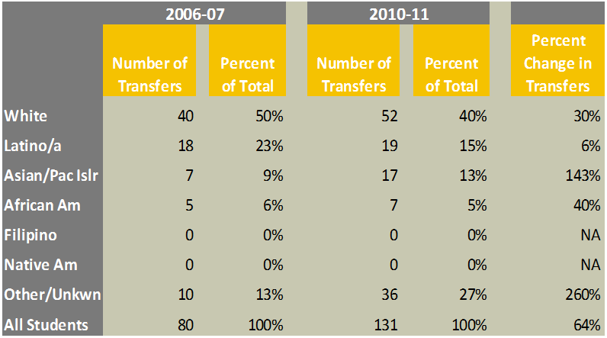

Number Transferred to CSU by Ethnicity
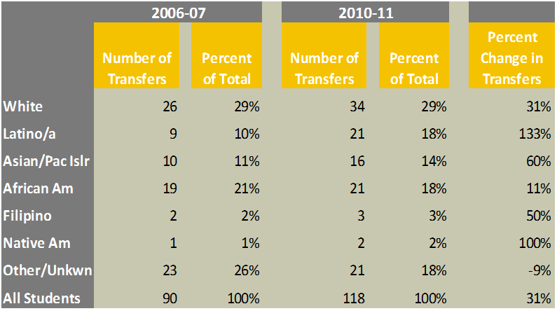

Transfers to UC were up 64% while transfers to CSU were up 31%. In 2010-11 Asian/ Pacific Islanders comprised 13% of transfers to UC and 14% of transfers to CSU while making up 17% of all students. Latino/as comprised 15% of transfers to UC and 18% of the transfers to CSU while making up 13% of all students. African Americans comprised 5% of transfers to UC and 18% of transfers to CSU while making up 20% of all students. The college plans to improve the transfer rate of African American and Asian/Pacific Islander students in particular, and the college continues to strive to increase the overall transfer rate of all students through additional programs and creating a transfer culture.

I think we also need to make sure we add the charts that Mike sent us, and ensure it helps to tell the story. BCC continued to improve student success.

Fiscal Capacity
[The institution documents a funding base, financial resources, and plans for financial development adequate to support student learning programs and services, to improve institutional effectiveness, and to assure financial stability.]
Summary of Berkeley City College Budget-Related Changes
Need narrative

For the last five years, Berkeley City College’s total base budget has averaged $13,771,489. The budget is largely comprised of salaries and benefits.

Berkeley City College’s Five-Year Budget

During that same time frame, Berkeley City College has increased in enrollment by approximately 15%. Between 2008-2010 Berkeley City College grew over 35%. This growth could have continued at the same rate had it not been for the state workload reduction. As a result of that reduction, BCC decreased in size over the next three years by 20% for an overall sustained growth over the 5 year time period of 15%. With the initial rapid growth, budgetary funds did not immediately follow that growth, but as is evidenced by the charts below, with full implementation of the budget allocation model, the funds will follow the FTES.

The chart below reflects budget reductions over a three year period. In recent years, when possible, the college has elected to keep reductions away from the classroom. Due to various contractual agreements such as faculty tenure and collective bargaining agreements, spending reductions have resulted in disproportionate reductions in the most flexible staffing groups, such as part-time faculty, teaching assistants, limited-term employees and student assistants, as well as the purchase of supplies and equipment.

Budget Reductions at BCC
Description | 2010 | 2011 | 2012
Salaries | 244,950 | 77,266 | 59,126
Books, Supplies, & Services | 53,500 | 53,128 | 98,550
Equipment | 60,160 | 7,944 | 5,765
TOTALS | 358,610 | 138,338 | 163,441

As can be seen in the table below, BCC’s budget increase mirrors the growth, but because previous growth did not have the funding that followed it, BCC is still not fully funded per the Budget Allocation Model. Do we want to say this? Great strides have occurred over the past several years, and we are excited that with the passage of Prop 30, and the passage of the Measure B Parcel Tax, the budget allocation model will be fully funded and will ensure appropriate funding at Berkeley City College.
FTES and Budget Fluctuations: 2008-2013
 | 2008 | 2009 | 2010 | 2011 | 2012 | 2013 | Net
 | Base
FTES | 3,291 | 4,145 | 4,562 | 4,315 | 4,027 | 3,651
Budget | 12,544,750 | 13,969,703 | 12,678,598 | 13,833,984 | 13,434,553 | 14,503,404
FTES |  | 854 | 417 | -247 | -288 | -375 | 361
Increase/Decrease
Budget Increase/Decrease |  | 1,424,953 | (1,291,105 | -1,155,386 | -399,431 | 1,068,851 | 1,958,654
FTES % Increase/ |  | 26% | 10% | -5% | -7% | -7% | 15%
Decrease
Budget Increase/ |  | 11% | -9% | 9% | -3% | 8% | 16%
Decrease

As seen below, the cumulative increase in FTES over the past 5 years of 15% mirrors the increase in the overall budget of 16%.

[talk about faculty hires, ( talk about how this will play a huge role in realizing the BAM) the parcel tax, passage of prop 30 and the full implementation of the BAM and the restoration of the 15% budget reductions so that we can bring back some tutors, instructional assistants, etc…]
- Budget Allocation Model
- College Infrastructure Building and Evaluation
- Established Shared Governance, Planning, and Data-Driven Decision-Making Process
- Classified Staffing Budget

Grants and Special Projects
Berkeley City College has secured grants and contracts to provide supplemental fiscal support to ensure its ability to deliver quality student learning programs and services. From 2009-10 to 2012-13 funding years, the college has received approximately $5 million in grants. The grants have supported learning communities and augmented support services for academically underprepared and other student communities such as CTE students in Public and Human Services, Spanish Medical Interpreter Program, Bioscience and Biotechnology, and Multimedia Arts. In addition, the college’s Title III grant has allowed the college to close the assessment loop as we look at student learning outcomes and assessment and amend our curriculum to improve student success. Grant funds have also been used to partially or fully pay for sections of classes that would otherwise not be offered, thus cushioning some of the impact of class reductions on the master schedule.
Berkeley City College Grants 2009-2013
Federal Grants | 2009-2010 | 2010-2011 | 2011-2012 | 2012-2013 | TOTAL
Title III | 400,000 | 400,000 | 400,000 | 400,000 | 1,600,000
Perkins | 137,534 | 135,985 | 133,910 | 133,978 | 541,407
CTE Transitions (Formerly Tech Prep) |  | 4,484 | 11,660 | 16,000 | 32,144
TRIO |  | 220,000 | 220,000 | 220,000 | 660,000
State Grants | 2009-2010 | 2010-2011 | 2011-2012 | 2012-2013 | TOTAL
Basic Skills | 90,000 | 89,744 | 90,000 | 90,000 | 359,744
CTE Community Collaborative | 59,057 | 60,347 | 136,994 | 135,345 | 391,743
East Bay Career Advancement Academy (EBCAA) |  |  | 140,000 | 70,000 | 210,000
Trade Adjustment Assistance Community College Training (TAACCT) |  |  |  | 200,000 | 200,000
Local Grants | 2009-2010 | 2010-2011 | 2011-2012 | 2012-2013 | TOTAL
California Institute for Regenerative Medicine (CIRM) |  | $329,475 | $337,310 | $369,895 | 1,036,680
Alameda County Mental Health |  |  |  | 61,925 | 61,925
 | 686,591 | 1,240,035 | 1,469,874 | 1,697,143 | 5,093,643

Federal Grants
Title III is an institutional effectiveness grant from the United States Department of Education. Its goals are to develop culturally sensitive pedagogies and curriculum and to improve tutoring, counseling and student services programs to enhance student learning. Title III also provides resources 1) to develop ongoing and comprehensive planning that uses data to enhance student success; 2) to provide professional development opportunities for faculty to improve pedagogies and curriculum; and 3) to support assessment of learning outcomes and strategic initiatives to close the assessment loop.
Perkins Career and Technical Education Improvement Act:

Perkins Career and Technical Education Improvement Act is a federal grant administered by the California Department of Education for the improvement of secondary and postsecondary career and technical education programs (CTE). Perkins IV defines career and technical education as organized educational activities that offer a sequence of courses that provides individuals with the academic and technical knowledge and skills needed to prepare for further education and for careers in current or emerging employment sectors. Career and technical education includes competency-based applied learning that contributes to student’s academic knowledge, higher-order reasoning and problem-solving skills, work attitudes, general employability skills, technical skills, and occupation-specific skills.
TRiO:

TRIO provides support services to low-income, first generation BCC students, including students with disabilities, to reach their educational goals: degree completion and/or transfer. Services include counseling/case management, priority registration, skill development, tutoring, transfer and career planning, campus tours and workshops. All intended to improve student success. Of the 149 students enrolled since 2011-2012, 129 remain active program participants and ten have graduated and/ transferred.
CTE Transitions (formerly Tech Prep) is funded through the Carl D. Perkins Career and Technical Education Improvement ACT of 2006 (Perkins IV) using the option of a “10% Reserve” set-aside from Title I, Part C Funding. CTE Transitions focuses on five objectives: outreach/career exploration, articulation, concurrent enrollment, credit by exam, and work-based learning. The goal of the grant is to help Career Technical Education students’ transition from secondary to postsecondary education and on to the world of work.
State Grants
The CTE Community Collaborative is a grant from the California Community Colleges Chancellor’s Office. The purpose of the project is to introduce middle school and high school students in the Berkeley City College service area to a broad spectrum of career choices and provide hands-on activities and targeted training in several of the industry sectors listed as strategic priority by the California Community Colleges Employment and Workforce Development Program: Multimedia/Entertainment, Green Career Pathways and additionally, Spanish Medical Interpreter. Activities also include curriculum development and articulation, the creation of stackable certificates and providing internship opportunities for students.
Trade Adjustment Assistance Community College Training grant, (TAACCT) is funded through the Department of Labor. It is a regional engineering, manufacturing and logistics economic and workforce initiative to preserve and expand the East Bay region’s manufacturing and logistics economies. This initiative seeks to build capacity to create and sustain new short and medium term training pathways leading to employment for TAA certified workers, dislocated workers, and other unemployed adults in the area of biotechnology.
East Bay Career Advancement Academy (EBCAA) is a grant funded by the California Community Colleges Economic and Workforce Development Division.
EBCAA is a central component of the college's efforts to bring more low income residents into career path employment to bridge the achievement gap facing our educational system and help low income students access careers in a growing regional industries, public and human service. EBCAA couples contextualized basic skills with technical training and expanded support systems to increase completion, ongoing enrollment, and employment among student groups who typically struggle to access and succeed in higher education.

The Basic Skills Initiative is funded by the California Community Colleges Chancellor’s Office. The Chancellor’s office defines basic skills as foundation skills in reading, writing, mathematics, and English as a Second Language, as well as learning skills and study skills, which are necessary for students to succeed in college-level work. To successfully participate in college-level courses, many community college students need to improve performance levels in math and/or English. Berkeley City College employs highly effective practices, such as innovative program structures, peer support, and counseling, to reach all students needing basic skills education.
Local Grants:
California Institute for Regenerative Medicine (CIRM):
Alameda County Mental Health Grant

Measure A funds resulted from local passage of the $390 million bond by the same name. It supports the District and its colleges in the areas of facility improvements, technology, instructional and non-instructional equipment, and library support. A total of $25,328,521 was allocated to Berkeley City College mainly for bulid-out of the new building that was completed in 2006, and for property acquisition but also including instructional equipment purchases. During 2011-12, Berkeley City College has a Measure A budget of approximately $1.6 million for Furniture, Fixture and Equipment (FF & E) and Technology. Measure A dollars have been used to upgrade technology, furniture, and library collections in addition to renovations and completion of the main single-building campus.
Berkeley City College runs its operations to be fiscally prudent while it also secures additional resources that ensure its ability to meet the needs of students and its existing programs and services. The college has altered its operations in ways to allow it to contract as well as expand to help ensure the quality of its student learning programs and services.
Operational Changes
There are several significant policy and fiscal developments which have provided important resources for Berkeley City College to effectively serve students with high quality support services and instructional programs now and into the future. These include the following:
- Approval of a district-wide budget allocation model which seeks to ensure funding equity across all colleges in the district, including Berkeley City College.
- The commitment by district administrators to support the purchase of a building with $12 Million in Measure A bond funds so that key space needs related to the number of students currently served can be addressed (faculty offices, classrooms, study spaces, a DSPS student services hub, and specialized instructional areas). The Peralta General Services Department identified this as a key project.
- Allocation of $1 Million in Measure A bond funds for much-needed technology updates, library materials, and equipment purchases.
- Commitment by the District Fiscal Services department, including the Information Technology unit, to provide centralized funding for library database annual renewals.
- Implementation of a district-wide staffing plan to ensure available funds are allocated to staffing priorities; one purpose of the staffing plan is to establish staffing parity across the colleges, including Berkeley City College.
- Utilization of faculty transfer procedures in spring 2011 and fall 2011 to enable the movement of faculty from other Peralta colleges to Berkeley City College in order to achieve parity in full time faculty.
- Approval of funds for the continuation of BCC’s strong department chair model in administering the instructional programs with fewer full time administrators in the Office of Instruction. For the 2011-2012 academic year, a negotiated reduction in department chair reassigned time left the college with 1.6 Full Time Equivalent Faculty for administration at the program and departmental level. In response to the college’s request to be made whole in the funding necessary to achieve desired chair and
coordinator support, the college agreed to fund 6.2 full time equivalent per semester for oversight of departments, coordination of specific programs, and coordination of Career-Technical Education (CTE) initiatives.
- Recruitment for two instructional deans into the positions held vacant since July, 2010 in the wake of hiring freezes.

Special Funding
Berkeley City College faculty and staff leaders, working with administrators, have made special funding opportunities a priority. While the primary resource for funding remains state general fund allocations along with annual categorical funding streams, supplemental funding is providing key additional revenue support. These special funding sources are crucial to the continuous improvement of programs and services at the college, especially with the reductions of state funding in recent years.
- Director of Special Projects: Funded by the Title III grant, this full time classified manager position offers grant management and project oversight for activities related to basic skills students and to assessment across the college.
- Title III grant: With $2 Million funded over five years, beginning October 2009, and eligibility to seek additional funding thereafter, this is a key funding source for the college. These funds support multiple activities to improve the outcomes for basic skills students and to support a culture of assessment at BCC.
- TRIO grant: This federal grant brings $1.1 Million over five years beginning October 2010, and eligibility for additional funding thereafter. This project enhances student services and supplemental instructional support for at-risk students.
- CTE grants: A number of CTE grants bring the college over $150,000, and provide the resources to strengthen career-technical education and enhance pathways for students from high school through college and on to careers.
- C.I.R.M.: A $1.1 Million grant from the California Institute for Regenerative Medicine (CIRM) funds a program of paid internships for biotechnology students who are placed in area laboratory environments at the end of their Berkeley City College Biotechnology program.
- Contract education: Partnerships with area high schools create high school-to-college pathways through leveraging of funding and offering specific accelerated courses at high school locations for advanced high school students.
- Community supporters: Through the special funding initiative of the college president, Berkeley City College has developed ongoing relationships with donors in the community who have provided approximately $50,000 through The President’s Circle in flexible funds to support college needs.

Administrative Capacity
Berkeley City College can demonstrate that it meets Eligibility Requirement #5, which reads: The institution has sufficient staff with appropriate preparation and experience to provide the administrative services necessary to support its mission and purpose.

Berkeley City College currently has seven administrators: a college president; two vice presidents (Instruction and Student Services); a business and administrative services manager; a dean of instruction; a dean of student services; and a director of special programs and grants funded by the college’s Title III grant (please see BCC Organizational Chart). Collectively, BCC administrators have over 150 years of experience in community college service and leadership.

The College President has served as an instructor and administrator at the K-12 level, dean and vice president of instruction, vice president of educational resources/ finance, has led facilities, educational, enrollment management and strategic planning, and has served as Vice Chancellor of Educational Services for the Peralta district. In addition to providing leadership for the college, Dr. Budd has a strong presence in the Berkeley community, and works with the President’s Circle to increase the awareness in the community of the vital role the college plays, as well as striving to identify additional funding sources for innovation and scholarships. Internally at the college, the president has led the various constituencies through a process of identifying goals for 2012-2013 [add more here]. She regularly conducts informal brown bag sessions open to the entire college to provide a time and space for college-wide dialogue on issues of concern.

The college Business and Administrative Services Manager oversees the college budget, and provides information and explanations regarding the budget to the college leadership. In addition, she is responsible for everything that concerns the physical plant, including security systems and parking. This year (2012-2013), BCC is completing the last construction phase for the six-year-old building, and the business manager is instrumental is assuring that the design and implementation meet the needs of the college.

The two vice presidents provide leadership for and administer their respective areas. The Vice President of Instruction has over 30 years of experience working in higher education as an instructor, grant coordinator, division dean, and vice president. In her current position as vice president, she works closely with deans, department chairs and program coordinators regarding planning for schedule reduction or enhancement, annual program updates and program review, faculty hiring and evaluation, grants and contract education, and community partnerships. She encourages and supports innovation in curricula, particularly that which addresses the needs of unprepared and underrepresented populations at Berkeley City College.

The Vice President of Student Services has 30 years of experience working in higher education at program, college, district and state levels. She has been a researcher and planner, classroom instructor, dean of academic affairs, assistant vice chancellor of enrollment management, and a vice president at BCC since 2009. Working with faculty and staff members, the vice president of student services oversees the division to ensure that it provides quality services to students, supports learning, and fulfills the mission of the College. The division assists students in developing the "whole student" for a student's intellectual capacity and achievement, emotional make-up, physical condition, social relationships, vocational aptitudes and skills, moral values, economic resources, and aesthetic appreciations through admissions and records, financial aid, outreach, placement assessment and orientation, counseling (academic , general, personal, and career), Program for Students with Disabilities, EOPS/CARE and CalWORKs, transfer and career services, student activities and associated students, and student discipline.

BCC is fortunate to have a full-time administrative position funded by the college’s Title III grant: Director of Special Projects and Grants. This administrator consults with faculty, community partners, representatives of grant consortiums, and grant writers in order to manage and provide oversight of BCC’s instructional grants, basic skills funds, and CTE funds. [add more here]

In July 2010, Berkeley City College lost two instructional deans due to relatively severe budget reductions throughout the Peralta district. The commitment on the part of the board, chancellor and college presidents was to keep budget reductions as far from the classroom as possible, so the Peralta colleges were required to achieve the budget reductions within their administrative positions. Although it was acknowledged that the colleges would lose efficiency in the administration of instructional programs, it was felt that a reduction in administration was much less drastic than a reduction in contract faculty, and the colleges had previously experienced a reduction in classified staff.

Through the college’s planning and budgeting committee, the Roundtable, the college approved funds for the continuation of BCC’s strong department chair model to assist in administering instructional programs with fewer full time instructional administrators. For the 2011-2012 academic year, a negotiated reduction in department chair reassigned time left the college with only 1.6 full time equivalent faculty for administration at the program and departmental level. In response to the college’s request to be made whole in the funding necessary to achieve desired chair and coordinator support, the college agreed to fund 6.2 full time equivalent faculty per semester for oversight of departments, coordination of specific programs, and coordination of Career-Technical Education (CTE) initiatives.

In spring 2012, two instructional dean positions were posted, and a Dean of Academic Pathways and Student Success was hired in April 2012. A second dean, Dean of Workforce Development, was hired in July 2012. Unfortunately for the college, the Dean of Academic Pathways was lured away by the offer of a full professorship at a university, but he was available to advise the new dean on BCC instructional processes and procedures prior to his departure. Currently, the Dean of Workforce Development and the Vice President of Instruction work closely on a daily basis with instructional department chairs in order to provide leadership to and oversight of BCC’s instructional programs.

The collective administrative efforts of all department chairs, program coordinators and directors as well as the lead administrators described in this section have ensured a stable college leadership structure. Together, they have established clear financial planning principles aligned with the college mission and educational priorities, and consider these as guiding principles when making short-term and long-term decisions in collaboration with the college’s shared governance model. Berkeley City College also continues to inform the District’s financial planning agenda, policies and procedures through various means including, yet not limited to, the Planning Budget Council, the Chancellor’s Cabinet and directly with the Chancellor and Vice Chancellors to assure the financial integrity of the institution.
At the College level, financial integrity is a principle that requires ongoing attention in the planning and budgeting process. Thus, the College makes transparent its planning, decision-making, allocations, expenditures and assessments of efficacy via its planning website, in shared governance meetings and through electronic communications. As evidence of their efforts, college administrators have institutionalized the following practices:
- Ensured college-wide participation in the development of annual institutional goals and outcomes;
- Institutionalized the integrated planning and budgeting processes;
- Welcomed critical input, expressions of concerns and recommendations to be shared with the administration and shared governance groups in open, transparent ways via forums, on-line, and via an anonymous Suggestion Box;
- Devised plans to enhance capacity and support quality programs and services;
- Used assessment and evaluations at the professional, course, program, service and institutional levels to improve organizational structures and practices; and
- Provided priorities and requests to District colleagues and leaders to promote strategic engagement in short- and long-term solutions that would assure quality student learning programs and services.

Instructional Services
Berkeley City College has been asked to make budget reductions each year since 2009-2010. It has been the commitment of senior administration to provide information as the situations develop, to seek college input and make full use of governance bodies to determine processes for making reductions, and to make budget reduction decisions fully transparent. The college governance bodies worked together to develop guiding principles for budget reductions:
• Support student success, access and equity.
• Maintain the highest quality of instruction and services.
• Keep cuts away from the classroom, as much as possible.
• Support continuing students over new students in categorical programs.
• Support critical initiatives such as basic skills.
• Seek input from the shared governance process.
• Maintain transparency, collaboration and communication.
• Support instruction and student services.
• Recognize that building maintenance and security enrich the learning environment.
• Gather ideas to reduce expenses and increase revenue.

These principles were used to address approximately $480,000 in budget reductions over two
years. As a result, the quality of programs and services at Berkeley City College has remained
at a high level and necessary efficiencies and modernization efforts have provided positive
results. BCC and the district continue to work collaboratively toward the implementation of a
resource allocation model.
The state-mandated workload reduction has impacted BCC’s schedule of classes, student enrollment, FTES generation, and hourly faculty FTEF. However, the charts below demonstrate that despite the challenges faced by Berkeley City College faculty, staff and students, overall retention rates, completion rates, and student success rates have not been adversely impacted by the budget and workload reductions.
Term | Campus | Total Graded | Success | Success Rate
2009 Sp | Berkeley City College | 13,794 | 8,977 | 62.2%
2010 Sp | Berkeley City College | 15,506 | 10,069 | 62.0%
2011 Sp | Berkeley City College | 14,936 | 10,043 | 64.8%
2009 Fall | Berkeley City College | 15,119 | 9,843 | 62.2%
2010 Fall | Berkeley City College | 14,500 | 9,836 | 65.5%
2011 Fall | Berkeley City College | 14,120 | 9,278 | 63.9%
Additionally, xxxxxxxxx
Retention and Course Completion Rate by College
Date run: 8/8/2012
Census Enrollment = Dropped after census or didn't drop
Course completion (received credit): Grade of A, B, C, D or PS
Completion Rate = Course Completion / Census Enrollment
Retained = A, B, C, D, F, IP, I, RD, PS, NP
Retention Rate = Retained / Census Enrollment
Term | Campus | Headcount | Census | Course completion | Completion Rate | Retained | Retention Rate
2008 Fall | Berkeley | 6334 | 14007 | 8988 | 64% | 10335 | 73.80%
2009 Spring | Berkeley | 6878 | 14921 | 9569 | 64% | 10952 | 73.40%
2009 Fall | Berkeley | 7546 | 16262 | 10441 | 64% | 12247 | 75.30%
2010 Spring | Berkeley | 7779 | 16454 | 10608 | 64% | 12244 | 74.40%
2010 Fall | Berkeley | 7381 | 15602 | 10420 | 67% | 11859 | 76.00%
2011 Spring | Berkeley | 7549 | 15883 | 10638 | 67% | 12322 | 77.60%
2011 Fall | Berkeley | 6912 | 14834 | 9766 | 66% | 11161 | 75.20%
2012 Spring | Berkeley | 6971 | 14870 | 9878 | 66% | 11165 | 75.10%

In an attempt to capture the real impact of budget reductions on instructional programs and services, BCC faculty were asked to respond to three additional questions as they completed department program reviews in fall 2012. The three questions are listed below.
- If your department experienced a reduction in resources, describe the impact of that reduction on the overall educational quality of your unit and the College.
- How does the department plan to sustain the quality of instruction and/or services offered through your department in the current environment of reduced resources?
- What does the department recommend that the college do to maintain quality educational programs and services?
Each departmental response has been documented in the matrix titled “Program Review Responses by Department” (see Appendix XX) as well as in departmental program reviews (posted on BCC’s website). In the section below, the College has categorized the responses with specific examples of ways in which instructional departments are meeting the challenge of reduced resources, including a reduction in the number of sections each term.
As seen in Figure XX, Berkeley City College experienced a 15% schedule reduction from 2008-09 to 2012-13 due to the state-mandated workload reduction. Department faculty were asked to describe the effects of resource reductions, including schedule reductions, on the overall educational quality of the department and college. Their responses are described below.
Impact of Schedule Reductions on Educational Quality
Several departments such as American Sign Language (ASL), Business, Computer Information Systems (CIS), English as a Second Language, Math, Modern Languages, and Multimedia Arts have documented the negative impact of budget cuts and schedule reductions on their programs. ASL has had to reduce the number of times per academic year it offers its capstone course. Business classes have been reduced by 40%, thereby reducing the number of electives available to students. A 50% schedule reduction in CIS is reflected in the downward trend of course offerings in the discipline over the last ten years due to the economic downturn. Math classes are impacted with a 27% increase in students per section as a result of schedule reductions. The Modern Languages Department chose to suspend course offerings in Arabic, French and Portuguese and to focus on Spanish in order to provide a full foreign language program to students. Finally, the Multimedia Arts Department has had to cut double sections of beginning courses, which impacts student enrollment in the more advanced classes in the program.
Despite these challenges, BCC faculty have strategically tried to address schedule reductions in such a way as to lessen the impact on students. The Art Department Chair writes,
While the Art program has experienced considerable cuts over the past three years, these cuts have served to strengthen our vision and priorities as a program. Access may have been diminished but quality of instruction and programs has not. In fact, cuts to course offerings have resulted in: more effective scheduling practices with courses on rotation; a greater focus on courses that serve many programs and a larger population versus specialty courses that served smaller groups; development of AA-Ts which strengthen our mission for transfer and student success and create clear pathways with academic integrity; development of a Public Arts certificate that specializes in unique offerings and prepares students for the work force; and revision of the Figure Studies certificate to be current and interdisciplinary. At the college level, cuts have also invited a more reflective and effective use of resources tied to planning, shared governance, and renewed discussion of the vision of our college (Art Program Review, Fall 2012).
There are numerous examples of Berkeley City College faculty swallowing their disappointment over prescribed schedule reductions and rising to the challenge of ensuring that course and program reductions impacted students as little as possible. AA-Ts or AS-Ts have been developed (or are being developed) in the following programs: Art (in development), Business Administration (in development), Communication (in development), English, History (in development), Math, Political Science (in development), Psychology, and Sociology. As BCC hires or accepts transfers of additional full-time faculty, the expectation of developing additional AA-T and AS-T pathways is made clear. As in Art, several department chairs have written in departmental program reviews about strategies implemented to lessen the impact of reductions and how they have used this time as an opportunity to reflect on and revise department and program curricula. Please see examples below.
Business: “Currently we are working on creating many certificates of proficiency in accounting and hope to have them in place before the end of this academic year” (Business Program Review, Fall 2012).
CIS: “On a positive note, even though we could not offer these courses in a timely manner [due to schedule reductions], many students have been able to find employment or transfer to four-year colleges. In fact, though the number of our class sections has dropped approximately 50%, our enrollment has only dropped approximately 25%. We strive to offer a full sequence of degree requirements by mixing daytime and evening sections and also offer some online/hybrid sections. Virtually all class sections fill.
Given the budget cuts and the cancellation of classes, we have structured many of the courses offered by the department to parallel the professional certificate programs offered by the industry. This also facilitates quick employment for the students. For example, CIS 36A and CIS 36B cover the same materials that are needed for the Oracle Certified Java Programmer and Oracle Certified Java Developer. CIS 85 covers the same materials that are needed for the Oracle Certified Web Component Developer. CIS 81 and 82 cover part of the topics required for the Oracle Certified Enterprise Architect” (CIS Program Review, Fall 2012).

English: “Due to budget cuts, the department no longer offers individual, drop-in tutoring. Instead, “writing workshop” classes (English 208 and 258) offer support from instructional assistants and student workers, who serve as ‘writing coaches,’ or tutors, in a highly organized, group tutoring format. Surveys have shown this to be a very successful approach, and the college is able to offer tutorial support very efficiently in this way. Informed by the results of assessments, members of the department work together regularly to improve their pedagogical techniques. For example, faculty have been involved in numerous Teaching-Learning Center faculty inquiry groups and “APPLEs” (did we define this, I may have missed it?) to improve curriculum design and teaching methodologies. Most recently, a group of five instructors met to create a “model schedule” for composition classes which has been shared with the department, and another group is working to create an online repository of materials for teaching the curriculum in this model schedule. In terms of technology, the English class at BCC is very different than it was five years ago. Almost all instructors in the English department utilize Moodle to create web-enhanced instruction in their courses. In addition, most English instructors use the smart classrooms to create engaging, student-centered activities in their classes. Finally, most English teachers use turnitin.com to improve their feedback about essay assignments and to guard against plagiarism (English Program Review, Fall 2012).
Communication, Humanities and Music respond similarly that since their program growth had been slow and careful, these disciplines were able to cut back sections with minimal impact, stating, “We were able to cut sections but keep a diversity of offerings through juggling daytime and nighttime and online offerings, create a rotation, etc.”
In addition, the Humanities Department Chair writes, “We continue to create and implement new courses. This semester we have created a new course called HUM 5: Storytelling in American Culture to strengthen the ‘culture & civilization’ strand of our Humanities program to include critical curriculum on folklore and folklife, or traditional expressive culture. This course has just been articulated at Berkeley City College as a CSU and IGETC GE requirement under Area C2 and 3B. It also meets the UC American Cultures requirement” (Humanities Program Review, Fall 2012).
Often the most vulnerable populations at Berkeley City College are most impacted by resource and schedule reductions. The number of sections in the ESL program at BCC has been reduced by 43%. However, the four Peralta colleges convened in their PEAC group [Peralta ESL Advisory Committee] to review the ESL curriculum in light of budget reductions, increased tuition, and new financial aid restrictions, as well as dismal outcomes for basic skills ESL students. The result of this collaboration has been astounding: a new, accelerated ESL curriculum aimed at helping students progress through the course sequence more quickly and with fewer acquired units. In the words of the ESL Department faculty, “We have used this time of reductions to radically revision and restructure our curriculum to allow for acceleration and to scaffold the skills needed for success in transfer and vocational programs. To inform our curriculum design, we used data from SLO assessments, student focus groups, and other Teaching and Learning Center sponsored inquiry and action projects. We have been named a ‘model district’ by California’s Acceleration in Context Initiative, and our work has been receiving statewide recognition” (ESL Program Review, Fall 2012).
The Chair of Social Sciences best sums up the approach of the majority of BCC departments when she wrote the following:
While Social Sciences is certainly smaller in terms of the number of sections offered than it was four years ago, the direction of the department as a transfer focused department has resulted in a more clearly structured and balanced department. Developing the AA-Ts has served to define clear pathways for students within our disciplines, led to greater coordination among the disciplines in terms of offerings and scheduling and clarified our role in the larger mission of the College. We have several transfer programs at the College that are not currently AA-T programs that require support from Social Sciences. Social Sciences would support converting these AA programs to AA-T programs. The hiring of a full time anthropologist and full time ethnic studies faculty would complete our department’s faculty needs and provide a more general support of College goals.

Sustaining Quality Educational Programs
Berkeley City College instructional programs are fundamentally sound and able to withstand the reductions of the past years. For example, ASL writes, “The strength of the program is that all the teachers use the same approach to instruction so that students’ progression is efficient and performance based, which requires new teachers to learn our methods” (???) (ASL Program Review, Fall 2012). Some departments, such as Math and Spanish, have agreed on a common textbook for beginning courses. Berkeley City College has experimented with acceleration not as a result of budget cuts, but as a way to address course and program completion as well as assisting students who become “stuck” in a basic skills sequence. As a result of program assessments, the English department has introduced a new, accelerated basic skills course, which is currently in the process of institutionalization as English 202. This course affords students the opportunity to gain the skills for success in English 1A in an accelerated mode. In fact, students completing the accelerated pathway have performed better on holistically-scored assessments than students completing the traditional path to English 1A (see data).
Additionally, the one-unit course Learning Resources class which has been linked to freshman and basic skills composition classes to create the college’s “first year experience” is currently being institutionalized as LRNRE 100. The curriculum for this course is based on the “ACE” curriculum (Academy for College Excellence) developed by Diego Navarro – curriculum which has been shown to be effective to increase student success in a number of studies, cited on the ACE website. Surveys among students who have taken the experimental version of this class have shown that they believe that taking the course has improved their chances for success in college. As a central component of program assessment, the faculty members who teach English composition (the majority of teachers in the department) come together every semester to score portfolio assignments, and the faculty come together as a whole to discuss results and plan innovations to instruction. Similarly, the teachers who are involved in courses for the major (leading to the AA or AA-T) also work together on program assessment and plans for improvement. They share specific teaching methodologies and materials. Creative writing instructors have just begun to work together on program assessments and will discuss the results next semester.
Department faculty base new initiatives on completion and success data. To address the poor performance of students in basic skills math (from 34% to 60%), BCC Math Department faculty in 2011-12 designed two approaches for improving success in pre-collegiate math courses. The first strategy was to design a pre-statistics course that presents an accelerated alternative to the traditional 2-semester algebra prerequisite sequence. Students electing to take this pilot accelerated path were tracked for success in the experimental course, and allowed to enroll in college-level statistics if the pre-statistics course was successfully completed. These students are currently being tracked in the college-level statistics course, and the college will have data as of January 2013 to compare success rates of the pilot path with success rates of the traditional path to college-level statistics.
The second Math Department strategy has been to completely rework the pre-collegiate math sequence – from Arithmetic through Intermediate Algebra – through modularization of sub topics. The traditional 16-unit sequence of courses has been divided into 20 half-unit segments that students can access at their own pace in a Math Lab (using the software My Math Lab). The college will have preliminary data in January 2013 regarding retention and success in the experimental sequence in comparison to retention and success in the traditional sequence of pre-collegiate math courses.
The Multimedia Arts department has five strands with five AA degrees and five certificates of completion in Digital Imaging, Web Design / Production, Digital Video Arts, Animation, and Writing for Multimedia. In response to Multimedia Arts student surveys in Spring 2011, department faculty deactivated outdated courses and designed Proficiency Certificates for all the strands to increase student completion and employment. By arranging core courses into small chunks, students accomplish some of their goals in mere semesters, encouraging them and providing them with useable certificates in the industry. To align with the changing industry landscape, the Proficiency Certificates focus on the discreet set of skills likely for employment. This concentration has enabled the department to continue its core courses effectively.

Student Support Services
Overview
Annual program planning takes place in Student Support Services as well as in Instructional Services, and assists units in responding to state budget cuts. BCC Student Services programs have experienced budget reductions in some areas but not in others. For example, two essential services - Admissions and Records and Financial Aid – are centralized through the Peralta Community College District office. These units have been given additional resources to address increased student demand, including added personnel and training. The Welcome Center at BCC has been instrumental in relieving some of the traffic at the Admissions and Records counter. Students are able to use the computers in the Welcome Center to submit online applications and update and view their program information. Student Ambassadors are available to provide customer service and technological assistance by helping students successfully enroll in classes and make necessary changes in their programs. In an ongoing effort to provide efficient, user- friendly services, the Admissions and Records department has supported the implementation of PeopleSoft and online official transcript ordering, and continues to work with faculty and college administrators to maintain accurate accounting of grade and attendance records. The office continues to share resources with the district and the other three colleges through collaboration and coordination.
In contrast, the demand for services in Articulation, Health Services, and Veterans Affairs has increased over the past several years, but these units have never had specifically designated budgets. Staffing in Articulation has been only 50% of the need identified in the Berkeley City College Education Master Plan in 2008. BCC currently has a part-time (.50) articulation officer. The plan for 2012-13 to increase articulation agreements is to focus on four-year public institutions to which BCC students primarily tend to apply. At this point, review and requests for updating of agreements with UC Merced, UC Berkeley, UC Davis, CSU East Bay, and San Francisco State University have been completed. With the passage of the Alameda County Parcel Tax and Proposition 30, the college will advocate for a full-time articulation officer in order to increase articulation agreements with all CSUs, UCs, and private colleges and universities; to provide more assistance with the development of Associate Degrees for Transfer; and to provide additional assistance to the college and district curriculum committees.
In fall 2012 BCC has been able to put into place increased health services for students funded by student health fees. These services include on-site personal counseling two days a week and on-site HIV testing services two hours per month. In addition, the college has received a 16-month mental health service grant to train students in peer advising, and plans to offer four hours a week of health services designated for youth. Student Services is partnering with a BCC instructional program – Public and Human Health Services – to identify students willing to work as peer advisors.
At BCC, the number of veteran students served has increased by 57% over the last three years, and an even larger increase is anticipated over the next two years as military released from duty return home. This growth has increased needed staffing from .25 to .75 FTE. BCC has been able to meet this need by redistributing classified responsibilities in order to provide quality services to students who are veterans; unfortunately, other services have been affected. BCC is working with the Oakland Veteran’s Center, an outreach program, to assist veteran students to stay in school. The 80.2% retention rate of veteran students in fall 2011 at BCC was 8 percentage points higher than the 72.5% overall retention rate at BCC during that same time period. In addition, the success rate of veteran students in fall 2011 at BCC was 72.8%, 7 percentage points higher than the overall success rate of 65.6%. Another program, VRAP, was initiated in July 2012. This is a one-year retraining program for veterans between the ages of 35 and 60, and is geared toward training programs at community colleges. The fall 2012 semester at BCC is the first semester veterans have been awarded these funds, and VRAP awardees constitute 7% of the current veteran population at BCC. Finally, in fall 2012, BCC veterans started a Veteran’s Club to assist and organize veteran students on campus. The club is open to all veteran and non-veteran students at all four of the Peralta Community College campuses.
Impact of Budget Reductions

Programs including Counseling, Transfer and Career Information Center, Student Activities, and all categorical programs have felt the impact of budget reductions. While the BCC student body (unduplicated headcount number) has almost doubled in the past six years, the number of full-time counseling faculty has dropped from four to three as a result of a full-time general counselor resignation. The district-wide hiring freeze affected the college’s ability to fill the vacant position. However, in recognition of the need for additional full-time counselors at BCC, the college was allowed to include counselors as part of its request for transfer faculty posted in spring 2011. In addition, BCC has been awarded nine new faculty positions for academic year 2012-13, and the first faculty positions advertised were for two full-time counselors. These two new counseling positions received full support from the Department Chair Council in its formal prioritization process.
The Counseling Department is partnering internally with other departments to enhance services to students. Video vignettes are being created by the college’s multimedia department which will inform students about counseling procedures, services, processes, FAQs, and so on. These vignettes will be embedded on the counseling web site and can be viewed in the counseling reception area. In addition, a more comprehensive and informative orientation has been developed and piloted which addresses many student concerns and questions at the onset of the BCC experience. In terms of improved technology, scanning technology has enabled counselors to access Student Educational Plans interdepartmentally, as well as official transcripts held at the District, and E-counseling has been implemented.
Some of the casualties of the previous years’ budget reductions include the following:

- 1 FTE classified staff member supporting Student Activities was eliminated.
- Associated Students (ASBCC) and clubs have received inconsistent advice and sporadic support as a result of the lack of classified staffing.
- Overflow counseling from categorical programs’ staffing deficiency has been absorbed by general counseling faculty members who are inadequately prepared for case management counseling.
- Reduced staff development funds limited the opportunity for faculty and staff to update and upgrade their knowledge and skills.

Categorical Programs

All categorically funded Student Services at California community colleges have been cut more than 50% by the state. In result, all full-time categorical counseling positions were replaced by adjuncts at BCC.

In addition to state budget cuts, BCC’s Disabled Students Programs and Services experienced a retirement this year of a Learning Disability (LD) Specialist and of a DSPS Counselor/Coordinator in 2009. To address the ongoing needs of DSPS students, BCC has just hired a full-time LD Specialist and a full-time DSPS Counselor/Coordinator (fall 2012). The DSPS programs in the district are working collaboratively on providing Deaf and Hard of Hearing services by using a district coordinator located at Laney College. The District Office provides approximately $1.2 million district-wide in match dollars for DSPS annually.

The 100% cut in funding supporting Student Ambassadors impacts the college’s plans to conduct and implement plans for out-reach and in-reach. This model program has been supported by funding from the District Office at one-third of the previous level.

Sustaining the Quality of Student Services at BCC

To sustain the quality of services, Student Services have been coordinated at both college and district levels through prioritization, partnership building, grants, collaboration, and resource sharing. Through the process of program review and Student Learning Outcome (SLO) development and assessment, both BCC and PCCD have integrated decision-making into resource allocation to keep vital services alive (see district-wide Student Services collaboration at http://www.berkeleycitycollege.edu/wp/student_service_programs/district-wide-collaboration-and-coordination/.)

Despite the state-mandated workload reduction, Berkeley City College faculty, staff and students continue to perform well, as evidenced below.

SLO Assessment. BCC Student Services SLO work has attained the proficiency level. BCC students who participated in SLO assessments ranked learning outcomes from all services very high. For example, through Assessment and Orientation SLO outcome measures addressing Information Competency, Self Awareness, and Personal Responsibility, the ranks averaged between 4.37 and 4.60 on a 5 point scale. Rankings of the seven items addressing Information Competency and Self Awareness on the Transfer and Career Center’s SLO survey ranged between 4.4 and 4.9. Of the 66 students responded to the DSPS SLO survey, over 80% of students agreed that DSPS has helped them in improving Self Awareness and Personal Responsibility. Student Services have used the SLO assessment findings as a foundation for program improvement.

Assessment and Orientation. In fall 2010 and 2011, the number of students attending orientation at BCC almost doubled the number of those at the other two Peralta colleges of similar size. Persistence, retention, and success rates of BCC students who received orientation in fall 2009, 2010, and 2011 are the highest among the four Peralta colleges. BCC’s rates averaged 5 percentage points higher than the lowest rate. Please see Student Services data 2012-13 at http://web.peralta.edu/indev/research-data/documents/. On the SLO Assessment survey, students ranked Assessment and Orientation very high – a median of 4.48 on a 5-point scale. Orientation staff plan to increase information provided to students at orientation by inviting special programs staff – such as PERSIST, PACE, EOPS, and TRIO - to make presentations. In fall 2012, BCC has successfully conducted cohort group orientation in order to streamline services to students.

Counseling. Success rates of student who received counseling services averaged 3.5 percentage points higher than the overall college rates over the last three years. Fall to fall persistence rates for students who received counseling services averaged 8.5 percentage points higher than the overall college rates over the last three years. Two new counseling faculty will begin their tenure-track assignments at BCC in January of 2013. BCC has an ongoing relationship with its feeder high schools, and both a high school student orientation and a high school counselor breakfast are scheduled in December 2012. Targeting incoming high school graduates, a comprehensive and informative orientation has been developed and piloted, addressing many student concerns and questions at the onset of their BCC experience. E-counseling has been implemented, offering counseling to the online student population. Counselors from grant/categorically-funded programs have been visiting classrooms, making presentations to students about counseling services and encouraging them to see counselors.

In addition, seven University of California campuses offer Transfer Admission Guarantees (TAG) to eligible BCC students. The students must meet all UC and transfer admissions requirements specific to the campus of their choice. The TAG program is an opportunity for students to receive an early guarantee of admission from one University, provided they complete all remaining requirements and maintain the minimum GPA for their major. Annually, BCC counselors assist over 100 BCC students in completing their TAG applications.

Furthermore, the Concurrent Enrollment Program is an opportunity for BCC students to take lower division courses at a participating 4 year school for the same price as the community college course. They are able to concurrently enroll at are UC Berkeley, CSU East Bay, and Mills College. Typically, students decide to take a university course that is required for their major, but is not offered at Berkeley City College. Annually, approximately 40 BCC students applied and are accepted by the Program.

Through the 2012-13 Student Services Program Review process, counseling needs in all categorical programs have been emphasized. The Student Services Council went through its shared governance process and prioritized all categorical counseling positions on the top of the faculty needs list.

DSPS. Success rates of DSPS students are equal to or higher than non-DSPS students. The number of DSPS students has increased by 3% since 2009-2010, and enrollment continues to grow annually. BCC has successfully filled one vacant faculty position and completed the hiring process for the full-time Counselor/Coordinator position. Short-term plans for the future include strengthening the network between DSPS and local agencies that serve people with disabilities, such as the Department of Rehabilitation, Center for Accessible Technology, and UC Berkeley’s College Internship Program; and identifying a space to use as an assistive technology (AT) lab to serve the increasing demand by DSPS students, who use such technologies to access and complete their coursework.
EOPS/CARE/CalWORKS. EOPS/CARE/CalWORKs programs have endeavored to sustain the quality of support services to program students by implementing the following collaborative and supplemental activities: 1) Students are referred to Graduate Counseling Interns for advising purposes and to counseling staff in other support programs; 2) Student Aides paid out of Federal Work Study funds are hired and trained to provide basic support services; 3) A book loan program has been created with some program funds and text book donations from students.

The EOPS Program served an average of 316 students over the last three years, while the state funded the college for only 100 students. EOPS students constitute 11% of BCC’s full-time student population. Between 2010 and 2012, 62 EOPS students received AA/AS degrees, 13 received Certificates, 33 transferred to UCs, and 38 transferred to CSUs.

Financial Aid. In 2010-11, a total of $6.87 million of financial aid was awarded to BCC students, an increase from $6.34 million awarded prior year. Pell Grant recipients increased by 43% from 1,098 in 2009-10 to 1,571 in 2011-12; while Pell awards increased by 47% from $3.45 million to $5.07 million. BCC Student Ambassadors have provided technical support to assist students in using on-site computers to complete financial aid applications. In addition, there is a plan to increase services to financial aid recipients by implementing an appointment system to facilitate faster completion of files, resulting in quicker disbursements for students.

Student Activities. A portion of the Student Activities responsibilities have been shared voluntarily by several BCC administrators, faculty and staff members, as well as UC Berkeley- BCC Service Community, a Community composed of BCC transfers to UC Berkeley and funded by UC Berkeley Chancellor’s Office. These BCC alumni have been returning to BCC and providing assistance with various support services issues. Resources have been identified to meet the needs of the Associated Students of Berkeley City College: the size of the student activity space has tripled, and new furniture and computer equipment have been purchased and installed.

Transfer and Career Center. The Center received an excellent SLO assessment result. On a 5 point scale, rankings of the seven items on the Transfer and Career Center’s SLO survey ranged between 4.4 and 4.9. In addition, a grant has added one .5 FTE student assistant with expertise in career technical programs. Over the last three years, the number of BCC transfers to UC and CSU increased by 13%, from 174 to 196. The Center regularly offers transfer and career events, including the following held in 2011-2012: fall 2011- Transfer Day event; spring 2012 - Transfer Night event and a Career Pathways Expo; five 4-year college campus tours; an average of 10 BCC campus visits per month by 4-year college representatives; monthly workshops.

Grant Funded Programs. Student Services have been supported by several grant-funded programs, such as TRiO and Perkins. TRIO provides support services to low-income, first generation BCC students, including students with disabilities, to reach their educational goals: degree completion and/or transfer. Services include counseling/case management, priority registration, skill development, tutoring, transfer and career planning, 4-year campus tours and workshops. All intended to improve student success. Of the 149 students enrolled since 2011-2012, 129 remain active as program participants and ten have graduated and/or transferred.

Recommendation for Quality Student Services Maintenance

With new college and district leadership on board, BCC Student Services would like to proactively join the college and district collaboration team to achieve the following:

- Full implementation of the Budget Allocation Model;
- Assessment of the structure of Student Services at the college so that the staffing, in quality and quantity, will strategically and proportionally reflect BCC’s student growth and changing demographics;
- Appropriately link available existing and new resources, e.g., international and non-resident student revenue, parcel tax, grants, etc., to meet the increasing demands for support services by the diverse student population, especially those from under-served, under-prepared, and under-privileged backgrounds;
- Enhance district- and college-wide planning development and decision-making process in the areas of facilities, staffing, technology, and finance.

Summary

In summary, BCC meets all accreditation criteria of Standard IIB. Student Services at BCC provides support to a diverse population including our prospective, current and previous students to enhance the achievement of the mission of our college. Through coordination, cooperation, and team work, student support services address the identified needs of students and enhance a supportive learning environment. At both the college and district levels, BCC identifies the learning support needs of its student populations and provides appropriate services and programs to address those needs; and assures equitable access to all of its students by providing appropriate, comprehensive, and reliable services to students. BCC continues to update and upgrade student services, e.g., counseling and academic advising delivery designed for the general student, as well as targeted student populations.

Together, we regularly and systematically assess student support services through program review, annual program updates, student learning outcomes (SLO), faculty and staff input, and other appropriate measures in order to improve the effectiveness of these services. Evaluation of these services provides evidence that we contribute to the achievement of student learning outcomes. Student Services at BCC uses the results of these evaluations as the basis for improvement. Please see BCC Student Services Program Review at http://www.berkeleycitycollege.edu/wp/student_service_programs/berkeley-city-college-program-review-summary/, SLO at http://www.berkeleycitycollege.edu/wp/student_service_programs/student-services-slo-home/, and district-wide Student Services coordination at http://www.berkeleycitycollege.edu/wp/student_service_programs/district-wide-collaboration-and-coordination/.

