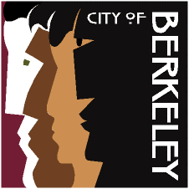

BERKELEY RIDES FOR SENIORS
& THE DISABLED

HIGH MEDICAL NEED PROGRAM

Health, Housing &
Community Services
Aging Services Division

About the Program:

Berkeley Rides for Seniors & the Disabled (BRSD) provides transportation assistance for City of Berkeley seniors and people with disabilities.

The High Medical Need Program (HMNP) is available to those already registered as a BRSD participant and have increased transportation needs due to frequent medically related appointments. Approved applicants will receive additional taxi script or wheelchair van vouchers to help supplement the cost of transportation to and from medically related appointments.

HMNP Program Requirements:

- Must be a registered participant with BRSD to be eligible to apply for the High Medical Need Program. *See info below to apply to BRSD program*

- Must have a medically related appointment at least 1 time per week.

- Medically related appointments include doctor visits, physical therapy or other related rehabilitation therapies, dialysis, radiation and chemotherapy treatment.

- Must have a Physician’s Certification signed by your physician verifying your medical visits.

BRSD Eligibility:

- You are a Berkeley resident; AND
- Anyone age 80 or over; OR
- Seniors age 70 to 79 who do not exceed the HUD very low-income threshold for Alameda County ($3,808 per month for a single person household and $4,350 for a two person household).
- Anyone who is East-Bay Paratransit certified, of any income or age

Where can I get a BRSD application?

You can call (510) 981-7269 and request an application or go to our website at https://cityofberkeley.info and download an application. Once you have completed the application and attached all requested documentation, please mail all of your materials to:

Berkeley Rides for Seniors & the Disabled
1900 Sixth Street
Berkeley, CA 94710

Contact Information: Please call (510) 981-7269

