`

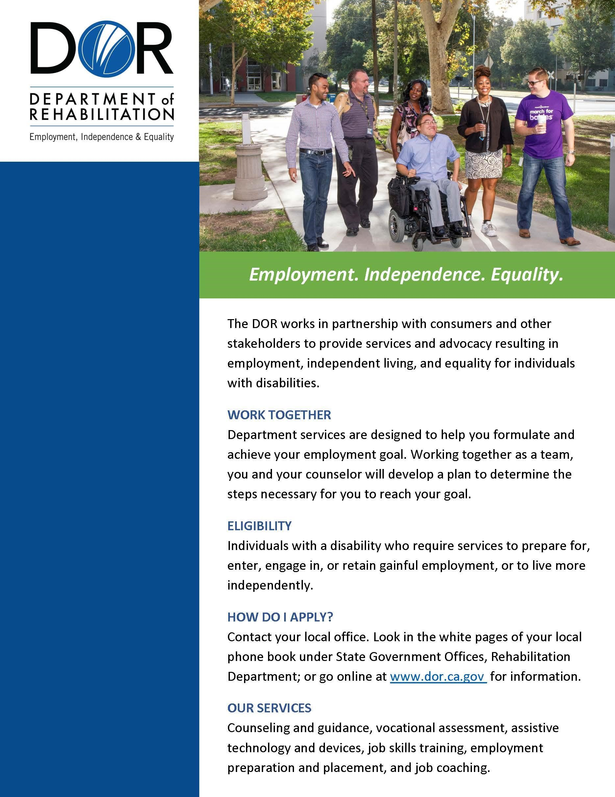

**GREATER EAST BAY**

**OFFICE LOCATIONS**

**Concord**

**District Office**

1485

Civic Court

,

Suite

1100

Concord, CA 94520

925.602.3953

(

Voice

)

**Antioch Branch**

3656

Delta Fair Blvd.

Antioch

, CA

94509

925.754.7700

(

Voice

)

**Fairfield Branch**

450

Chadbourne Rd

.

, Suite

A

Fairfield, CA 94534

707.428.2080

(

Voice

)

**Oakland Branch**

1515

Clay Street

,

Suite 119

Oakland, CA 94612

510.622.

2764

(

Voice

)

**Fremont Office**

39155

Liberty Street

,

Suite F630

Fremont, CA 94538

510.794.

2458

(

Voice

)

**Berkeley Branch**

3075

Adeline Street

,

Suite

170

Berkeley, CA 94703

510.883.6000

(

Voice

)

**Richmond Branch**

1003

W. Cutting Blvd, Suite

100

Richmond, CA 94804

510.232.7062

(

Voice

)