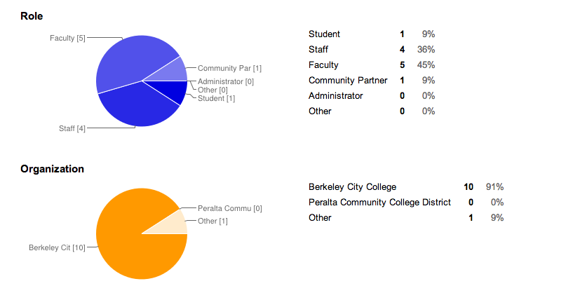

What did you find most meaningful about the work we did during the two days? Why? | What do you still have questions/concerns about? Why? | Is there anything else you would like to add?
The most useful thing to me was the framework--connection, entry, progress, and completion--that allowed for an organized and systematic way of exploring those places in which students get stuck or discouraged. | I am concerned that we don't have enough counselors and that some counselors don't always give the correct information, possibly because they don't receive the correct information, or help students when they feel overwhelmed or frustrated. | I would like to continue the discussion started at the retreat.
I think reading Sara's story was one of the most beneficial learning exercises. The information shared in that story was honest, and it accurately portrayed some of the challenges a great number of students face. | Transition phase: How do we continue to actively engage in some of the most systemic challenges BCC faces, and do so efficiently?
Working with faculty, staff, admin, and most especially the fantastic students present at the retreat. | Nothing right now. | Although I am aware of some of the stigma associated with community college, I was surprised to hear the level of the concern from students. With this in mind, I paid attention to some of the language the WE use. We should stop using diminutive terms to describe our excellent faculty, staff, and facilities. Why not use the same language that "real" 4-year colleges use?
There were several things I found very meaningful:  -Hearing the accomplishments of BCC during the past years  -Reviewing student data and brainstorming on the reasons why it is the way it is and how to improve them  -Identifying obstacles and solutions to obstacles during the different phases students go through during their community college years  -Setting short and long term goals | During retreats like these, the common fear of participants is that there would not be any follow-up to all the goals and/or action items that were established. It would have been great to establish timelines or benchmarks for the goals discussed during the retreat.
hearing the students' experiences | Our understanding of the capacity, missions, current challenges of our community organizations as well as their perceptions of BCC. | connecting classroom learning/curriculum/program of study to community civic engagement
Working with various Education and community partners as well as students and faculty about the challenges and triumphs of working with BCC. Everyone was committed to student success and the mission of BCC. | There was a disconnect between student experience and the student services offered. When students were speaking up about their struggles and ways the college could address them, the dean of student services stood up and said that those services were already being offered and that if there questions we should talk to her. I don't think it was the students' intent to criticize but it does offer a lens by which to measure the success of the programs being offered.  The student data was very insightful and informative. This was the first time that I was able to see comprehensive data on the make up of students and their success at BCC and beyond. I'm not sure if this was speaker issue but sometimes the speaker would say something that was not supported by the data that was being presented. Perhaps it was in another slide but the slides were number-heavy and sometimes difficult to navigate through. It was, however, extremely helpful to see some data being that it was never shared before. | Thank you for putting together such a great event. I learned a lot about BCC's internal structure and its goals as a college. Meeting everyone there was inspirational!  THANK YOU!
Hearing from students and community | How we can best respond to community needs given our limited resources | Very well planned, useful workshop
The plight of "Sarah" who wanted to enroll in community college classes, but found it so confusing and unorganized.....I can so identify with her, knowing from first hand experience what BCC students are confronted with. I empathize with them. | I do not think that we came up with too many answers that will actually be followed through!!
Exchange of ideas for the Educational Plan and the beginning of the discussion about what programs are important moving forward.  I missed most of the Student Services discussion on Day 1, but hope that the ideas will be the basis for improving our Students' experiences. | nothing right now
What I found most meaningful was the opportunity to learn from others, share my student experience, and to collaborate on a common purpose, ultimately transforming not only our students but our campus and community as a whole. | I am concerned about not really engaging industry participants. We over powered the conversation, and although good, I believe it would have strengthened industry participant's commitment to Berkeley City College, believing they were offering some insite.  After the retreat, some part time faculty approached me, expressing that their voice wasn't heard. They mention that specific tenured faculty overpowered the conversation, as usual. My concern with this is that we will have more of the same.  Finally, I hope we take advantage of the prestigious research institution a block away. Go bears! | I am super excited about the direction we are headed in.  Now that I think back though, I remember being really concerned about how challenged, concerned, weary people felt about change or trying new things, which I feel limits our opportunity for success. Also, many, even the students that participated, found it difficult connecting with the student experience. There were few who did recall their student experience and had tons to share, but did not feel included or able to contribute to the conversation. Too much wining going on and their are tons of successful models out there. Finally, we all need to really acknowledge what's not working, not as blame or fault, but as awareness, so we can identify problems, act, and move forward. There was a lot of protecting themselves and promoting their personal programs, which aren't the only way, especially when we recall the diversity of our student population at BCC.  Overall, I am super excited to be a part of BCCs transformation. :)
The exercise identifying barriers to student success was very helpful. Sarah's story gave the group something concrete to work with. | Our groups that came up with ideas for how to remove the barriers did some good work, but things seemed to be all over the road and we didn't end up with a feeling that the ideas could move to the next level where they could be implemented.

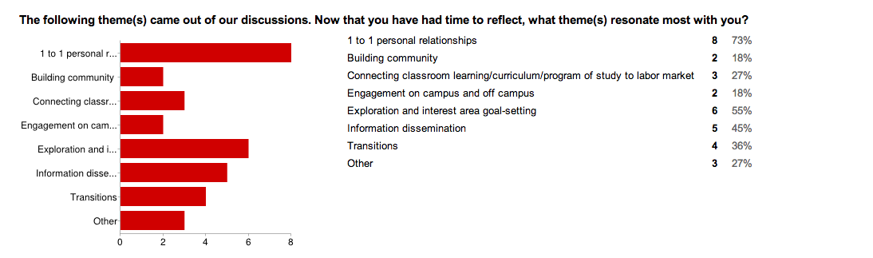

“Other” responses:

1) Fighting the negative stigma that community college is substandard
2) Building a stronger relationship between Instruction and Student Services
3) Strengthening Student Services Productivity

