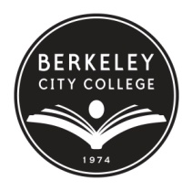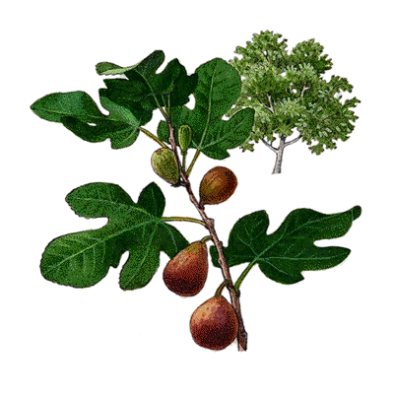
FIG (Faculty Inquiry Group)
Fall 2012 Final Report
Teaching and Learning Center
Please submit by email to bcctlc@peralta.edu by Friday, December 14, 2012

Team Leader: Louisa Roberts
Other Participants: Joan Berezin, Joshua Boatright
Should everyone receive the stipend? Yes
- What was your final inquiry question? If your question evolved over the course of the semester, please briefly describe how it changed.

The original question explored the primary reasons why the majority of students in a first year U.S. history course lacked adequate research skills. As we investigated the writing/research backgrounds of the students, we found while there was significant disparity in their academic experiences, all benefitted from additional support in the library. The question quickly and inevitably changed into what could be done to improve these skills with a library-instructor partnership.

- What previously published research or documentation of other related work informed your project?
(Please paste 2 or more links here, or attach PDFs to the email with this report, that we can add to the TLC digital library.)

Reabeka King (2012): Essentials of Basic Writing Pedagogy for Librarians,
Community & Junior College Libraries, 18:2, 55-66

Roselle, Ann, (2009), “Preparing the Underprepared: Current Academic Library Practices in Developmental Education”, College & Research Libraries, 70:2, 143-156.

Sue Samson, Kim Granath, (2004),"Reading, writing, and research: added value to university first-year experience programs", Reference Services Review, Vol. 32 Iss: 2 pp. 149 – 156
http://www.emeraldinsight.com/journals.htm?articleid=861776&show=abstract

Deborah Moore, Steve Brewster, Cynthia Dorroh, Michael Moreau, (2002),"Information competency instruction in a two-year college: one size does not fit all", Reference Services Review, Vol. 30 Iss: 4 pp. 300 – 306
http://www.emeraldinsight.com/journals.htm?articleid=861702&show=abstract

- What was your primary research process? Please describe briefly, and link to online materials or attach relevant documents with your raw data in Word or Excel, so that they can be submitted to Task Stream, the school’s assessment database.

The students were surveyed throughout the semester. The surveys explored the students’ familiarity with the library’s resources, the students’ perceived understanding of basic research skills and the English and/or ESL course experience(s) of the students. See also: attached survey summaries.

Also, literature reviews were conducted on library-instructor partnerships and basic skill learners in community colleges.

- Please describe your key findings (bullet points are fine).
Please consider the following, as applicable: What patterns emerged? What was surprising? What has led you to ask additional questions? What has impacted your thinking and work?

- Students learn information types when given relevant assignments that include different types of print and electronic media.
- Students are more likely to ask for assistance with library research when offered extra credit to do so.
- Students are more likely to participate in writing workshop when offered extra credit.
- WHAT WAS SURPRISING:
  - The number of students who completed English placement exams but did not take the recommended courses.

- How do your findings relate to the existing research you found on this topic?

Previous research demonstrated that basic skill learners, and the majority of first year college students, benefit from instructor-library partnerships that are based in their own classrooms, through assignments directly related to their subject courses. Students are more likely to learn how to navigate and differentiate information sources through coursework. Academic librarians can provide the instruction necessary to teach students how to select information sources appropriate for their assignments. The history students who were evaluated for this FIG, and who increased their use of library resources in order to complete assignments for their history course, saw an overall improvement in their understanding of information types; a follow-up FIG will examine their information literacy earlier in the semester and with more surveys to measure their progress or lack of progress.

- Based on your key findings, secondary research, and discussion, what recommendations did you develop?
Please be as specific as possible, and consider the following, although not all will apply to every project, of course:
- What changes/interventions could be made in the classroom? At the program/department level? At the school/district level?

Students in research-oriented courses would benefit from curriculum that requires use of library resources and interactions with library staff. Instructors in relevant courses would benefit from partnering with the BCC library before the start of each semester to develop library coursework that would improve student success in research-based assignments.

Currently, the BCC library does not have enough librarians on staff to fully support all instructors who may wish to incorporate tailored library programs into their courses. Increasing the library budget would also allow for more resources to be purchased that would directly support the curriculum; additional library technicians would be required to process new materials quickly throughout the semester.

- Does your inquiry suggest other areas of inquiry (future FIGs)?

Yes. Joan Berezin, Joshua Boatright and I would like to explore additional ways in which students can be evaluated for information competency in specific areas, and develop tools for analyzing progress and/or targeting information literacy deficiencies.

- Does your inquiry suggest products/actions that would require some focused work by a small group (future APPLEs)?

After specific tools for teaching and evaluating information competency have been developed in a follow-up FIG, an APPLE intended to tailor these tools for specific courses could be useful as well.

- Does your inquiry suggest training in/sharing of effective teaching practices that could benefit others? (future DARTs)?

Including information instruction in all research-based courses would require instructor training and partnership with library staff to identify the most appropriate resources for each course and/or assignment.

- What connections/questions/applications arose through sharing with other colleagues at the colloquium?

The idea for this FIG came about when Joan Berezin expressed frustration to Louisa Roberts regarding chronic problems she experienced with her students who lacked basic research skills to complete the assignments in her course. By discussing these problems, it was decided that a partnership could both improve her students’ academic performance while expanding library services to students who may not be aware of what is available to them in the library. The primary questions that remain to be answered are: what are the best practices for expanding student and instructor information competency and what is the most efficient and effective way for the library to support curriculum with the current shortage in library staff and other resources.

- Any other comments?

Thank you!

