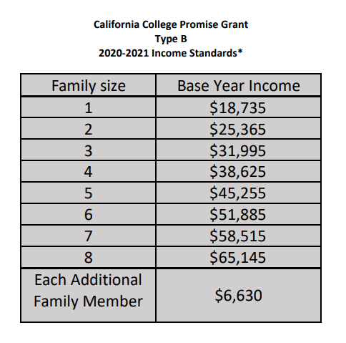
* These standards are based upon the federal poverty guidelines, as published each year by the US Department of Health and Human Services. Under Title 5 of the California Code of Regulations, the student or student’s family must have a total income in the base year (in this case, 2018) that is equal to or less than 150% of the U.S. Department of Health and Human Services Poverty Guidelines based on family size.
The base year is defined as the income year used for the determination of an expected family contribution (EFC) for federal Title IV student financial aid unless professional judgement is exercised by a financial aid office to use the current year income.

