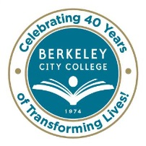
STUDENT EQUITY TASK FORCE
AGENDA
Wednesday, March 18, 2015
9:30 am – 11:30 am
BCC Conference Room 451A/B
Chair: Brenda Johnson

Agenda Review Brenda

Approve minutes of 2/25/2015 Brenda

BCC Scholars Carlos/Fatima

Foster Youth/Students with Disabilities/ Veteran’s Affair Fatima/Windy/Jennifer

Dreamer’s Mostafa /Carlos

40 Plus Students Antonio

Student Parents Brenda

Campus Engagement/Focus Groups All

Next Steps Brenda

* * * * * * * * *

~ Student Equity Task Force meetings are open to the college community ~

Our Mission: Berkeley City College’s mission is to promote student success, to provide our diverse community with educational opportunities, and to transform lives.

Our Vision: Berkeley City College is a premier, diverse, student-centered learning community, dedicated to academic excellence, collaboration, innovation and transformation.

