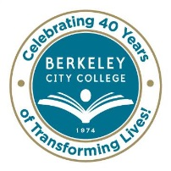
STUDENT EQUITY COMMITTEE
AGENDA
Wednesday, February 25, 2015
9:30 am – 11:30 am
BCC Conference Room 451A/B
Chair: Brenda Johnson

Agenda Review Brenda

Spring 2015 Implementation and Evaluation Calendar Carlos

BCC Scholars Carlos/Fatima

Foster Youth/Students with Disabilities/ Veteran’s Affair Fatima/Windy/Jennifer

Other Possible Equity Gaps (using five indicators) All

Campus Engagement/Focus Groups Brenda/Carlos/Debbie

Next Steps Brenda

* * * * * * * * *

~ Student Equity Planning meetings are open to the college community ~

Our Mission: Berkeley City College’s mission is to promote student success, to provide our diverse community with educational opportunities, and to transform lives.

Our Vision: Berkeley City College is a premier, diverse, student-centered learning community, dedicated to academic excellence, collaboration, innovation and transformation.

