DRAFT
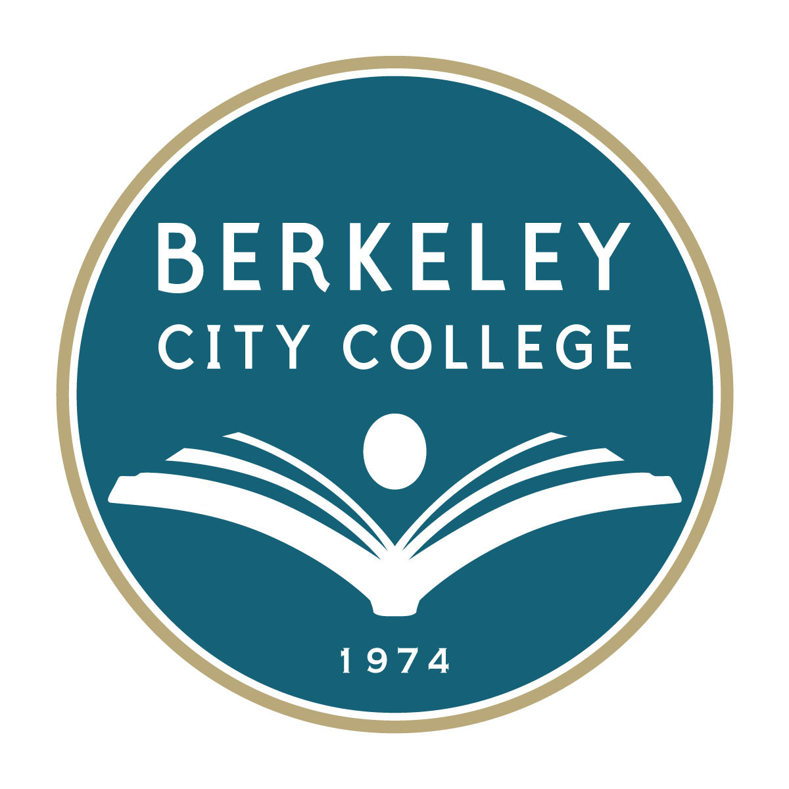
Prioritization Criteria for PASS Expenditures at Berkeley City College – Draft, May 6, 2014

Measure B ballot language stipulates that Measure B money will be spent to “support affordable college education including: providing core academic programs including math, science, and English; training students for successful careers; and educating students to transfer to university [but will spend] no funds for administrators’ salaries, and [that] all funds [will be spent] in our college district.”

OVERARCHING CRITERIA
In line with: BCC Mission, BCC Goals, BCC Vision and Values, Closing the Achievement Gap, SSSP and data | Yes |  | No
Supported by APU | Yes |  | No
Criteria | Clearly Meets Criterion  (3) | Meets Most Aspects  (2) | Partially Meets Criterion  (1) | Does Not Meet Criterion  (0)
Fulfills language of Bond Measure B* | Provides core academic programs, including math, science, and/or English, AND leads to transfer or successful careers | Provides core academic programs, including math, science, and/or English, OR leads to transfer or successful careers | Addresses some elements of the Measure B ballot language | Does not meet any of the criteria noted in the Measure B ballot language.
Fulfills or expands instructional or student services program not fully funded by BAM* | This program is not funded by BAM (not currently funded). | This program is mostly not funded by BAM (mostly not currently funded). | This program is mostly funded by BAM (mostly currently funded). | This program is fully funded by BAM (currently funded).
Additional number/FTES students served | Enable enrollment growth with 100 or more headcount/FTES. | Serves additional between 50-99 - headcount/FTES. | Minimum impact on enrollment growth. | No impact on enrollment growth.
Directly supports students | All funding provides direct support for students. | Most of the funding provides direct support for students. | Most of the funding does not provide direct support for students. | None of the funding provides direct support for students.
Is sustainable | The college will continue to support this program after the Bond expires, pending assessments; the need is clear and the cost is reasonable. | The college might support this program after the Bond expires, despite minor concerns regarding the cost and/or the need. | The college might not be able to support this program after the Bond expires due to the high cost or because it is not a high priority. | The college is not likely to continue to support this program after the Bond expires because of the high cost and because it is not a high priority.

* PASS is designed to support the following that is not fully funded by the District BAM:
- Fulfill or expand an instructional and/or student services program
- Add course(s) or course section(s) to meet a demonstrated student demand
- Acquire technology or equipment needed to start or to improve an instructional or student services program
- Acquire or renovate facilities needed to start or to improve an instructional or student services program

Updated May 6, 2014

