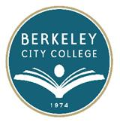
EDUCATION COMMITTEE FOR QUALITY PROGRAMS AND SERVICES

AGENDA
Thursday, May 8, 2014

12:15 pm – 1:30 pm

Room: 311

- Approve Agenda 12:15-12:20
- Review and approve meeting minutes 12:20-12:25
- Draft proposal of PASS Rubric and Budget 12:25-12:35
  - Updated memo from Chancellor Ortiz
- Accreditation Update – 12:35-12:50
  - Dr. Vanessa Vega
- Educational Master Plan 12:50 – 1:00
  - Deadline: November 30, 2014
- Student Equity Plans 1:00 -1:10
  - Deadline: November 30, 2014
- Updates from Senates and PIE Committee 1:10-1:20
- Others 1:20-1:30

