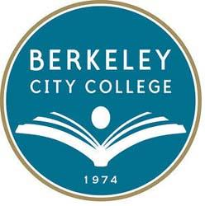
BCC Distance Education Committee
Date: April 2 ,2020
Chair: Chris Bernard
Mission: Berkeley City College’s mission is to promote student success, to provide our diverse community with educational opportunities, and to transform lives. The College achieves its mission through instruction, student support and learning resources, which enable its enrolled students to earn associate degrees and certificates and to attain college competency, careers, transfer, and skills for lifelong success.
Vision: Berkeley City College is a premier, diverse, student-centered learning community, dedicated to academic excellence, collaboration, innovation and transformation.

TIME | AGENDA TOPIC | DESIRED OUTCOME | Minutes/Action Items
12:15-1:30pm | - UCB Accessibility Expert Discusses ALLY | - Learn about accessibility features | Present  Chris Bernard, Linda McAllister, Thomas Kies, Roberto Gonzalez, Mary Clarke-Miller, Srujana Tumu (from the district; non-member), Joe Feria-Galicia(UCB accessibility expert)
12:30-1:30pm | - Presentation by Joe Feria-Galicia | - Learn about Ally and other tools | JFG discussed how Cal uses Ally and Adobe Acrobat to create accessible materials for students. Ally is able to remediate documents for students in various formats. JFG shared his screen and showed how to use the Ally tool and also showed how to use Adobe Acrobat Accessibility tool. JFG mentioned that Cal has student remediation experts who go through and remediate materials for instructors.  Action: JFG will share all materials. CB will follow up with the district DE Committee to discuss ALLY capabilities.

