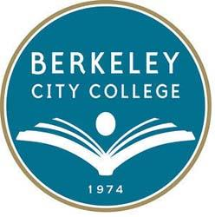
BCC Distance Education Committee
Date: March 12, 2020
Chair: Chris Bernard
Mission: Berkeley City College’s mission is to promote student success, to provide our diverse community with educational opportunities, and to transform lives. The College achieves its mission through instruction, student support and learning resources, which enable its enrolled students to earn associate degrees and certificates and to attain college competency, careers, transfer, and skills for lifelong success.
Vision: Berkeley City College is a premier, diverse, student-centered learning community, dedicated to academic excellence, collaboration, innovation and transformation.

TIME | AGENDA TOPIC | DESIRED OUTCOME | Minutes/Action Items
12:30-12:35pm | - Call to Order  - Review Membership | - Review Agenda | Present  Chris Bernard, Linda McAllister, Mary Clark-Miller, Jenny Yap (non-member)
12:35pm-1:20pm | - EMERGENCY REMOTE TEACHING TRAINING AND AVAILABILITY | - Delineate the POCR process | Discussed plan to discuss the role of the DE committee as the college develops plans to deal with the COVID-19 pandemic. Members of committee and other DE leads in other departments are running workshops today and tomorrow to help faculty transition to remote teaching.  Faculty will need assistance and the committee members will be available to run trainings and meet with faculty on Zoom. Will continue to work on schedule.  Depending on how long the college buildings will remain closed to the public, further trainings or a support infrastructure will need to be developed.  Need to convey to faculty that teaching online in this emergency situation does not constitute distance education per Title 5.  Action: Committee will remain in contact with administration and work with faculty and department chairs to develop and modify plan as needed.

