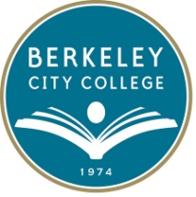

BERKELEY CITY COLLEGE (BCC)

2050 Center St., Berkeley, CA 94704; (510)981-2800; www.berkeleycitycollege.edu

PLEASE JOIN US!
BCC;S 6th Annual FELI (Five-Day Experiential Learning Institute)
June 1-5, 8:30 am-5 pm
Breakfast and Lunch Provided

A five-day transformative learning model, the FELI mirrors the PERSIST Foundations Course which launches each college bridge semester. Instructors, staff and administrators experience an essential component of the program as an educationally disadvantaged student does.
Using curriculum developed by the nationally renowned Academy for College Excellence, we will identify and explore:
• Leadership and Learning Styles of ourselves and others
• Positive Team Building
• Listening techniques toward effective communication
• Reflection toward self-management of behaviors
• Faculty-specific discussion about teaching and learning in the evolving classroom
Contact Chris Lebo-Planas (aleboplanas@peralta.edu) for more information and evidence of success here at BCC!

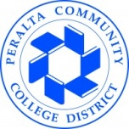

PERALTA COMMUNITY COLLEGE DISTRICT

