.
Student Services Council
Minutes
Tuesday, August 29, 2023, 1 :00 pm – 2:30pm
Leads: BCC Student Services Administrators
Mission: Berkeley City College’s mission is to promote student success, to provide our diverse community with educational opportunities, and to transform lives. The College achieves its mission through instruction, student support and learning resources, which enable its enrolled students to earn associate degrees and certificates, and to attain college competency, careers, transfer, and skills for lifelong success.
Vision: Berkeley City College is a premier, diverse, student-centered learning community, dedicated to academic excellence, collaboration, innovation and transformation.
Agenda Item | Description |  | LEADER | DESIRED OUTCOME
- Preview Agenda  - Review 5.2.23 minutes |  |  | All | Review Agenda
- 3a. Eforms  3b. CVC-OEI update  - Week in review | What went well, what could we improve?  SA: smooth 1st week; repeated technical issues with canvas login, student didn’t know what campus solutions was, if students could not log into campus solutions, they were referred to the LRC; students did not know where resources are at BCC; need an updated directory; job opportunities and starting a club, students did not know where to go; more student bulletin boards would be good; Rolling out Handshake (John working on the back end set up); Older students are not comfortable navigating the course catalog online, they asked for a printed catalog; students were looking for in person classes, need more.  Luis: student services resource fair- went well, saw 55 students, explained why they might want to access counseling; how can we plan for student flow better in advance. Counseling retreat 9/7 at Conservation Hall, 2 dates for GP 10/29 and 2/9 GP convening.  Izzie- 180-200 used the food pantry in the first week.  Lisette – Wanted it to be informal, just have students aware of HSI presence on campus |  | Amy  Amy, John, Student Ambassador Jade | Information  Discussion/Future improvements
- Enrollment Workshops & Express Registration | - How did they go? 1st time doing enrollment workshops- served 245 students. FA staff were in attendance. Helped Express Registration focus on registration. Andrea, Susan, Gail and Amy supported them. Need cell service and wifi in Room 126. Have SAS and EOPS come to them, need 2 counselors for each session.  - Express Registration-75 for zoom  - How many attended? 245 EW, (75 online for Express Registration) How many enrolled? Not sure  - Plus/ Delta- Students wanted more in person classes, specifically MMART, we’re losing our students to campuses with in person classes.  - Feedback for student course selection |  | Amy and Gail | Discussion  Future Improvements
- Campus Reservations | 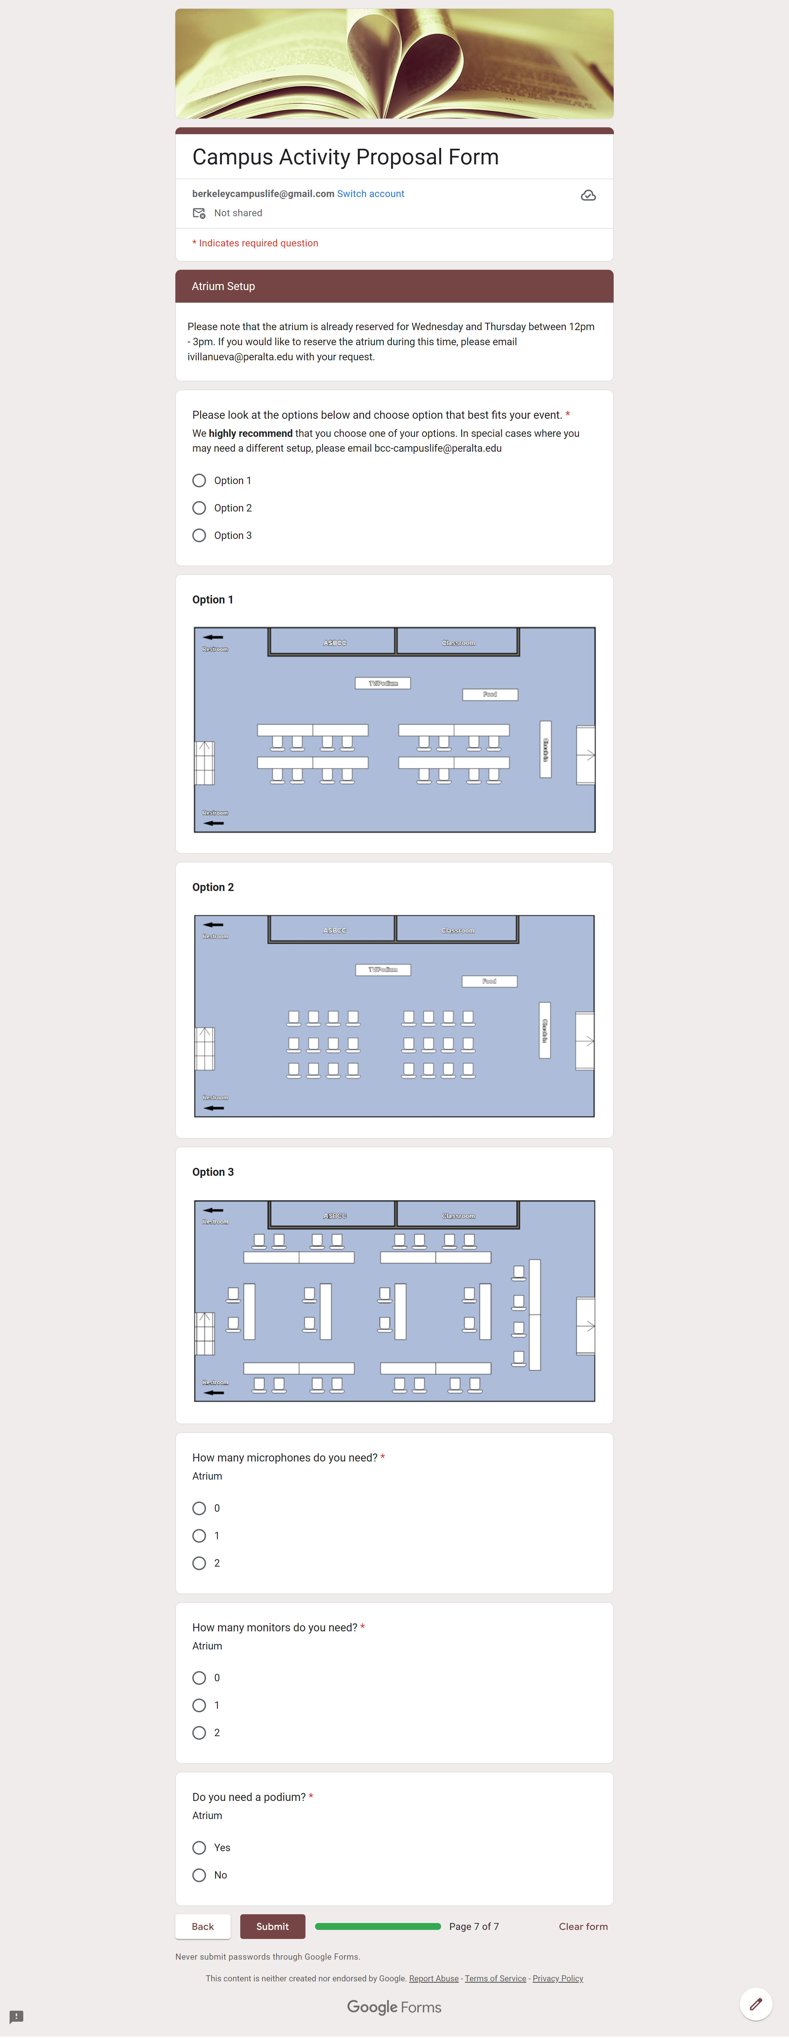https://docs.google.com/forms/d/e/1FAIpQLSevtSeYAWtK1fSD_u8SSuMrhqJjsrXXBrBX3u557t--VvZZsg/viewform |  | John | Information sharing
- Visit from BUSD Families | Alejandra Frias from BUSD Family Engagement Office  -Listening Sessions with parents: visits to local colleges  -Saturday in-person in October and another in February  -Spanish  -Application and registration process; financial aid; certificates  ____________  OUSD has a family engagement office or equity office  Albany, Emeryville, El Cerrito  Dual Enrollment Night |  | Lissette & Zaira
- Announcements | Earn and Learn HS Career Fair 11.8.23  Counseling Dept Retreat Sept. 7th  Free Weekly Meals – Wednesdays – Resumes Aug 30  Assembly Bill (AB 302) --> Lactation Pod is open (Download app via QR code to open door and check on occupancy)  AB 1995 (Chapter 407, Statutes of 2016) --> require a community college campus that has shower facilities for student use to grant access to those facilities to homeless students  Transfer Fair Wed Sept 28 from 10AM - 1PM  Oct 16-18 Undoc Student Week of Action  Latine Heritage Month(9/15-10/15): Downtown Berkeley Pachanga, Julio Salgado, Jose Joaquin Figueroa, We Still Here (plus music)  Patelco Financial Wellness Workshops start 9/14
Membership: Bold indicates attendance  - Stacey Shears, Vice President of Student Services  - Dr. Amy H. Lee, Dean of Enrollment Services  - Martin De Mucha Flores, Acting Dean of Counseling and Student Equity  - John Nguyen, Associate Dean of Student Engagement and Basic Needs  - Ernesto Nery, Director of Financial Aid  - Jasmine Martinez, Executive Assistant to VP Student Services  - Jeejun Bertuso, Veterans Coordinator  - Danielle Spencer, Student Support Services Staff Assistant  - Dr. Elissa Jaw, SAS Coordinator/Counselor  - Ramona Butler, EOPS/CARE Coordinator  - Carolina Martinez, SEA Coordinator  - Susan Truong, Adult Ed and Dual Enrollment Counselor |  | - Lisette Flores, HSI Director  - Gail Pendleton, Enrollment Services/Coordinator  - Andrea Williams, CTC Coordinator  - Luis Chavez, Counseling Chair or Designee  - Christina Taing-Rivera, LC Counselor  - Janine Greer, Wellness Center, MH counselor  - Ronda Johnson, Next UP Counselor  - Joseph Bielanski, Articulation Officer  - Hue Huynh, Senior A&R Specialist  - Zaira Sanchez, HSI Program Coordinator  - Dana Cabello, Student Services Staff Assistant, Counseling  - Alejandra Oseguera, EOPS Counselor  - Izzie Villanueva, Basic Needs Coordinator  Guests: Jade Thieu (Student Ambassador)

