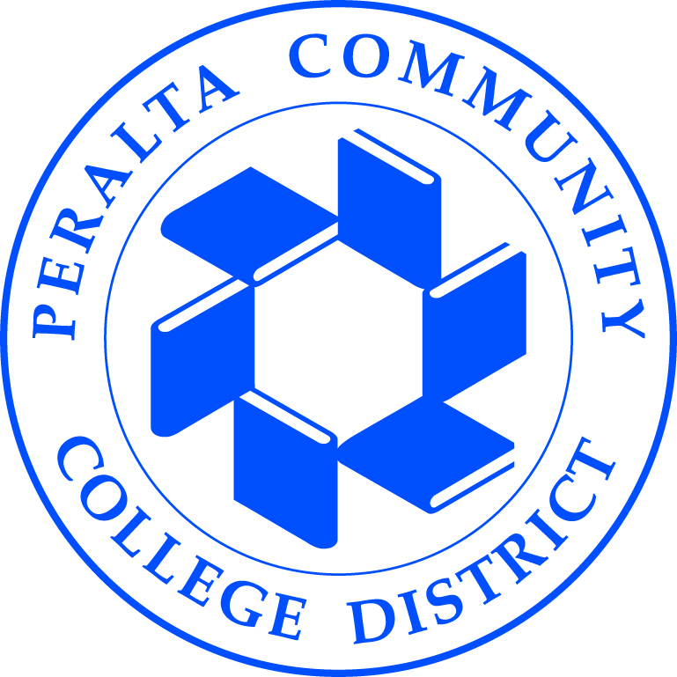
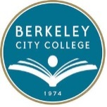
BERKELEY CITY COLLEGE
Planning for Institutional Effectiveness (PIE)
Meeting Minutes
February 2, 2017

PRESENT: Hannah Chauvet, Lisa Cook, Pieter de Haan, Heather Dodge, Jennifer Lowood, Alejandro Perez

AGENDA ITEM | SUMMARY OF DISCUSSION | FOLLOW UP ACTION
- Call to Order | 12:20 p.m.
- Approval of the Meeting Minutes |  | Approved
- TLC | The TLC Symposium will take place on Friday, May 5, 2017.
- Spring 2017 Course Assessment To-Dos | The assessment liaisons were given a list of courses that are due to be assessed this semester. They were also given a list of courses that should have been assessed between Fall 2015 to Fall 2016. We are requesting for assessment results and/or a new schedule for those courses.
- Global Awareness and Valuing Diversity ILO Assessment | During the Fall 2016 semester, we assessed the Global Awareness and Valuing Diversity ILO. We only received 194 samples from 11 classes, 6 disciplines. Since we deemed that this is not enough of a sample size, we are extending the deadline to end of Spring 2017 so that we can encourage more faculty to contribute student work.
- Planning for the Spring 2017 Assessment of Ethics and Personal Responsibility ILO |  | Tabled
- Action Plan Examples (APE) Website | J. Lowood reported working on the Action Plan Examples. The PIE Committee reviewed the changes and decided to add more categories.
- Spring 2017 Meeting Dates | Below is a list of PIE Committee’s Spring 2017 meeting dates:  - February 2, 2017  - February 16, 2017  - March 2, 2017  - March 16, 2017  - April 6, 2017  - April 20, 2017  - May 4, 2017  - May 18, 2017
- Combining Assessment Data with Achievement Data | No discussion.
- Other Items | No discussion.
- Next Meeting Date | February 16, 2017
- Adjournment | 1:30 p.m.
Berkeley City College’s mission is to promote student success, to provide our diverse community with educational opportunities, and to transform lives.

