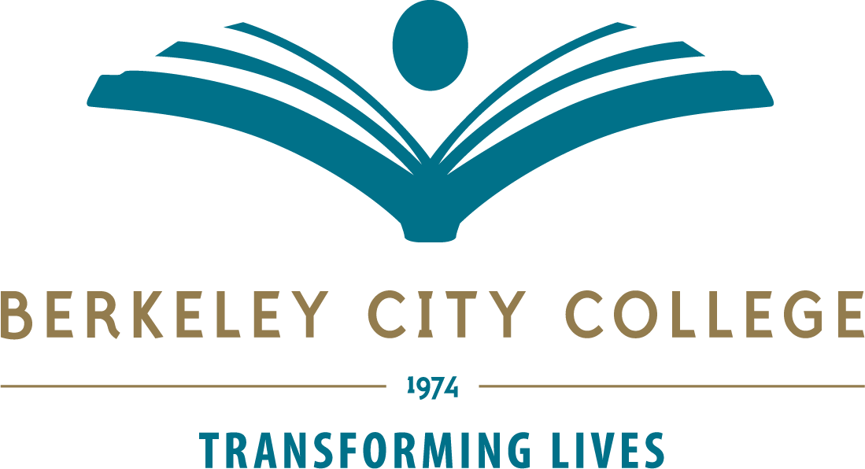

Vice President of Student Services
Service Area Outcomes
- SERVICE AREA OUTCOME 1: Encourage an environment that is welcoming, helpful and respectful for student success and equity
MEASURES: Minutes of Student Services Council, Student Services Program Reviews, Student Activities and Campus Life, Welcome Desk, Student Ambassadors, Quick Stop, Admissions and Records, Financial Aid Office

- SERVICE AREA OUTCOME 2: Provide accurate and timely support services to students
MEASURES: Counseling, EOPS, DSPS, Financial Aid Office, Admissions and Records, Career and Transfer Center, Veterans Services, Next Up, Student Activities and Campus Life, Student Equity and Achievement Program, FYELC

- SERVICE AREA OUTCOME 3: Ensure that Student Services information is communicated effectively with the campus and external community
MEASURES: Enrollment Management Committee Minutes, Website communication, College Catalog, Schedule

