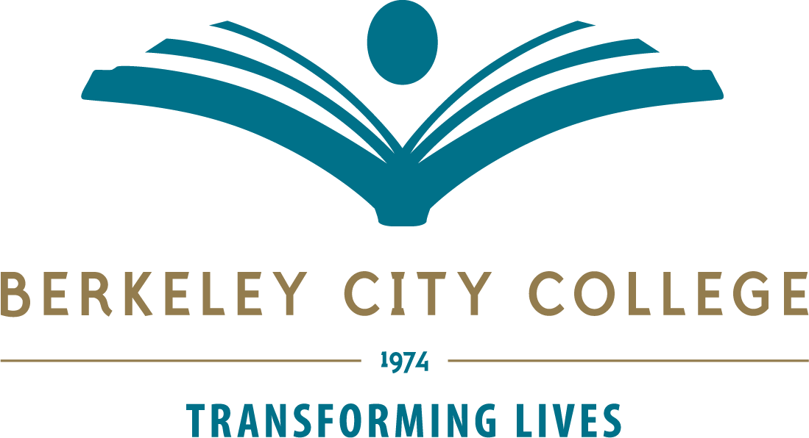

College Roundtable Strategic Planning Retreat – May 29 2019
Location: 451A/B Time: 8:30 am – 2:00 pm
Co-Chairs: R. Tomaneng, President and Kelly Pernell, Academic Senate President

TIME | AGENDA TOPIC | LEADER
8:30a-9:00a | Sign-In and Continental Breakfast | R. Tomaneng
9:00a-9:10a | Welcome & Introductions  -Review Agenda  -Retreat Outcomes | R. Tomaneng  K. Pernell
9:10a-9:25a | BCC Strategic Goals-Vision for Success Alignment | P. Sayavong
9:10a-9:25a | Connecting the Dots: BCC/PCCD Plans & State Initiatives  -Revised PCCD Goals-Vision for Success Alignment  -Student Centered Funding Formula  -Integrated Strategic Enrollment Management Plan  -Guided Pathways Plan | R. Tomaneng
9:35a-9:45a | Student Equity” Activity | S. Slaughter
9:45a-10:30a | Assessment of BCC Equity Framework: RP Group’s Six Success Factors | K. Pernell  J. Lenahan
10:30a-11:20a | Review of Conceptual Frameworks for Equity  -Principles for Equity Mindedness  (Bensimon et al, Center for Urban Education-CUE)  -Equity-driven Systems Change Model-ESC (Skyline College)  -Equity & Cultural Humility Model (Veronica Neal) | R. Tomaneng  S. Shears
11:20a-11:30a | Break
11:30a-12:15p | Categorical Budget Presentations  -EOPS/Foster Youth  -DSPS  -Veterans  -Student Equity and Achievement Program | B. Johnson  B. Johnson  J. Lenahan  S. Shears
12:15p-12:45p | Lunch
12:45p-1:30p | Categorical Budget Presentations continued…  -Adult Education  -Strong Workforce & Perkins  -Guided Pathways  -Parcel Tax | M. Joseph  F. Gamez  K. Hay  S. Slaughter
1:30p-2:00p | Next Steps & Closing | R. Tomaneng  K. Pernell

Mission: Berkeley City College’s mission is to promote student success, to provide our diverse community with educational opportunities, and to transform lives. The College achieves its mission through instruction, student support and learning resources which enable its enrolled students to earn associate degrees and certificates, and to attain college competency, careers, transfer, and skills for lifelong success.

Vision: Berkeley City College is a premier, diverse, student-centered learning community, dedicated to academic excellence, collaboration, innovation and transformation.

