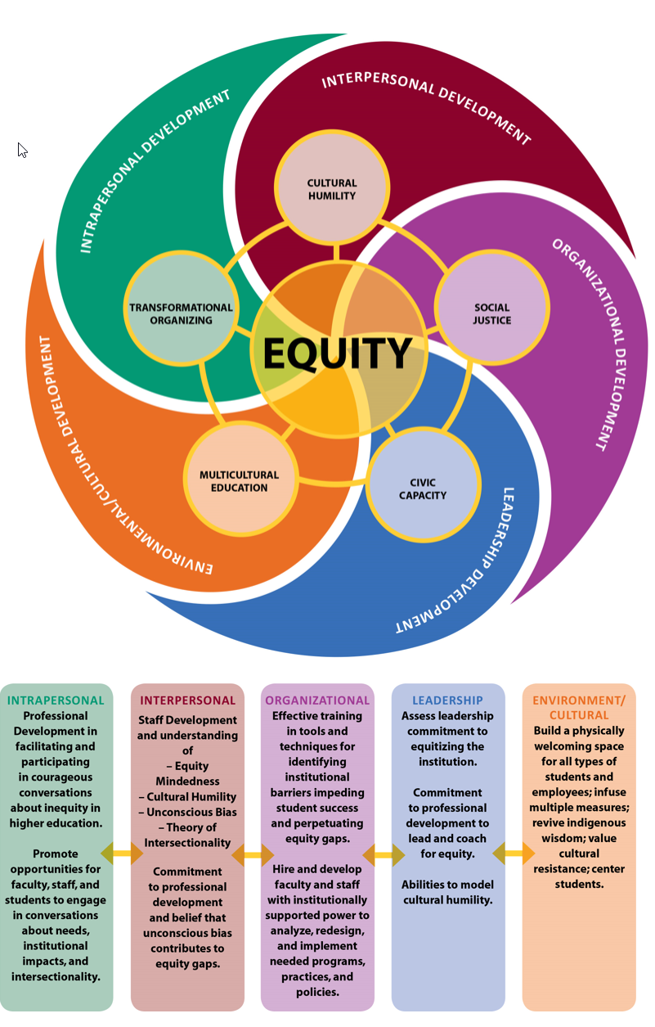

Veronica Neal’s Equity and Cultural Humility Framework