BERKELEY CITY COLLEGE INTEGRATED STRATEGIC ENROLLMENT MANAGEMENT PLAN
2018-2021
DRAFT

INTRODUCTION
_____________________________________________________________________________________
A construction of the Berkeley City College (BCC) Integrated Enrollment Management plan (ISEMP) came particularly timely in 2018-2019 year not only because it is time for assessment, reflection and revision through action plans but also due to the multiple new state and federal legislated initiatives that now frame our plan much differently from the past.

Process:
The development of the BCC ISEMP 2018-2021 is based on BCC’s 2018-2020 Strategic Plan that elicits five distinctive goals with measurable indicators that have been adopted by the College Roundtable for Planning and Budget Council in XXXX 2018. These goals and indicators align with the BCC Educational Master Plan (EMP) for 2016-2021 that strongly emphasizes the college’s commitment to achieve equity and to eliminate the educational gap in student access (participation), learning, completion, and success with exemplary programs and services to ensure the college’s energies are directed toward the success of all students.

BCC 2018 -2021 Strategic Plan also aligns with the Peralta Community College District (PCCD)’s Strategic XXXX Plan which is linked with the California Community College Chancellor’s Office Vision for Success. A cross-walk chart that reflects this alignment is included in the Appendix section (Appendix 1).

Major Legislative Changes:
BCC is ready to implement AB 705 in time for summer and fall 2019 priority registration (April 2019) for Math and English. So as to avoid unnecessary and excessive placement of students into remedial courses, high school coursework, school grades, GPA, and/or self-guided placement methods will be used to determine students enrollment into transfer-level courses in Math and English. At BCC, courses in English and Math have been augmented by adding supporting courses (NC and CR) to ensure student’s successful completion of transfer-level courses in a one-year timeframe.

BCC developed a work plan for the 2018-2019 for the California Community College Guided Pathways (GP) model in spring 2018 focusing on a) Cross-functional inquiry, b) Shared Metrics for identifying challenges and tracking student success, and c) Integrated Technology. Infrastructure for Student Success. BCC is in the process of formulating four key work groups that are led by the Administrator and Faculty co-leads: Preparation, Moving in, Moving through, and Moving on. Cross functional groups consisting of faculty, students, classified staff and administrators will take a critically important role in addressing and achieving some of the goals identified in the BCC ISEMP as many of the work plan activities in GP and BCC ISEMP overlap.

Also in 2018-2019, California legislators changed the funding formula for the California Community Colleges. Departing from the traditional SB 361, apportionment-base model funding, a Student Centered Funding Formula (SCFF) was introduced and implemented in where Enrollment (or Base), Supplemental (low income and marginalized population), and Student Success (accountability for completion of programs, job attainment with living wages , and transfer to 4 year institutions) allocations constitute three major components of the new funding formula. Three year stability has been established for the colleges to transition into this formula fully by 2020 – 2021, with the distribution ratio of 60% Enrollment/Base, 20% Supplemental and 20% Student Success.

BCC MISSION, VISION, VALUES, and 2018-2020 STRATEGIC GOALS
_____________________________________________________________________________________

Mission

Berkeley City College’s mission is to promote student success, to provide our diverse community with educational opportunities, and to transform lives. The College achieves its mission through instruction, student support and learning resources which enable its students to earn associate degrees and certificates, and to attain college competency, careers, transfer and skills for lifelong success.

Vision

Berkeley City College will be a leader in equitable academic excellence, collaboration, innovation and transformation, as a premier, diverse, student-centered learning community.

Values

Berkeley City College embraces values which allow all members of our college community to grow and thrive. Our commitments are to:

• Academic Excellence and Student Learning. We value our students’ intellectual capacity and potential, as well as their varied educational and experiential backgrounds, learning styles, and educational objectives.

• Multiculturalism and Diversity. We value diversity, which fosters appreciation of others, depth of understanding, insight, empathy, innovation and creativity, characteristics our institution seeks in its students, faculty and staff.

• Engaged Citizenship in a Complex Changing Global Society. We value the fact that students live and work in an intercultural and increasingly complex society and world.
BCCEMP.6.21, 2016 Page 11?

• Innovation and Flexibility. We value a climate of inquiry and innovation, because it encourages our students to question the typical and expand their thinking in a flexible manner that allows them to understand life’s dynamic potential.

• A Respectful and Collegial Workplace. We value the high quality that characterizes everything we do, and the ability to achieve academic excellence in a collegial workplace. We value the achievement of intercultural proficiency across all employee groups, a living wage for every full time employee, and an environment which supports continuous professional development.

[Mission adopted by Berkeley City College, as revised, March 2016. Vision and Values adopted by Berkeley City College, as revised, April 2016.]

2018-2020 BCC Strategic Goals

(I) Strengthen Resilience
(II) Raise College Competence
(III) Enhance Career-Technical Education Certificates and Degrees
(IV) Increase Transfer and Transfer Degrees
(V) Ensure Institutional Sustainability

BERKELEY CITY COLLEGE INTEGRATED STRATEGIC ENROLLMENT MANAGEMENT PLAN MISSION
____________________________________________________________________________________
The Berkeley City College Integrated Strategic Enrollment Management Plan (BCC ISEMP) represents a college-wide collaborative effort, guided by the college’s mission, vision and strategic priorities, to achieve our goals for outreach and recruitment for students, sequenced pathway course and program offerings, job attainment with living wages, and transfer to 4 year institutions.

BROAD GOALS OF THE BCC ISEMP
_____________________________________________________________________________________
- Reflect, assess, and revise 2015-2018 BCC ISMP to be in alignment with the 2016-2021 BCC Educational Master Plan (EMP) goals and priorities.
- Create clear course sequencing pathways per term for each Certificate and Degree and increase number of students successfully completing each program per term/year.
- Develop a comprehensive and effective inreach, outreach, recruitment, and marketing plan that supports meeting BCC’s enrollment and FTES goals.
- Meet and exceed college enrollment and FTES goals by increasing student success, retention, persistence and completion.
- Increase student satisfaction and engagement across all support services, instruction, and auxiliary services at BCC to contribute to student retention, persistence and completion.
- Aim to have a bullet-proof technology infrastructure (eliminate unnecessary technological glitches) for student use: admission, registration, Student Educational Planning (SEP), add codes, wait lists, Financial Aid, etc.)
(7. BCC ISEMP contributes to the PCCD 5 year Integrated Strategic Fiscal Plan that is required by ACCJC per the November 20, 2018 letter – submission date, May 1, 2019)?include in appendix?

BERKELEY CITY COLLEGE GUIDING PRINCIPLES
_____________________________________________________________________________________
- Students first
- Paradigm shift for new direction with support
- Encourage innovation
- Promote data-driven discussion and decision making
- Promote cross-pollination
- Exhibit fiscal responsibility
- Focus on long term viability

BCC ENROLLMENT MANAGEMENT COMMITTEE CHARGE
_____________________________________________________________________________________
- Develop BCC ISEMP 2018-2021 and identify benchmarks in coordination with the Roundtable Council and Guided Pathway Design Team.
- Align BCC ISEMP with exiting 18-20 strategic priorities and goals
- Align BCC ISEMP with district-wide priorities and goals
- Align BCC ISEMP with college budget priorities based on SCFF and its calculator
- Monitor and track progress made on the BCC ISEMP to ensure that the actions are leading to the goals of the BCC ISEMP.
- Develop BCC ISEMP process that avoids duplication of resources and work
  - Align and/or combine ISEMP committee with existing college committees (Enrollment Management Committee and Guided Pathway Design Team/Advisory?)
- Develop BCC ISEMP informed improvement and institutional effectiveness process to track CC ISEMP work, institutional performance for system-wide improvements.

THE FRAMEWORK
_____________________________________________________________________________________
The 4 areas illustrated in the Guided Pathways (GP) graphic below represent key phases in the student life cycle and pathways that will lead them to achieve their goals of attaining certificates and degrees and/or certificates and degrees with jobs with living wages and transfer to 4 year institutions.

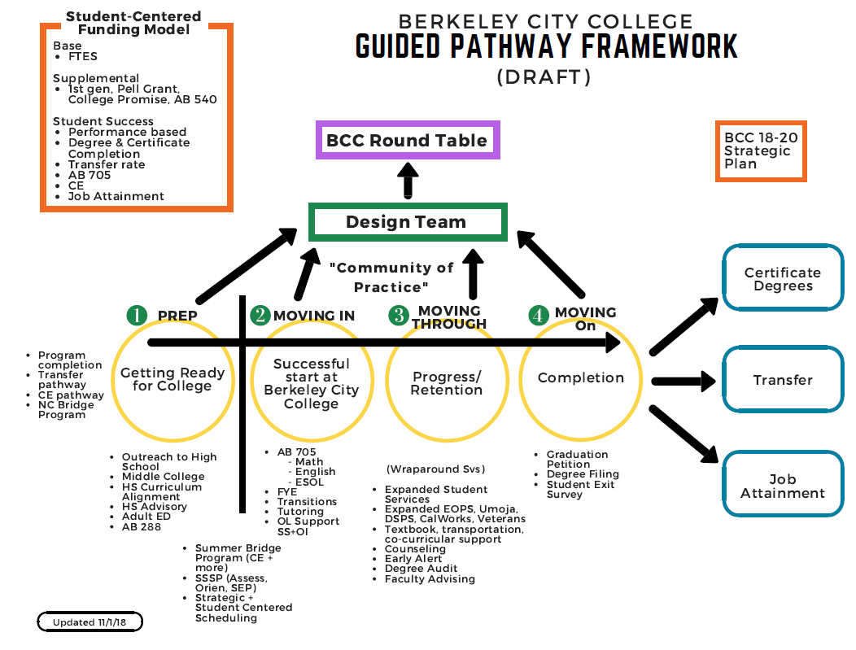

STUDENT CENTERED FUNDING FORMULA AND ENROLLMENT MANAGEMENT GOALS FOR BCC
________________________________________________________________________________
(Notes)
- Phoumy’s data on SCFF to be here
- Once obtaining a clear reduction target from the District’s finance and the Academic affairs for 19-20, then BCC can proceed to project its enrollment per the SCFF.
As of February 15, 2019, there is no such information available for us to work on it.
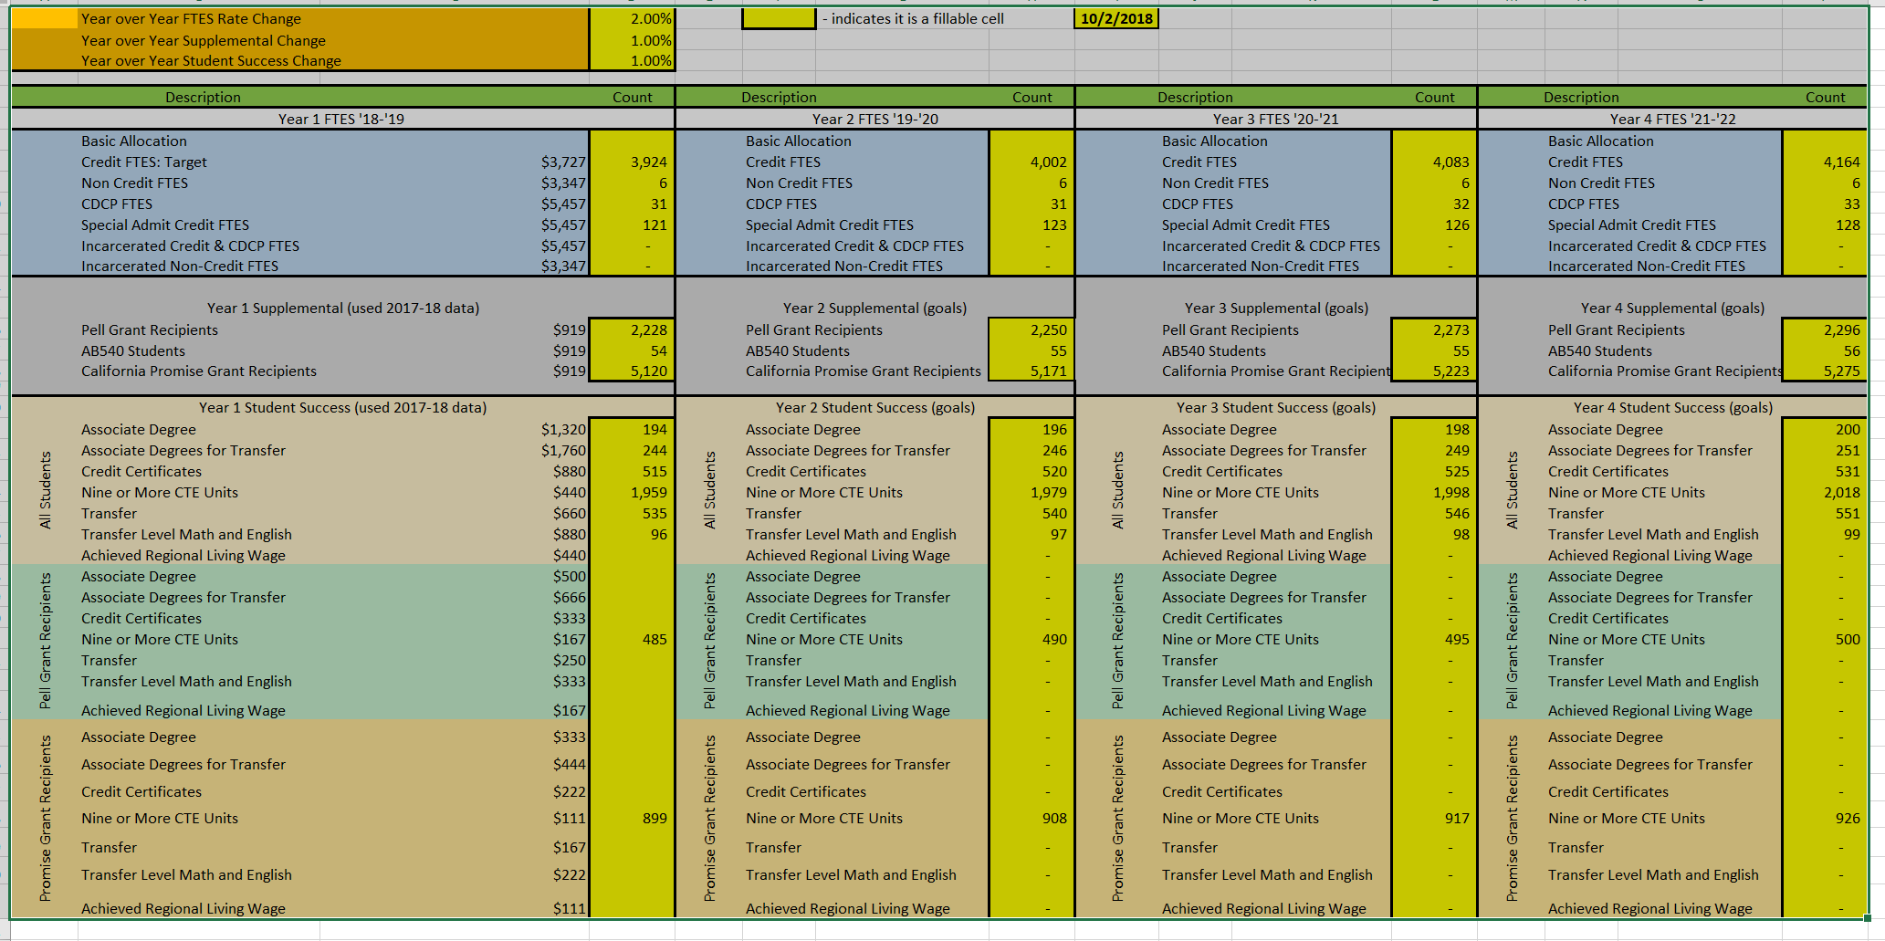

STRATEGIC FRAMEWORK (2018-2020 BCC STRATEGIC PLAN) TO ACHIEVE BCC ISEMP GOALS
____________________________________________________________________________________

To achieve the targets of our 2018-20 Strategic Plan indicators of excellence, Berkeley City College will apply the following framework:

1. Utilize researched based best practices to increase student access (participation), learning, completion, and success with exemplary programs that include:
- Utilizing previous learning experiences for placement
- Guided exploration for undecided students
- Clearly delineating program requirements (default course sequence)
- Developmental education transformation
- Providing proactive, embedded and integrated student support
- Maximizing and enhancing learning communities
- Increasing student engagement in support and instructional services.

2. Develop integrated communities of practice aligned to the students’ educational pathways to provide more connected learning experiences inside and outside of the classroom;

3. Incorporate technology tools to communicate, support and customize the student experience;

4. Develop data infrastructure to track and evaluate student and program progress;

5. Develop mechanisms to assess the student experience to ensure quality programs and services.

BCC INTEGRATED STRATEGIC ENROLLMENT MANAGEMENT GOALS
_____________________________________________________________________________________

Following BCC ISEM goals are developed based on the delineated activities identified in the BCC Guided Pathways Work Plan 2018-2019 (Appendix X) as well as the BCC 2018-2020 Strategic Plan (Appendix X). Each action is linked with these activities listed in these two documents. In addition, person(s) or group(s) responsible for each activity and aimed timeline for execution are noted.

Glossaries: GP Work Plan1 (WP1), GP Work Plan 2 (WP2), GP Work Plan 10 (WP10)
GP Work Group Preparation (PP), GP Work Group Moving In (GPMI), GP Work Group Moving Through (GPMT), GP Work Group Moving On (GPMO)

- Strategic scheduling of Classes:

Actions | BCC 18-20 Strategic plan | BCC Guided Pathways | Responsible | SCFF | 18-19 | 19-20 | 20-21
Offer courses focused on historical data & students’ needs that create effective pathway for completion. | GIII.H  GV. B | GP1 | Chairs  Deans VPI | All | X | X | X
Increase Online Education courses where pedagogically appropriate, and where the demands are, ensuring student success | GII.B  GII. C  GV.F | WP 1 &2 | IPC  Chairs  Deans, VPI  DE Committee (new)  Academic Senate | All | X | X | X
Increase Dual Enrollment courses with all USD partners where USD students enter into BCC pathway programs in both General Education (GE) and Career Education (CE) areas. | GI.H | WP 1&2 | Chairs  Deans, VPI  DE Committee (new)  Academic Senate | All | X | X | X
Increase number of Dual Enrollment students under AB 288 or Career and College Access Pathway (CCAP) and increase number of college- transfer- level ready students entering into BCC. |  | WP 1&2 | District AA  Deans, VPIs,  Presidents and Board | District AA, Legal, Presidents, Board |  | X | X
Increase number of Adult School students matriculating into BCC’s pathway programs including ESOL and NC CDCP. | GIV.F  GIII.B | WP 1&2 | Associate Dean of Educational Success, Dean of Liberal Arts, VPI | Supplemental | X | X | X
Increase numbers of students who enter into Learning Communities (LC) who will all have clearly delineated 2 year SEP (or pathway sequence of course taking plan). | GI.B  GII.A  GI.D | WP 1&2 | Associate Dean of Educational Success, | Supplemental & completion | X | X | X
Offer courses based on the sequencing in alignment with the Guided Pathways Initiative  Multiple format of summer course offerings (i.e. 6-week session with 8-week session, etc.) | GII.E | WP1&2 | Chairs  Faculty  Deans  VPI | All | X | X | X
Implement Teacher Education Program Pathways with USD/Adult Schools, BCC, and 4 year institutions. Increase number of students who obtain Certificates and Degrees. | GIII.C | WP 1&2 | Chairs  Faculty  Deans  VPI | Credit Certificates  Completion o 9 or more CE | X | X | X
Develop Computer Science (CS) program that is competitive in the area (departing from CIS) | GIII.D | WP1&2 | Chairs  Faculty  Deans  VPI | All completion | X | X
Complete Multimedia Arts program alignment through curriculum revisions and increase number of students who complete MMART programs. | GIII.E | WP 1&2 | Chairs  Faculty  Deans  VPI | All completion | X | X
Increase work-based learning opportunities particularly for CE area and increase number of students obtaining jobs with living wages. | GIII.M  GIV.E | WP 1&2 | Chairs  Faculty  Deans  VPI | All completion |  | X | X
Implementation of Block Scheduling. (Appendix X) |  | WP1&2 | Chairs  Faculty  Deans | WP1 |  | X | X

- Strategic Outreach
Social Media Efforts
Actions | BCC 18-20 Strategic plan | BCC Guided Pathway | SCFF | Responsible | 18-19 | 19-20 | 20-21
Implement Website Refresh, http://www.berkeleycitycollege.edu/wp | GI.A | WP1 | All | PIO, Dean of Enrollment Services | X | X | X
Develop and implement Virtual Tour on the website; |  | WP1 | All | PIO, Dean of Enrollment Services | X | X | X
Develop and implement online Advertising: Six month campaign branding BCC’s attributes and CE Pathways; | GIII. L | WP1&2 | All | PIO, Dean of Enrollment Services, Dean of Business, Science, Technology | X | X
Develop student video testimonials for content marketing and promotion of BCC brand; | GIII.L | WP 2 | All | PIO, Dean of Enrollment Services, | X | X | X
Increase focus on digital marketing: Mongoose (mass texting platform), HIBU (digital marketing system) and GovDelivery (mass email system) |  | WP2 | All | PIO, Dean of Enrollment Services, Campus Life Director, Career and Transfer Center, Counseling | X | X | X
Increase interactive social media messaging with monthly thematic post |  | Wp2 | All | PIO, Dean of Enrollment Services | X | X | X
- Other Advertising Efforts

Actions | BCC Strategic plan | BCC Guided Pathways | SCFF | Responsible | 18-19 | 19-20 | 20-21
Produce Career Education collateral |  | GP PP | All programs, 9 or more CE units | Dean of Business, Technology, CE and Multimedia Arts,  PIO | X | X | X
Develop and place Glacier Ads in local high schools |  | GP PP | All | PIO | X | X | X
Develop and place Radio ads via Iheart Radio and Spotify |  | GP PP | All | PIO | X | X | X
Develop and place Bart and AC Transit Ads |  | GP PP | All | PIO, Dean of Enrollment Services | X | X | X

- Enrollment Services
Financial Aid and Admissions and Records

Actions | BCC 18-20 Strategic plan | BCC Guided Pathway | SCFF | Responsible | 18-19 | 19-20 | 20-21
Implement “Student Success” activities - monthly financial literacy workshops and weekly financial aid support during college hour; | GI.A | WP1  GPMT |  | Dean of Enrollment Services, Financial Aid Supervisor
Schedule monthly evening Financial Aid Workshop; | GI.A | WP1  GPMT |  | Dean of Enrollment Services, Financial Aid Supervisor
Improvement of financial aid appeal process to make student friendly; | GI.A | WP1  GPMT |  | Dean of Enrollment Services, Financial Aid Supervisor
Inreach to new and current students who have not applied for financial aid; | GI.A | WP1  GPMT |  | Dean of Enrollment Services, Financial Aid Supervisor
Inreach to current students who have not yet completed an education plan. | GI.B |  |  | Dean of Enrollment Services, Financial Aid Supervisor

Admission and Records

Actions | BCC 18-20 Strategic plan | BCC Guided Pathway | Responsible | 18-19 | 19-20 | 20-21
Customer Service training to reduce complaints, and increase productivity; |  |  | Dean of Enrollment Services
Customer Service training to reduce complaints, and increase productivity; |  |  | Dean of Enrollment Services
Student Ambassadors as student service “navigators;” |  |  | Dean of Enrollment Services
Streamline operations & aligned service hours across Counseling, Financial Aid, Admission and Records, Assessment, Cashier and Welcome Desk; |  |  | Dean of Enrollment Services
Implement extended service hours year round and during peak;  In process mobile-friendly queuing technology |  |  | Dean of Enrollment Services

- Student Support Services

Actions | BCC 18-20 Strategic plan | BCC Guided Pathway | Responsible | 18-19 | 19-20 | 20-21
Increase number of students who complete the Student Educational Plan (SEP). | GI.B | GP1, 2, 10  WP PP | Counseling,  GP PP group, Student Support Services counselors | X | X | X
All incoming students are introduced to academic and support services (Library, Learning Resource Center (LRC), Career and Transfer Center, Wellness Center and other categorical programs and services) | GI. E | GP 1,2  WP PP, MI | preparation and moving in groups |  | X | X
Identify Faculty Advising Coordination | GI.G |  |  |  | X | X
Increase online academic and support services for online learning students | GII.I | GP 1,2,&10  WP, MT | Moving Through group |  | X | X
Provide counseling for CE as a liaison | GIII.F  GIII.I | GP 1&2  WP,PP, MT, MO | Counseling, Moving through, Moving on | X | X | X
Ensure that the functions of the Starfish are implemented effectively (Early Alert, Connect, Major selection, etc.) | GI.F
Develop and ensure that AB 705 placement and review process are in place in time for the priority registration for Summer and Fall 2019 | GII.G | GP |  | X | X | X
Strengthen “just in time” academic wrap-around support services such as the library and Learning Resources Center (LRC) | GII.H
Develop a career and transfer center and/or job development, including opportunities for internship and job attainment. | GIII.P
Embedded tutoring to be in all English, Math and ESOL. | GI.E | GP 1&2  MI, MT |  | X | X
Centuralized Tutoring to be set up for BCC with apportionment | GI.E | GP 1&2  MI, MT |  | X | X

- Professional and Staff Development

Actions | BCC 18-20 Strategic plan | BCC Guided Pathway | Responsible | 18-19 | 19-20 | 20-21
Increase support services for online instruction and student services | GII.I
Conduct a bi-annual CE training for counselors to learn about  Bcc CE programs and retention and completion strategies for student success. | GIV.J |  | SWP
Enhance embedded tutoring
Beyond ESOL, English, and Math for apportionment |  |  |  | X | X | X
Increase use of “Zero Textbook Cost” or “Minimum Textbook Cost” for all coures to eliminate barriers for students. | GIV. H

- Customized Outreach with Community Partners

Actions | BCC 18-20 Strategic plan | BCC Guided Pathway | Responsible | 18-19 | 19-20 | 20-21
Schedule monthly visits to local high schools w/ on-site and off-site batch enrollment, student panels, college fairs, pre-college financial literacy, and “getting ready for college” workshops (Berkeley, Albany, Emeryville, Oakland); |  |  | OI and SS team | X
Partner in the second year of UC Berkeley’s Upward Bound/Trio;

Outreach to places of worship, home schooled students, restorative justice organizations, chamber of commerce and county health and human service divisions. | GV.C

- Campus Life and Student Activities

Actions | BCC 18-20 Strategic plan | BCC Guided Pathway | Responsible | 18-19 | 19-20 | 20-21
Increase campus-wide activities to promote student engagement. Work closely with faculty to increase co-curricular program opportunities in the college such as Voter Friendly Campus initiative, Food Insecurity Project, service learning, and volunteer opportunities.

Develop a mentorship program so that members of the student government can mentor First Year Experience (FYE) students.

Encourage several clubs to build a club pathway with high schools and UC Berkeley.
Encourage clubs like the Black Student Union, Latinx Cultural Club, and Muslim Student Association are working with their counter parts in local high schools to build pathways.

Encourage members of the student government to participate in outreach and inreach activities such as visiting high schools, providing campus tours, and tabling to help students with the matriculation process.

BCC AND PCCD COLLABORATION FOR EFFECTIVE ENROLLMENT MANAGEMENT
_____________________________________________________________________________________

- Technology and customer service
All technology that serve our students to work effectively.

Tools | Responsible | 18-19 | 19-20 | 20-21
Starfish | VCSS, VPSSs, Student Services  District IT | X | X
People Soft Degree Audit | VCSS, VPSSs, Student Services  District IT
Power BI | VPAA, VPIs, Instruction  District IT, Research |  | X | X
Passport | VCSS, District IT
CANVAS | VCAA, CANVAS coordinators,  District IT | X | X
Website | PIO, Dean, Enrollment Services | X | X
Add Code (permission code) | VCAA, VPSSs  District IT
Financial Aid | VCSS, Student Services, Financial aid
Dual Enrollment Process & registration | VCAA, VCSS,VPIs, VPSSs,  Outreach, District IT
Evaluation process per AB 705 | VPI, VPSS, Counseling, Faculty (Math, English, ESOL), Student Services | X | X | X

- Delineation of responsibilities

