Berkeley City College
•
2050 Center St., Berkeley, CA 94704 (510) 981-2800 www.berkeleycitycollege.edu

BCC CIVIC ENGAGEMENT

In 2010, BCC launched the Institute for Civic & Community Engagement (ICCE} project and website. ICCE adopted the foHowing definition of civic engagement as proposed by Dr. Thomas Ehrlich and colleagues in .Civic Responsibility and Higher Education:

"Civic engagement means working to make a difference in the civic life of our communities and developing the combination of knowledge, skills, values and motivation to make that difference. It means promoting the quality of life in a community, through both political and non-political processes." (Preface, p.vi)

''A morally and civically responsible individual recognizes himself or herself as a member of a larger social fabric and therefore considers social problems to be at least partly his or her own; such an individual is willing to see the moral and civic dimensions.of issues, to make and justify informed moral and civic judgments, and to take action when appropriate." (Introduction, p. xx)

BCC Civic Engagement Work (Historyllimeline):

2010-Launch of BCC ICCE Websi(e and Civic Engagement Club 2011- The Democracy Commitment is est. in NYC
2011 & 2012 - BCC Civic Engagement awarded UC Chancellor's Community Partnership Grants (est. BCC Transfer Service Community)
2012 - BCC hosts Emerald Cities Collaborative
2013 -,-Service-Learning FIGS used to explore Cross-Curricular Service-Learning work in Political Science, Art and Public & Human Service Programs
2014-BCC joins The Democracy Commitment

2017-2018-Re-Launch ofBCC Civic Engagement Work

FOUR PILLARS OF BCC CIVIC ENGAGEMENT

S_TUDENT CLUBS AND CAMPUS LIFE
  - Civic Engageme1!t Club & Partnership Club.
  - Awareness Campaigns and Issue based advocacy
- SERVICE-LEARNING
  - The Democracy Commitment
  - Courses & Programs that embed civic engagement assignments and/or
Learning Outcomes§

INTERNSHIPS AlyD VOLUNTEER/SM
  - BCC Community Partners
- BCC "G.O.T.V. PROJECT"
  - Campus Vote Project
  - Alameda County Voter Registrar
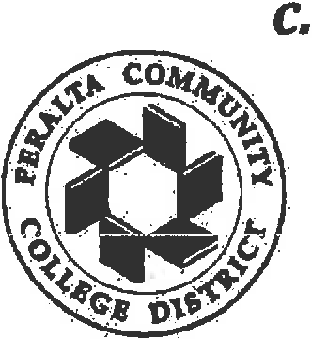
!-,eague of Women Voters (Berkeley Chapter)

The Peralto Colleges: Berkeley City College, College of Alameda, Loney College and Merritt College

Fall 2017

- Identify/Record where on campus Civic Engagement/Service-Learning type activities are already happening {Clubs, Programs, Individual Courses, Community Partnerships already in place, etc).
- Identify faculty/counselors who can be recruited later for capacity building of civic engagement college-wide.
0 PD Workshop on Civic Engagement work at OCT. 26 Flex Day.
- Collaborate with Public Information Officer to update website content & deveiop marketing strdtegy for "BCC: Civic Engagement Work and Opportunities" (awareness, recruitment and completion metrics).

Fall 2017 and Spring 2018

- Collaborate with ASBCC to recruit student leadership and members for Civic Engagement Club. Identify goals and scope of the student club and what other partnership/coalition could be coordinated with other clubs to organize campus-wide activities. Civic Engagement Club activities TBD in partnership with the students {give students examples of past activities from previous CECs}.
- Collaborate with and implement Fair Elections Legal Network's Campus Vote Project
- Develop and conduct presentations to Shared Governance Committees and College Flex , focused on the history, scope, role, pedagogy and goals of the Democracy Commitment {TDC) and other Civic Engagement initiatives at BCC (e.g. Campus-Vote project, Civic Engagement Club, and Courses/Programs.that embed Service-Learning projects). Work to develop strategy to expand all of the above. ·
- Work with Berkeley Chapter of League of Women Voters and other community partners to host events on campus (e.g. local candidate debate, community Issue forms, voter reg drives, organizing internship opportunities, etc.
- Coordinate BCC team {faculty, student leaders) to send to Campus Camp and TDC Conference in Spring term.
- Work with Curriculurn Committee, Departments and Office of Instruction to approve Social Science classes in "Leadership, Organizing and Civic Engagement". Design a TWO semester Social Science "Non-Credit" class (e.g. Social Science 1OOA & Social Science 100B) for student leaders {student government, club leadeis, ambassadors, etc.) to enroii in and earn a Leadership/Public Service Certificate. Estimations: "Non-Credit" hours would = 56 hours each semester for student (3'.5 hours a week for 16 weeks). Map courses and certificate to "Non­ credit" area: Workforce Development (Careers in Non-Profits, Political/Issue Campaigns, Community Organizer, Volunteer Recruitment Coordinator, etc .) Roll Out GOAL: FALL1 2018.

,I

Students, College Administrators, Faculty, and Election Officials
Working Together to Overcome Barriers to Student Voting

Campus Vote Project California Community College Opportunities
Campus Vote Project's Community College Program aims to improve registration and voting rates of community college students and the members of their communities by partnering with administrators and faculty to provide essentiai registration and voting information, and engaging students in the democratic process.

Who We Are

The Fair Elections Legal Network, a national nonpartisan election reform organization working to promote access to the ballot, launched Campus Vote Project (CVP) in 2012 after five years of supporting student voter registration and ballot access. CVP works with administrators, faculty, students and election officials to reduce barriers to student registration and voting.

The Los Angeles Community College District is one of the largest community college systems in the country and includes nine schools that serve 135,000 students from 40 cities and communities. LACCD educates almost three times as many Latino students and nearly four times as many African-American students as all of the University of California campuses combined. Eighty percent of LACCD students are from underserved populations.

Why Community Colleges Are So Vital

Community college students represent a crucial component of the new American majority and are often overlooked by political campaigns, and nonpartisan registration and GOTV efforts. Involving these students empowers them to be bridges back to their families and peers, taking information and empowerment to their own communities.

The information gap about registration and voting and about candidates and issues affecting their communities has led to record low participation for California 18- to 24-year-olds. In the 2014 general election, this age group's _voting rate was 8.2%, a little m' ore than one-quarter of the overall turnout rate of 30.9%.

Community colleg_e s are uniquely positioned to provide students with a nonpartisan entry into the registration and ballot access process, as well as the civic knowledge regarding the functions of different government offices and civil discourse around important community issues th t are motivators behind increased democratic engagement.

Many voters fail to participate in local and state elections and are less aware of issues decided by those office holders. CVP and community college partners will collaborate to develop nonpartisan voter education information that explains what decisions these state and locf!I elected officials make that directly impact students and their communities such as, education funding, housing policy, economic development and job training, health care, and clean energy investments.

Greater Engagement Benefits Students

MC&U's A Crucible Moment: College Learning and Democracy's Future called for the higher education community to recommit itself to prioritizing the teaching of skills like critical thinking and civil debate of controversial issues necessary for a healthy democracy. The report collected research findings that suggest "that students who participate in civic learning opportunities are more likely to persist in college and complete their degrees; obtain skills prized by employers; and develop habits of social responsibility and civic participation."

Voter registration and voting should be a building block for students to stand on as they become active citizens, not a hurdle to participation. Institutions of higher education further a key element of their educational mission when they assist students to become registered voters and start down a path of civic learning and democratic engagement.

Statutory Requirements Involving Student Voter Registration

- Higher Education Act: requires good faith effort to widely distribute voter registration forms as well as individual distribution to all students physically in attendance.
- California Student Voter Registration Act requires the Secretary of State to distribute voter registration forms to high schools and higher education institutions. Community colleges campuses a/so must provide a process for voter registration in any automated class registration systems.

What The Program Would involve:

CVP has identified programs that can help your institutions educate your students in civic activities, particularly voting, and can work with your team to develop a comprehensive campus-based plan. We can:
- Provide Voter Education Materials
  - CVP will produce voter information palm cards, posters and other materials to help demystify the voting process for students.
    - California - specific materials on voting issues and the voting process
  - CVP will help administrators and faculty connect issues students care about to the democratic process through materials like o r Debate Watch Guide and customizable§. Reasons Students Should Get Out and Vote.
- Provide support for faculty initiatives and curriculum
  - Faculty is a trusted source of information and CVP will work with faculty to distribute nonpartisan election information during class or through email or an assignment system.
  - Faculty can incorporate democratic engagement into their syllabi and help their students understand the responsibilities of different offices, how they affect issues students care about, and how a student can effectively exercise their right to vote
- Promoting Civic Discussions on Campus
  - CVP will work with partner campuses to host issue and candidate forums that engage students and the community
  - Incorporating registration and ballot access information into these forums directly connects the how of the electoral process with the why.
- Pilot: Student Poll Worker Programs:
  - Recruiting students to be poll workers has an important educational benefit by allowing students to see democracy in action while serving their community. These job experiences will add to experiential learning and give an added work credential to students. Students will also help alleviate a severe shortage of younger and bilingual poll workers in LA County.

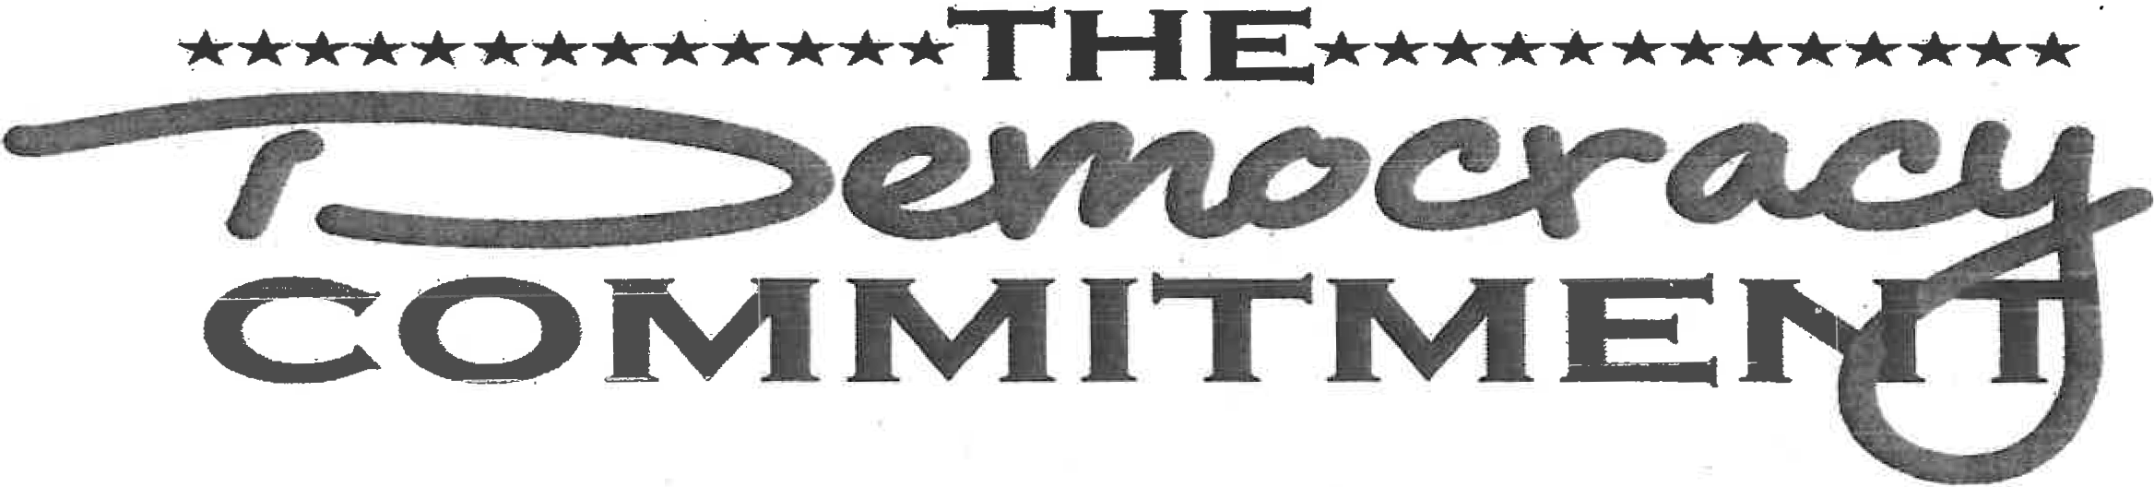

The Mission of The Democracy Commitment is to advance the community college commitment to serving the economic, public policy, and social needs of their students and community. Through advocacy, innovation, and leadership, The Democracy Commitment supports campus efforts that are rooted in the exchange and production of knowledge and resources in mutually beneficial partnerships with their local and global communities. It is the mission of TDC to ensure that every community college student graduates with an education in democracy and citizenship.

The vision is to spearhead the efforfl_n assisting community colleges to develop and prepare their students to become leaders who are engaged and productive members of our global society, who make civic-minded decisions and contribute innovative solutions to address the complex social, health, economic, scientific, and civic issues of our time.

Member institutions become "stewards of place" aimed at revitalizing democracy in the communities in which they are based and from which their students come. TDC nationally supports the fact that community colleges are co mitted to and . responsible for their communities, and assist in providing opportunities to achieve their missions rooted in democracy.

Member institutions are automatically eligible for participation in programs including national initiatives, projects, and grant-funded opportunities.
Administrators, faculty, staff, and students alike can take advantage of member rates when registering for TDC and TDC-sponsored summits, workshops, and meetings.
Additionally, everyone within your campus community can take advantage of sele ted publication discounts and exclusive permission to copy and distribute selected publications at no additiona charge for faculty development and other internal campus activities.

BCC Democracy Commitment Coordinator· Matthew Freeman
(510) 981-2949

mfreeman@peralta.edu OFFICE: 559 @ BCC ·

