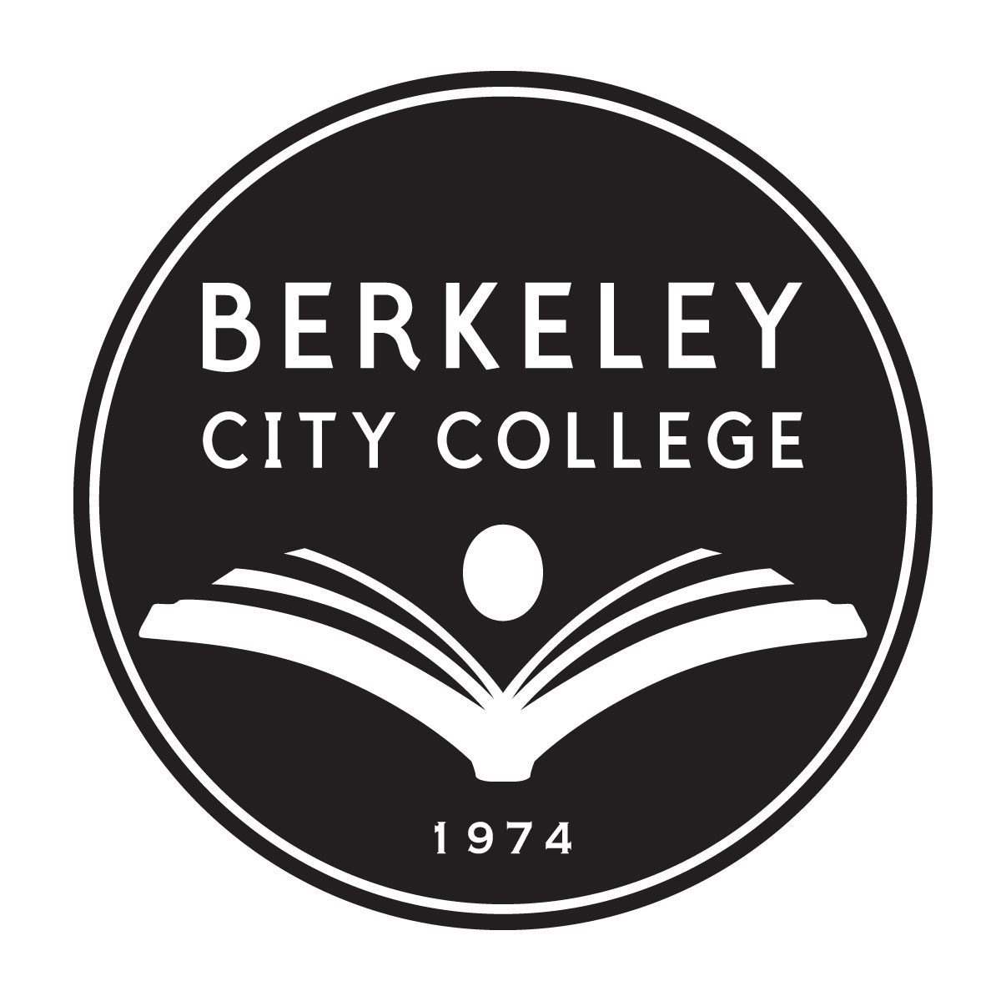

Faculty Prioritization Considerations
February 2015

By 2025 job seekers without a college degree will outnumber the job possibilities available to them (Johnson, 2009), leaving individuals without a degree with limited opportunities for sustainable, living wage work (Auguste, Hancock, & Laboissiere, 2009). In addition, individuals without college degrees are less likely than their more educated peers to vote, participate in civic activities, and have good health (Giroux, 2009). Therefore, it is a social imperative that Berkeley City College strives to eliminate any equity gaps, increase completion rates for all individuals and preserve our democratic society.

BCC Vision 2024 and Education Master Plan goal

When Berkeley City College turns 50 in 2024, we want to be known for excellence in transforming lives and innovation in education. To make our vision a reality, our Education Master Plan goal is to eliminate the equity gap and advance student success with exemplary programs. We will continue to rely on our college mission, vision, values and learning outcomes to guide our efforts.

External Needs

Labor Market Indicators –

Within the liberal arts programs, there is continued need from our local industry to ensure that students, who graduate with a degree in one of the liberal arts areas, have:
- Strong communication skills,
- Analytical and problem-solving skills, and
- Demonstrated ability to apply knowledge and skills in real-world settings

Based on current labor market indicators for our region, the following program areas need focus and development to meet industry demand:
- Computer Science Programming/ Computer Science Engineering
- Information Communications Technologies
- Business/Economic

Internal Needs

Student Educational Goals -
For the Fall 2014, based on student demographic data, BCC student educational goals are as follows:
- 52.2% Transfer with or without an AA degree
- 16.6% 4-year college student taking courses
- 7.8% undecided regarding educational goal
- 5.3% AA/certificate only
- 18.1 % other
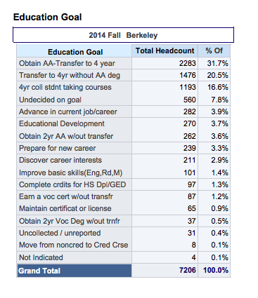

Benchmarks | African American | Latino | Active Military and Vets | Students with Disabilities | Foster Youth
Access to | Advantage | Advantage | Disadvantage | Unclear /  Limited Data | Unclear / Limited Data
Pre-Transfer foundational course completion | Disadvantage | Slight Disadvantage | Advantage | Advantage | Unclear / Limited Data
Transfer course completion | Disadvantage | Slight Disadvantage | Advantage | Advantage | Unclear  /  Limited Date
UC Transfer | Disadvantage | Slight Disadvantage | Unclear / Limited Data | Unclear / Limited Data | Unclear / Limited Data
CSU Transfer | Advantage | Advantage | Unclear / Limited Data | Unclear / Limited Data | Unclear / Limited Data
Degree/Certificate | Advantage | Advantage | Unclear / Limited Data | Unclear / Limited Data | Unclear / Limited Data
Student Needs

Access -
- Reinvent approaches to assessment and placement at entry.
- Strengthen opportunities for students to explore and learn about our programs.
- Create more intentional opportunities for students to connect with faculty outside of the classroom for advising and mentorship to support entry into a program of study.
- Strengthen access to 21st century learning opportunities for all students

Equity –
- Utilize disaggregated data to determine key areas of focus and develop a Berkeley City College Academic Support Index (ASI)
- Strengthen learning communities to promote integrated, proactive, case-managed academic and student support services
- Increase college math completion
- Support with research and information studies for transfer level courses
- Increase mental health services and support
- Professional development

Student Success with Exemplary Programs –
- Strengthen commitment to career and life readiness by respond to current and projected demographic and economic trends
- Align educational support systems and academic programs to meet current and projected student and community needs
- Support and enhance engaging learning approaches
- Enhance acquisition of 21st century knowledge and skills
- Partnerships for sustainable success

Student Completion Data – (duplicated students)

Resources

Auguste, B. G., Hancock, B., & Laboissiere, M. (2009). The economic cost of the US education gap. The McKinsey Quarterly.

Giroux, H. A. (2009). Education and the Crisis of Youth: Schooling and the Promise of Democracy. Educational Forum, 73(1), 8–18.

Johnson, H. (2009). Educating California: Choices for the future. San Francisco, CA: Public Policy Institute of California. Retrieved from http://www.ppic.org/content/pubs/report/R_609HJR.pdf

