**BCC Vision 2024: Education Master Plan**

*In 2024, when Berkeley City College turns 50, we want to be known for excellence in transforming lives and innovation in education. Our Mission, Vision, Values and Learning Outcomes will guide our work as we move forward.*

**Education Master Plan Goal**

Eliminate the achievement gap and advance student success with exemplary programs.

**Philosophical Framework: The RP group’s Six Factor of Success**

*The RP Group conducted extensive research on student success in California Community Colleges. BCC has worked closely with consultants from this organization to help BCC evaluate and plan based on empirical data. A literature review and discussions with key practitioners and researchers indicate student support activities must be (1) integrated into students’ daily experience and (2)included in the overall curriculum. This research also demonstrates that students are more likely to succeed when they are directed, focused, nurtured, engaged,*

*connected and valued****.***

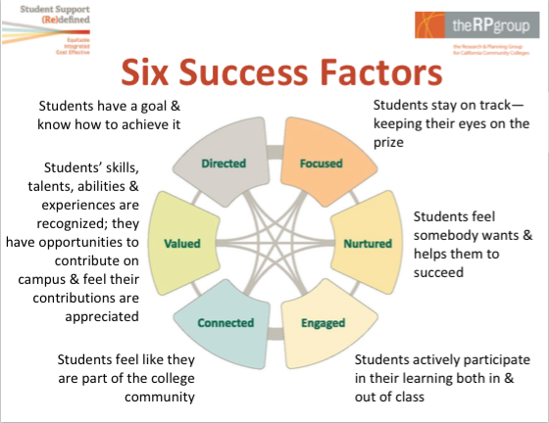

**Areas of Focus: Access To and Through, Equity, & Exemplary Programs**

Access To and Through

*By 2025 job seekers without a college degree will outnumber the job possibilities available to them (Johnson, 2009), leaving individuals without a degree with limited opportunities for sustainable, living wage work (McKinsey & Company, 2009). In addition, individuals without college degrees are less likely than their more educated peers to vote, participate in civic activities, and have good health (Giroux, 2009). Therefore, it is a social imperative that Berkeley City College continues to work to increase completion rates for all individuals to preserve our democratic society.*

Key Strategies:

* Reinvent approaches to assessment and placement entry.
* Strengthen opportunities for students to explore and learn about our programs.
* Create more intentional opportunities for students to connect with faculty outside of the classroom for advising and mentorship to support entry into a program of study.

Equity

*Diversity and equity efforts are important because they are fundamental to quality and excellence. Moreover, diversity is more than a black-and-white binary; it now includes race, ethnicity, gender, sexual orientation, disability, nationality, religion, and a host of other dimensions. Conversations around equity should take into consideration these dimensions as well as special populations, such as foster youth, active military and veterans, and students with disabilities.*

**

Key Strategies:

* Utilize disaggregated data to determine key areas of focus and develop a Berkeley City College Academic Support Index (ASI).
* Strengthen learning communities to promote integrated, proactive, case-managed academic and student support services
* Professional development

Exemplary Programs

*Strengthening existing programs to support all students to and through to completion of their educational goals is imperative to our work in transforming lives.*

*Exemplary programs will have the following qualities:*

* Commitment to Career and Life Readiness
  + Respond to current and projected demographic and economic trends
* Educational Support Systems and Intentional Design
  + Meet current and projected student and community needs
* Engaging Learning Approaches
* Equitable Student Access to 21st Century Learning
* Student Acquisition of 21st Century Knowledge and Skills
* Partnerships for Sustainable Success

WORK TO BE DONE –

-**Determine qualities of exemplary academic and student support programs**

- Insert external and internal scan from self-evaluation

- Insert current programs, FTEF, FTES and student achievement data

**Indicators of Success in Achieving our Goal**

Core Indicators:

* Increase successful course completion to 70% for all students
* Increase the number of students who receive a certificate, degree and/or transfer by “x”% with no gaps

Milestone Indicators for degree/transfer seeking students:

* Enter a program of study & complete a comprehensive Student Ed. Plan (SEP) by end of the 2nd semester.
* Complete a stackable certificate or 20 transferable units by end of the 1st year, including summer
* Complete college-level math by end of 3nd semester
* Participate in work-based learning opportunities on and off-campus