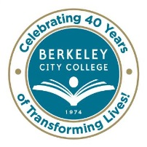
COLLEGE ROUNDTABLE FOR PLANNING AND BUDGET
AGENDA
Monday, September 15, 2014
12:15 pm – 1:30 pm
BCC Conference Room 451A/B
Chair: Debbie Budd, President

Agenda Review Debbie

Review of Accomplishments and Measurable Outcomes from 2013-2014 Debbie

Setting Goals and Objectives in line with 2014-2015 District Goals Tram/Katherine
- Setting Audacious Goals

Shared Governance Manual and Flow Chart May/Tram

Equity Planning Timelines and Updates Brenda/Carlos

Budget Discussion May/Shirley/Katherine
- SSSP
- PASS
- Special Projects
- Equity Planning

Educational Master Planning Tram

Re-Validation of our Mission, Vision and Values at September 23rd Board Meeting Debbie

Accreditation Jenny/May

* * * * * * * * *

~ Roundtable meetings are open to the college community ~

Our Mission: Berkeley City College’s mission is to promote student success, to provide our diverse community with educational opportunities, and to transform lives.

Our Vision: Berkeley City College is a premier, diverse, student-centered learning community, dedicated to academic excellence, collaboration, innovation and transformation.

