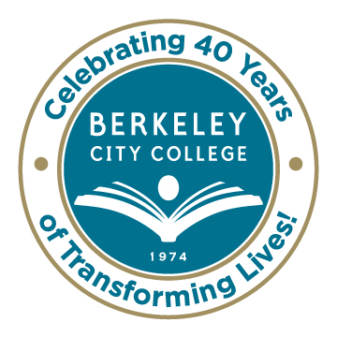
College Roundtable for Planning and Budgeting

AGENDA
Monday, December 8, 2014

12:15 p.m. - 1:30 p.m.

Room: 451A-B

Chair: Dr. Debbie Budd

- Review of Accreditation Self-Evaluation - May / Jenny / Debbie

- Summary of Annual Program Updates – Tram/May
  - Timeline for Spring
    - Flex Day – APU Summary & Ed Master Plan Goal, Strategies and Present Program Gaps

    - January 30 & February 7 – Faculty Prioritization (Senate and Chairs) 2-5 Develop Rubric Based on Needs on January 30. February 6 Prioritize

    - March – Budget Presentation/Development

    - April/May – Prepare for 2015-2016 Program Review and Finalize Education Master Plan

- Review of Equity Plan - Debbie / Brenda

- Review of Shared Governance Flow of Information and Recommendations – All

- Property Acquisition and Timing - Debbie

- Other

***********
Our Mission: Berkeley City College’s mission is to promote student success, to provide our diverse community with educational opportunities, and to transform lives.

Our Vision: Berkeley City College is a premier, diverse, student-centered learning community, dedicated to academic excellence, collaboration, innovation and transformation.

