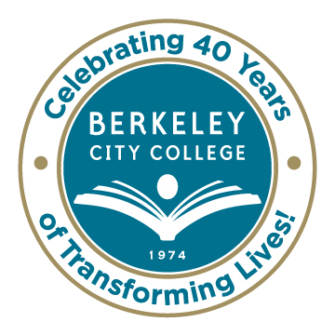
College Roundtable for Planning and Budgeting

AGENDA
Monday, November 17, 2014

12:15 p.m. - 1:30 p.m.

Room: 451A-B

Chair: Dr. Debbie Budd

- Equity Plan Review and Discussion - Carlos and Brenda/ All

- Highlights from Educational Master Planning Meeting - Debbie/ Antonio/ Brenda/May

- Academic Advising Proposal - All

- Accreditation – Review of Abstract and Actionable Improvement Plans - May

- Property Acquisition and Planning Steps - Debbie

- Discussion of New Definition for Basic Skills - All
  - Pre-Collegiate
  - Pre-Transfer Level

- Other

***********

Our Mission: Berkeley City College’s mission is to promote student success, to provide our diverse community with educational opportunities, and to transform lives.

Our Vision: Berkeley City College is a premier, diverse, student-centered learning community, dedicated to academic excellence, collaboration, innovation and transformation.

