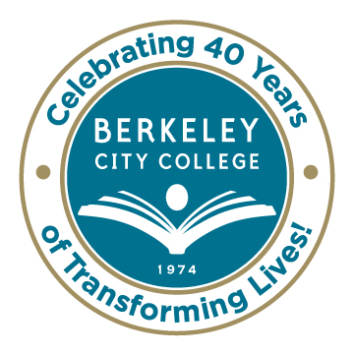
College Roundtable for Planning and Budgeting

AGENDA
Monday, October 13, 2014

12:15 p.m. - 1:30 p.m.

Room: 451A-B

Chair: Dr. Debbie Budd
Planning
  - Educational Master Plan
    - Highlights from October 3rd Meeting
    - Next steps, and next meeting

  - SSSP Plan
    - Highlights from plan; Due to state October 17th

  - Equity plan
    - Updates and highlights

Strategic Goals in line with our Mission/ Vision/ Values
  - Review of approved goals
  - Workgroups for activity discussion

Shared Governance Manual - Final Review and Adoption

Accreditation- Sharing of Institutional Self-Evaluation
  - Standard 2 - Thursday, October 16, 12:15-1:30 p.m.
  - Standard 3 - Monday, October 20, 12:15-1:30 p.m.
  - Standard 4 - Tuesday, October 21, 12:15-1:30 p.m.
  - Standard 1 - Wednesday, October 22, 12:15-1:30 p.m.

Faculty Advising - Plan for Implementing

***********
Our Mission: Berkeley City College’s mission is to promote student success, to provide our diverse community with educational opportunities, and to transform lives.

Our Vision: Berkeley City College is a premier, diverse, student-centered learning community, dedicated to academic excellence, collaboration, innovation and transformation.

