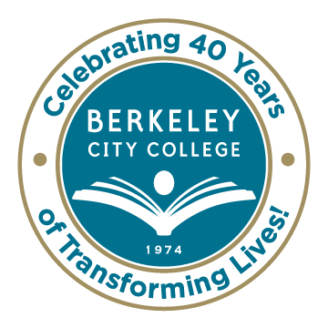
College Roundtable for Planning and Budgeting

AGENDA
Monday, February 9, 2015

12:15 p.m. - 1:30 p.m.

Room: 451A-B

Chair: Dr. Debbie Budd
Discussion Topic Facilitators:
Dr. Debbie Budd, President
Mr. Antonio Barreiro, Interim Dean, Academic Pathways & Student Success
Ms. Sharon Millman, Facilities Project Manager, PCCD
Ms. Shirley Slaughter, Director, Business & Administrative Services
Dr. May Chen, Vice President, Student Services
Ms. Jenny Lowood, Faculty
Ms. Tram Vo-Kumamoto, Vice President, Instruction

- Review of Agenda and January 26th Roundtable Minutes – Debbie

- BCC Wireless Network – Antonio 12:15 p.m.

- New Facility Survey and Preliminary Results – Sharon 12:25 p.m.
  - Highlights from Facilities Committee Meeting – Shirley
  - Next Steps – Debbie

- Accreditation – Debbie/May/Jenny 12:45 p.m.
  - Town Hall – February 11th, 2014, 12:15 p.m. – 1:15 p.m.

- Planning, APU Results and Faculty Prioritization Results – Tram 1:00 p.m.

- Other

***********

Our Mission: Berkeley City College’s mission is to promote student success, to provide our diverse community with educational opportunities, and to transform lives.

Our Vision: Berkeley City College is a premier, diverse, student-centered learning community, dedicated to academic excellence, collaboration, innovation and transformation.

