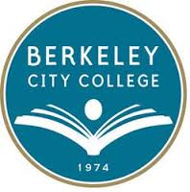
Vision 2024: Berkeley City College at 50
November 14, 2014
11:30-1:30
Education Master Plan Meeting #3 – Faculty Advising

11:30 | Welcome and Introductions
11:30-12:00 | Education Master Plan Proposal – presentation
12:00-12:30 | Discussion re: proposal – Concerns/ Needs
12:30-1:30 | Activity – Small group discussion regarding faculty advising

