SPANISH MEDICAL INTERPRETER TRAINING

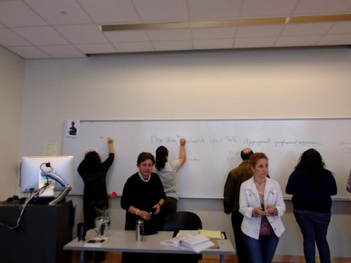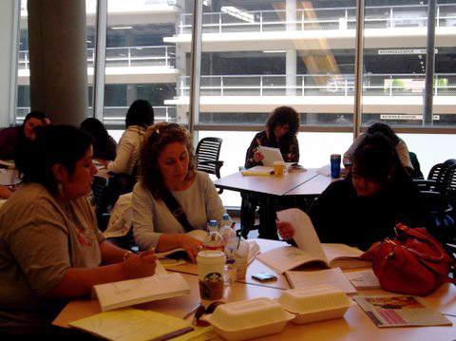

BRIDGING THE GAP SPANISH
MEDICAL INTERPRETER COURSE
Spanish 801, 0 Units
(40 hour course is nationally and internationally accredited)
Fee based, Non-credit Class Begins
Wk. 1) April 14, 15, & 16, 2026
and
Wk. 2) April 21 & 22, 2026
(9:30 am to 6:00 pm)
The training covers interpreter roles and ethics, interpreting skills, medical terminology, the impact of culture, and an overview of the health care system. Upon completion, the student receives a “Certificate of Completion” and qualifies them for the National Medical Interpreter Certification Exam.
Please contact Dr. Alvaro Vergara-Mery at vergaramery@hotmail.com Or
Francine Lewis at flewis@peralta.edu 510-981-2828 on the Berkeley City Campus.
Berkeley City College
2050 Center St.,
Berkeley, CA 94704
Fee is $695. *includes the course text book, Glossary, and Guide to Common Medications

