Berkeley City College’s mission is to provide our diverse community with
educational opportunities, promote student success, and to transform lives.

Introduction and Directions

Berkeley City College (BCC), in conjunction with the Peralta community College District, has an institutional effectiveness process which consists of the following components: a District-wide Strategic Plan which is updated every six years; Comprehensive Program Reviews (CPRs) which are completed every three years; and Annual Program Updates (APUs) which are completed in non-program review years.

TIMELINE
The Annual Program Update (APU) for 2025-26 marks the second year in a three-year cycle.
The APU timeline has been developed for each program and services to guide everyone through the semester. Please review and work with your Deans, Managers, and/or Supervisors to complete this APU.

The 2025-26 Annual Program Update will be reviewed and analyzed for alignments to BCC’s 2024-28 Educational Master Plan’s five strategies for success and three indicators of success that will lead us to achieve our goal of equitable student completion.

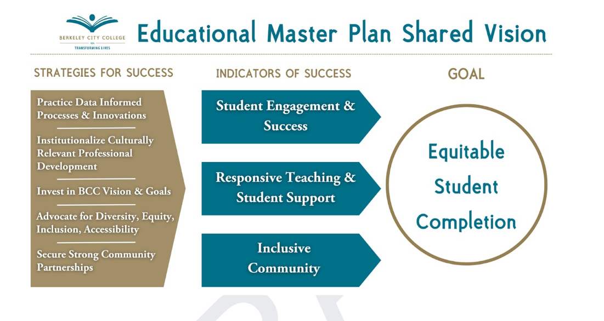

The 2025-26 APU serves as a one-year update to the 2024-25 Comprehensive Program Review (CPR), based on the assessment of the progress and challenges. It is important to be reminded that the EMP incorporated the State Chancellor's Vision for Success as well as Student Centered Funding Formula (SCFF) in our five year roadmap and our CPR process. Please use these foci as your reference to update and prioritize your department’s goals.

RESOURCE REQUEST
In this process of making continuous quality improvement, there is an opportunity for each instructional department, student support service area, and administrative unit to request resources that support achieving the stated goals.

The APU process directly leads to the institutional resource allocation process and budget planning facilitated by the Budget Advisory Committee (BAC) for the following academic year (2026-27). The process for this can be found here (2025-26 APU Timeline). This is an opportunity for your department to request resources in Fund 01 (General Funds) to support your department goals and set outcomes that support BCC’s goal of Equitable Student Completion.

TECHNOLOGY REQUEST
Finally, for the resource request section, please connect with your Deans, managers, and supervisors regarding your technology needs so that you can be informed about the equipment that is already addressed in the BCC Technology Refresh Plan. If your requests are covered in the Refresh Plan, you do not need to request them in the 2025-26 APU.

If you have questions regarding other material in the Annual Program Update, please contact your Dean or Manager. If you have questions regarding data, please contact Dr. Phoumy Sayavong, Senior Researcher and Planning Analyst (psayavong@peralta.edu).

Please email the completed Annual Program Update
to your Dean by November 26, 2025.

Berkeley City College Profile
Click here to view the Berkeley City College Student Demographics Dashboard.
This 2-page dashboard will provide data on the demographics of our student body from the past two years such as headcount, ethnicity, enrollment status, age group, educational goals, and majors.
College Outcomes | 2021-22 | 2022-23 | 2023-24 | 2024-25
Full Time Equivalent Students (FTES) | 2668 | 2958 | 3221 | 3230
Productivity (Avg. Goal = 17.5) | 12 | 14 | 15 | 15
Success Rate* (%) | 68%* | 68%* | 69%* | 72%*
Degrees + Certificates Awarded (#) | 960 | 864 | 960 | 933
*Excludes “EW” grades

To view your 2024-25 Program Review, click here.

1a. Department Mission
Please verify the mission statement for your department. If your department has not created a mission statement, provide details on how your department supports and contributes to the College’s mission.
Name(s) of member(s) completing this APU | Department | Completion Date
List faculty names with assignments in fall 2025.
Full Time | Part Time

1b. Department Priorities & Goals
Review your department’s three-year priorities and goals from the 2024-25 CPR and describe any updates you would like to make this year.

2. Program Assessment
Berkeley City College is committed to a culture of assessment to improve instruction, services, and institutional planning. Findings from SLO, PLO, ALO assessments, and program review data are used to direct resources for areas that are well aligned to the Educational Master Plan and BCC Strategic Plan.

Due to the critical role that course and program assessments play in our institutional planning and to be in compliance with the Accreditation requirements, assessments must be completed to qualify for the CPR resource allocation requests.

<Click here to view your Round 5 Assessment Calendar>
2a. Explain how your department is using SLO and PLO assessments to inform curriculum and program revisions as well as your resource requests. Briefly discuss at least 3 examples that demonstrate the use of assessment to identify successful practices and areas for improvement.

2b. Status of SLO and PLO completion in Round 6 of the Assessment Cycle (Fall ‘24 – Spring ‘27).
Is your department on track for completing SLO course assessments and PLO assessments in Round 6? Briefly describe your progress. What is the current percentage of completion of course assessments in your department?
Identify issues or concerns that may prevent your department from completing 100% of SLO course and program assessments in this cycle. Identify specific courses in your department that did not complete an SLO assessment in Round 5 (Fall 21 - Spr 24). Briefly explain how these courses will be prioritized for assessment in Round 6.

3. DEPARTMENT ENROLLMENT & OUTCOMES
Reflecting on 2024-25 outcomes, are there any adjustments to your plans in 2025-26 or 2026-27? If so, select two or more data dashboards below that are related to your department’s priorities and goals from the 2024-25 Program Review. If you are using other data sources, please identify the source and add a link or screenshot in your description.

Some important areas to consider can include:
- Describe which activities and/or strategies your program used to contribute to the gains?
- What do you see as key factors in your department that contributed to an increase in success and completion rates of these student groups?
- What are some strategies for improvements your department can make?
- What support does your program need to accelerate to improve these outcomes?
- Reviewing the data provided below, what strategies would your department employ to address bringing more high school students to BCC?

For assistance with data dashboards, contact Phoumy Sayavong at psayavong@peralta.edu

DATA DASHBOARDS (Click on the name of the dashboard to view the data)
- Course Completion & Retention | 5. Enrollment Trend and Productivity
2. Dual Enrollment | 6. Degrees and Certificates
3. Transfer | 7. DataMart
4. Data Vista | 8. Persistence by Student Groups
Provide reflections here…

4. Curriculum based on Pathways for Equitable Completion
Based on the curriculum mapping and planning of your program answer the following questions.
Provide an update to your department’s plan for sequencing degrees and programs to ensure students successfully complete the programs in the least amount of time.

5. Engagement
Discuss the status of faculty and classified staff engagement in institutional efforts such as committees, presentations, and departmental activities. How are faculty in the department engaged?
Please list the committees that full-time faculty participate in during 2024-25 and fall 2025.

6. Prioritized Resource Requests
In the 2025-26 APU, you have provided your resource requests which went through the BAC process. In this section, include resource requests from last year that are still needed and/or new resources that have emerged. Provide justifications (e.g., assessment data). If there are no resource requested, leave the boxes blank.

Resource Category | Description/Justification | Estimated Cost
Personnel
Classified Staff
Student Worker
Part Time Faculty
Professional Development
Department wide PD needed
Personal/Individual PD needed
Supplies
Software (for whom or role?)
Books, Magazines, and/or Periodicals
Instructional Supplies
Non-Instructional Supplies
Technology & Equipment
Description/Justification (Before you list your technology request, click here to view the latest Technology Refresh Plan to verify whether it has already included.)
New
Replacement
Facilities
Classrooms
Offices
Labs
Other
Library
Library materials (including streamline media needs)
Library collections
OER
Other
OTHER Description

Thank you for your time and effort in completing the Annual Program Update!
Please email the completed Annual Program Update to your Dean by November 26, 2025.

