Berkeley City College’s mission is to provide our diverse community with
educational opportunities, promote student success, and to transform lives.

Introduction and Directions

Berkeley City College (BCC), in conjunction with the Peralta community College District, has an institutional effectiveness process which consists of the following components: a District-wide Strategic Plan which is updated every six years; Comprehensive Program Reviews (CPRs) which are completed every three years; and Annual Program Updates (APUs) which are completed in non-program review years.

TIMELINE
Annual Program Update (APU) 2022-2023 timeline has been developed for each program and services to guide through the semester. Please review and work with your Deans, Managers, Department Chairs and/or Supervisors to complete this APU.

For BCC, 2022-2023 marks a critically important year as the college is in the process of revising its Educational Master Plan (EMP) for the next 5 years (2024-2028). This college EMP process will inform the District with their planning for their Strategic Plan. This year’s APU will take an especially important role for the EMP process, carrying your analysis, planning and strategies to support our students success, retention, and equitable completion.

The APU is intended to primarily focus upon planning for the subsequent year based on the institutional priorities. While developing the College’s EMP for the next 5 years, the college and the district focused on the Vision for Success identified by the California Community College Chancellor’s office as well as Student Centered Funding Formula (SCFF) that clearly delineate the categorized outcomes that the Colleges should be focusing. Please use these foci as your reference to prioritize your department and other goals.

RESOURCE REQUEST PROCESS
In this process of making continuous quality improvement, there is an opportunity for each program, student services, and department to request resources that support achieving the stated goals. The APU process directly leads to the institutional resource allocation process and budget planning facilitated by the Institutional Planning and Allocation of Resources (IPAR) Committee for the following academic year (2023-24). The process for this can be found here (2022-23 APU Timeline). This is an opportunity for each department to request resources that will support your department goals and set outcomes.

TECHNOLOGY REQUEST
Finally, for the resource request section, please connect with your Deans, managers, and supervisors regarding your technology needs so that you can be informed about the equipment that is addressed in the BCC Technology Refresh Plan. If your requests are covered in the Refresh Plan, you do not need to request them in this APU.

If you have questions regarding other material in the Annual Program Update, please contact your Manager. If you have questions regarding data, please contact Dr. Phoumy Sayavong, Senior Researcher and Planning Analyst (psayavong@peralta.edu).

Please email the completed Annual Program Update to your Supervisor by November 30, 2022.

College Profile
Click here to view the Berkeley City College Student Demographics Dashboard.
This 2-page dashboard will provide data on the demographics of our student body from the past two years such as headcount, ethnicity, enrollment status, age group, educational goals, and majors.
College Outcomes | 2018-2019 | 2019-20 | 2020-21 | 2021-22
Full Time Equivalent Students (FTES) | 4161 | 3,931 | 3,622 | 3,259
Productivity (Avg. Goal = 17.5) | 13 | 13.2 | 13 | 10.9
Success Rate (%) | 69% | 77% | 75%* | 70%*
Degrees + Certificates Awarded (#) | 948 | 1,109 | 1,027 | 960
*Excludes “EW” grades

To view prior Program Reviews, click here. To view prior Annual Program Updates, click here.

1a. Program Description
Please verify the mission statement for your program. If your program has not created a mission statement, provide details on how your program supports and contributes to the College’s mission.
The Admission & Records (A&R) Office serves as the first point of contact to the college for new and continuing students, as well as the general public. Admission & Records is dedicated to student access and success to reduce challenges that students are facing by providing accurate, timely and exceptional customer service regarding applications, registration, online access and academic policies while providing responsive respectful service to students, faculty, staff and the community.
Name(s) of member(s) completing this APU | Program | Completion Date
Hue Huynh | Admissions & Records | 12/09/2022
List staff names with assignments in fall 2022.
Full Time  Sr. Admissions & Records Specialist - Hue Huynh  Admissions & Records Technician - Tam Vo  Admissions & Records Technician - Brendan Garcia  Admissions & Records Technician (Assigned to BCC as A&R Clerk) - Elinor Chin | Part Time  N/A

1b. Program Priorities & Goals
Based on the Vision for Success and SCFF, and your program’s mission, what are your program’s priorities and goals for 2022-23?
The Admissions & Records department has partnered with student services, including counseling and other stakeholder groups under the Enrollment Management Plan to support the students. Admission & Records is dedicated to student success by closing equity gap and achievement gap.

2. Student Equity, Success, & Completion
Using the data dashboards provided below, review and reflect upon the outcome trends for your program. Please also review overall BCC’s data linked here.

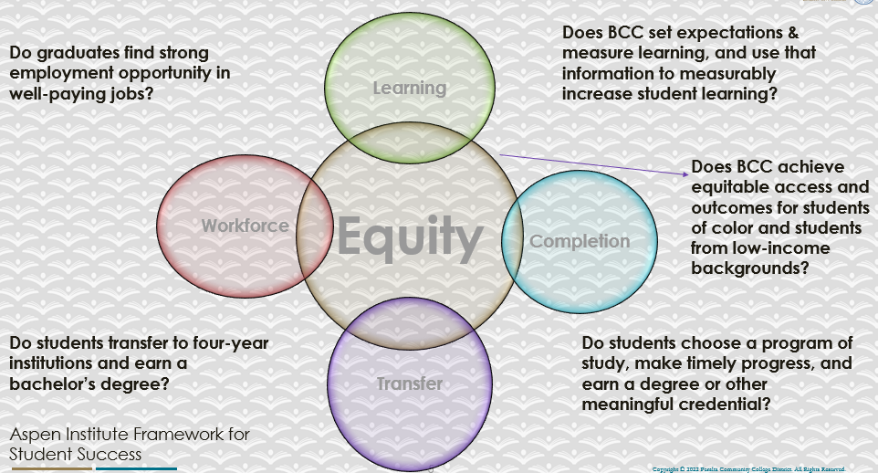

For assistance with data dashboards, contact Phoumy Sayavong at psayavong@peralta.edu
What are the group of students that needs more attention to achieve goals?
Looking at the Course Completion & Retention rates in the chart below, the Hispanic/Latino, Black/African American, Pacific Islander and those students from the age of 19-24 and 25-29 have lower completion rates. These are students that have been determined as the disproportionately impacted (DI) groups which may need more support. These group of students may be new to college who have just graduated from high school or students who have just arrived from a different culture experiences/background, first generation students who do not have any experience/knowledge and need more assistance.

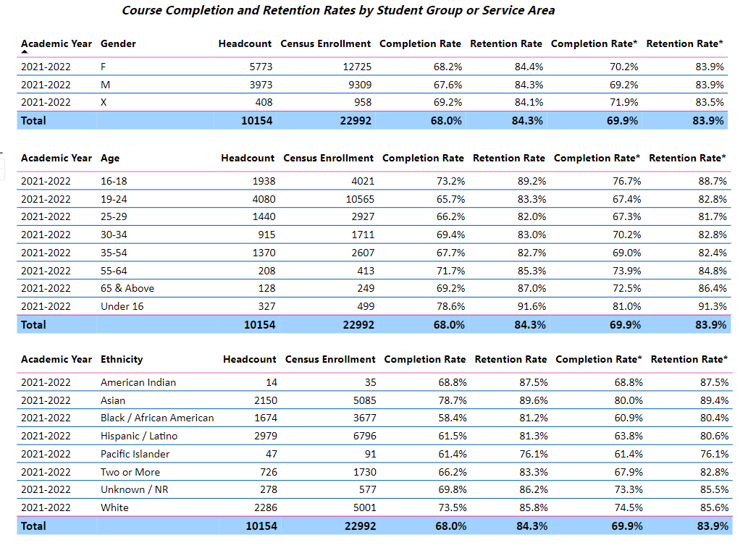
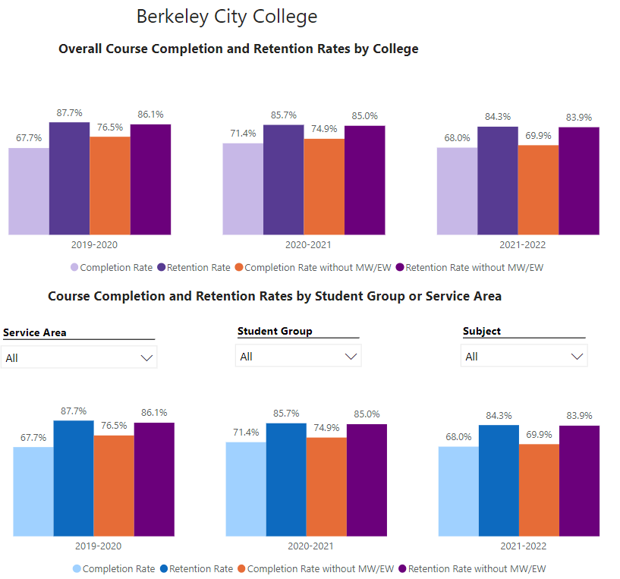

What are key factors in your program that contributed to positive success and completion rate?
What are some improvements your program can make? Identify strategies.
The students’ completion rate can be affected from many factors. It could be challenges that they are facing with enrollment, for example, prerequisite that prevents them from enrolling, to the academic disadvantage that they have experienced during classes, lack of technology, or support from the faculty could be one of the major issues as well. Many times, we have received requests from students that ask us to help communicate with their instructors because they cannot contact or relay their problems to the professors in a timely manner.
If we could have the student services department and instructional department work collaboratively to support the students, especially those in the DI groups, this process will be more successful and will best serve the students for their needs. To demonstrate, A&R will work with the counseling department to make sure the students are cleared to enroll in the courses toward their educational goal in a timely manner and during the academic progress. If the students have a problem with courses that they are enrolling in and need help from the faculty, the staff from instructional office or the designated person could assist the students to get the problem resolved.

3a. Enrollment Trend and Productivity Dashboard
*Note that completion and retention rates are presented with the inclusion and exclusion of excused withdrawals (EW) and military withdrawals.
What are the enrollment trends in your program in the last three years (if applicable) or college?
Student Demographics | 2018-2019 | 2019-2020 | 2020-2021 | 2021-2022
Annual Headcount | 10,903 | 10,759 | 11,431 | 10,135
Total Enrollment (census) | 30,298 | 31,007 | 27,153 | 22,428
Ethnicity
African-American | 16% | 15.2% | 15.75% | 16.47%
American Indian/Alaskan Native | 0.2% | 0.3% | 0.21% | 0.15%
Asian | 24% | 23.9% | 23.45% | 21.19%
Hispanic | 25% | 25.9% | 26.61% | 29.35%
Multi-Ethnicity | 7% | 6.9% | 7.5% | 7.16%
Pacific Islander | 0.3% | 0.3% | 0.52% | 0.46%
Unknown | 3% | 5.1% | 3.49% | 2.74%
White Non-Hispanic | 24% | 22.5% | 22.47% | 22.48%
Gender
Female | 55% | 56% | 58% | 57%
Male | 42% | 41% | 39% | 39%
Unknown | 3% | 3% | 3% | 4%
Age Group
Under 16 | 2% | 2% | 2% | 3%
16 to 18 | 11% | 13% | 16% | 19%
19 to 24 | 45% | 45% | 42% | 39%
25 to 29 | 18% | 16% | 16% | 14%
30 to 34 | 9% | 9% | 9% | 9%
35 to 54 | 11% | 11% | 12% | 13%
55 to 64 | 2% | 2% | 2% | 2%
65 + | 2% | 2% | 1% | 1%

College Outcomes | 2018-2019 | 2019-20 | 2020-21 | 2021-22
Full Time Equivalent Students (FTES) | 4161 | 3,931 | 3,622 | 3,259
Productivity (Avg. Goal = 17.5) | 13 | 13.2 | 13 | 10.9
Success Rate (%) | 69% | 77% | 75%* | 70%*
Degrees + Certificates Awarded (#) | 948 | 1,109 | 1,027 | 960

What strategies would you recommend to increase student enrollment in your program?
The Admissions & Records has partnered with different student services departments to support the students and make sure that the students have been successful with their registration/enrollment. A&R participated in the Express Registration Enrollment Days to assist new and continuing students with enrollment issues and streamline enrollment process that aligns with the BCC’s Enrollment Management Plan. Not only that, we are assisting AB540 and undocumented students to enroll in the courses when they are reaching out to us for assistance. We provide priority registration to DI groups and assist undocumented students with the enrollment process. With the free fee campaign, we have increased the enrollment rates as well as worked together with the financial aid office to encourage the students to apply for FAFSA. It would be a major help due to the students who qualify for financial aid will not have to worry much about financial issues and could enroll into the courses that are needed to complete their educational goals. Since we have the basic need program here at the campus, A&R office could also relay that information to the students if they are struggling with financial issues or basic needs. We learn that the students are more engaged and enroll in more classes when they are worry –free.

Community Colleges are funded based on the Student Centered Funding Formula (“SCFF”) which is comprised of the following allocations:

Student Centered Funding Formula: Focus and Priorities
% Of Allocation | Categories
70%  Base Allocation: FTES (Enrollment) | - Credit FTES  - Non-Credit FTES  - Special Admits (Dual Enrollment, etc.)
20%  Supplemental Allocation | - Pell Grant  - AB 540  - Adult School  - Promise Grants
10%  Student Success Allocation | - Associate Degrees  - ADTs  - 9 or more CE units  - Transfer  - Transfer level Math and English in the first year

List the Program’s progress and reflection on how to maintain or increase student enrollment. Please describe retention (i.e., remain enrolled for a full semester) and persistence (i.e., enroll in consecutive semesters) efforts.
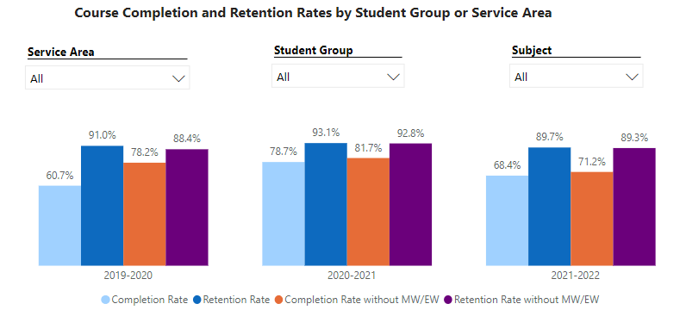

Please describe your unit’s efforts in identifying Pell Grant recipients, College Promise Grant recipients, Adult Education, and AB 540 students. What processes are in place to accurately report these students each semester?

College Outcomes | 2018-2019 | 2019-2020 | 2020-21 | 2021-22
Full Time Equivalent Students (FTES) | 4,161 | 3,931 | 3,622 | 3,259
Pell Grant Recipients | 2,387 | 2,281 | 2,181 | 1,826
College Promise Grant Recipients | 4,373 | 4,143 | 4,011 | 3,500
AB 540 Students | 74 | 51 | 22 | 69

Due to the update in the AB540 Affidavits, the undocumented students can file for affidavit and self-reporting. The students would fill out the CA Non-resident tuition fee exemption form and submit it to the Admissions & Records office for processing. There is no supporting document required from the students unless staff needs more information while reviewing the affidavit. With this new update from AB 19 and California College Promise Grant, we have received a rapid increase numbers of undocumented students from our department. In addition, BCC campus also has its own undocumented center that assists students to advocate for their in-state tuition fee and dream act application. Many students find it very helpful with the assistance they receive from the undocumented department and A&R department for processing their AB 540 affidavit.

3b. Course Completion and Retention Rates Dashboard – Student Services
*Note that completion and retention rates are presented with the inclusion and exclusion of excused withdrawals (EW) and military withdrawals.

If you need more guidance with this item, click here for additional support. Click here for additional guidance for how to view and use equity data. If you would like to view BCC’s Equity Plan, click here.
On page 3 of the “Course Completion and Retention Rates by Subject” dashboard, what are the completion and retention trends by gender, age, ethnicity in your program/service area? How can your Program improve trends over the next year?
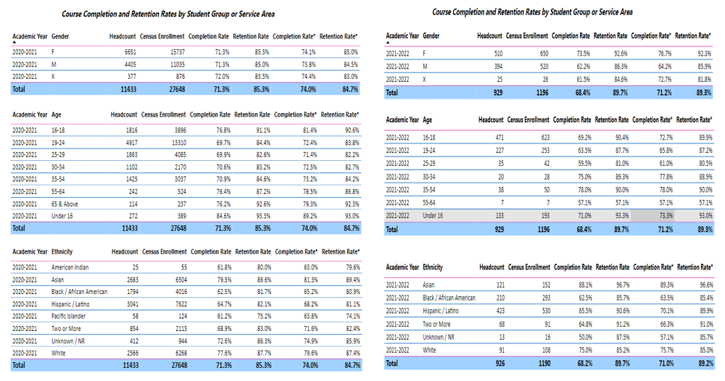

What population(s) showed outcomes gains and which need more support?

Disaggregate the data and outcomes as far down as a possible then ask:
- What trends do you notice when examining course success rates for student populations by ethnicity? Which factors do you believe have the greatest impact (positive or negative) and cause variation between student course success rates in your Program? Describe some specific methods your Program is planning or implementing to address these equity gaps. How will you evaluate the efficacy of these interventions?

- How has pivoting to online instruction contributed to potential reductions in student success? Provide some specific examples of practices that staff in your Program have found ineffective in the online environment.
Please review the video from the RP Group acknowledging the interrogation De Anza Community College committed to in their analysis of course completion and success rate.
How do these outcome trends in your program compare to the college average?
How will these outcome trends you identified in this section affect your program goals and plans for the next year and what are your strategies to shift the trend to go towards positive direction?

The completion rate for 2021-2022 is a little lower than previous year 2020-2021 by 3-4% but the retention rate is a bit higher by 4-5%. Even though the students did not completed/passed the courses but they have remained in the courses and tried not to withdraw the classes. The data shows that the female students have more completion rates and retention rates compare to the male students. It could be that they are more focused and could reach out for more resources available on campus and other areas that could help with they are needed whereas the male students are lacking of the support and resources that could potentially assist them in achieving their goals. Similar to the age groups, the younger group of students has lower rates than previous year. They could be new and have no college experience. We could support these students by reduce the equity gap and achievement gap. A&R office will provide the students with clear instruction of the registration/enrollment process and will work collaboratively with student services department and instructional office to see where the gap that prevents the students to achieve their goals and will work together to find the solution to resolve the problem.

3c. Degrees and Certificates Dashboard
On page 1 of the “Degrees and Certificate Awards Trends” Dashboard, what are the award trends for your program/service area (e.g., overall, by gender, age, and ethnicity)? On page 4, what population(s) award trends showed gains in your program and which populations need more support?
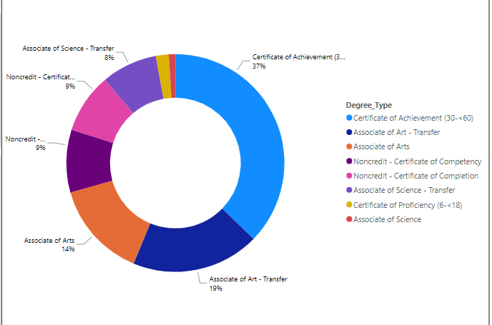

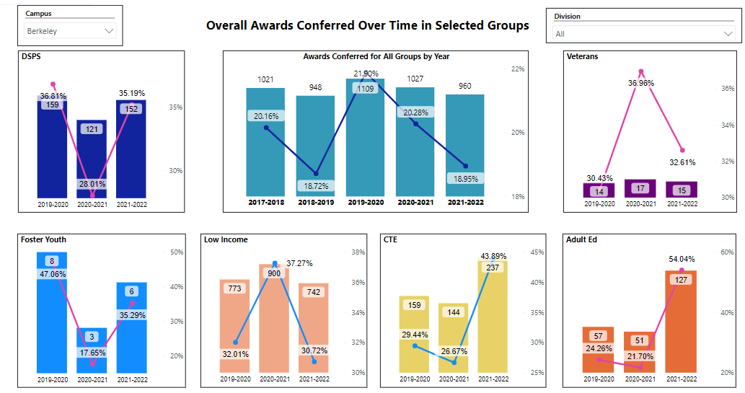
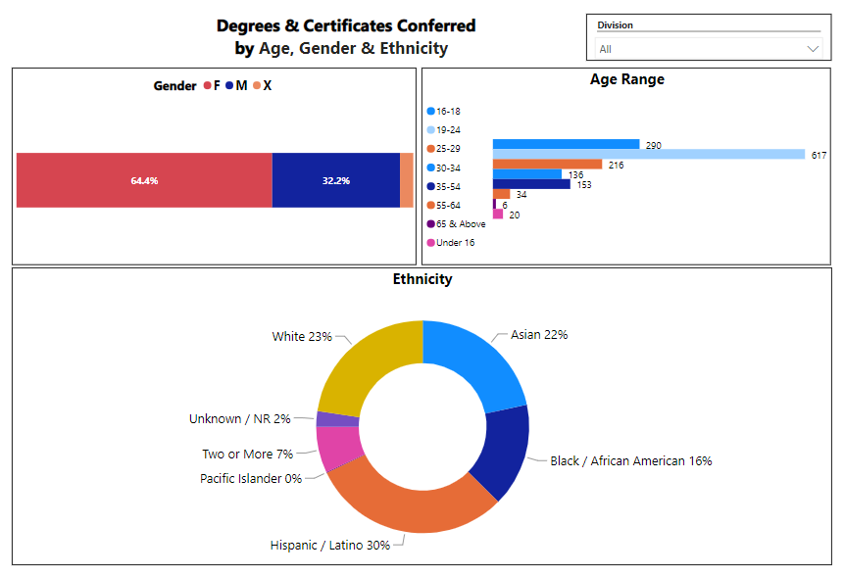

For the academic year 2021-2022, Berkeley City College has awarded a total of 906 degrees and certificates. The number of awards is lower than last year, but BCC staff has contributed and worked hard to implement the Associate degrees for transfer and this year has marked our fourth year in a row for the Champion of Higher Education for excellence in transfer awards. The awards that we have processed include 134 (14.36%) Associate in Art (AA) Degrees and 9 (0.96%) Associate in Science (AS) Degrees, 177 (18.97%) Associate in Arts for Transfer (AA-T) Degrees, and 77 (8.25%) Associate in Science for Transfer (AS-T) Degrees, and 375 (37.3%) Certificates of Achievement and 18 (1.93%) Certificate of Proficiency. In addition, there are totals of 170 (18.22%) noncredit certificates, combine of the Certificate of Competency and Certificate of Completion for the Non-credit programs. Per the data, female students are those that have the most completion rates and degrees/certificates awarded. And according to the selected students groups, we could see that the DSPS, Foster Youth, CTE and Adult ED groups have more awards compare to the Veterans and Low Income students. The financial could be a major barriers for these low income students who have been struggling with financially issue while focusing on their school just like how the veterans have traumatized experience from their previous services which could have impacted them. While helping to find the solution that could help these selected group of students, we also want to focus on the DI groups. According to the Ethnicity chart provided in our school data, we see that the Hispanic/Latino students and Asian students, have the awards percentage that is lower than previous year for about 2-3 % percent. Though the Black/African American students have the percentage that is a bit higher (3%), the awards rates are still very low compare to other groups. These are the DI groups that we really want to pay attention to and provide them with more support. Our goal is reduce the achievement gap and to increase the number of awards and help the student to complete their educational goal. The evaluators in A&R office have been evaluating the external transcripts from other CA community colleges and CA universities, to enter and post transfer credits from those institution to our internal system. The district transcript coordinator is also working closely with the evaluators to help evaluate the private and out of states transcripts. This process will help students and counselors to incorporate transcripts credits in the development of SEPs. Students will be able to view the transfer credits reports in their students’ account and track their academic progress. They will then be able to know the courses needed to complete their programs. While the evaluators are continuing to work on entering the transfer credits, the district is also doing testing and implementing the Audit Degree tool to help with the degree processing. Hopefully, the transcript evaluation will lead to the improvement of the Degree Audit tool, that is scheduled for implementation, is still on going and will be announced once it goes live.

3d. Transfer Dashboard
This dashboard does not provide data by subject. Reflect on what you can do to affect student transfer. How may your Program help to support BCC student transfer? (e.g., serve on panels, strengthen GP in your dept, change curriculum, increase number of AD-Ts, etc.)
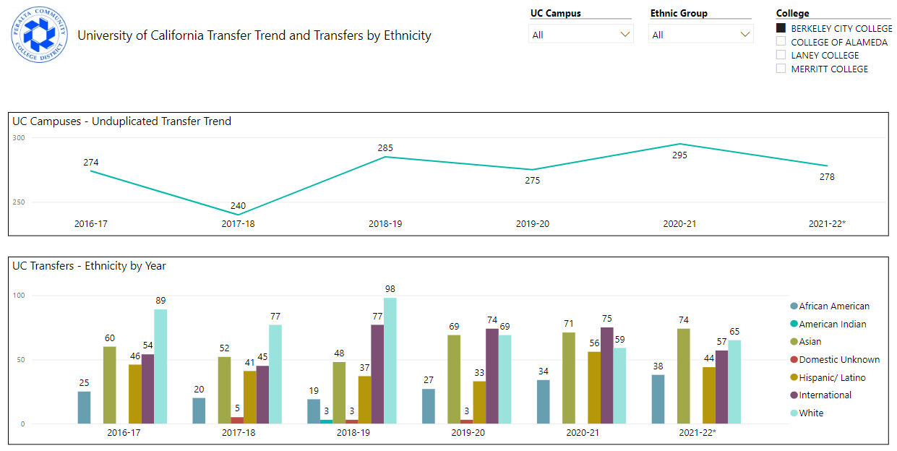
The 21-22 academic year does not have a higher number of students transfer rate compare to last year 20-21, but the number has not dropped too much compare to 19-20 and 18-19 years. Admissions & Records office has actively supporting students transfer goal by providing transcript services, enrollment verification letters (College Reports, Dean Reports, etc.), evaluate transfer credits and process students’ degree/certificate petition, as well as referring student to see the counselor or schedule an appointment with transfer/career center for assistance with UC/CSU transfer applications.

3e. Curriculum based on Guided Pathways
View your program through the lens of student equity outcomes.
- How is your Program making pathways for students to complete their goals?
As mentioned Admissions and Records is not only the first point of contact, we also provide services to students throughout their education goals. We assist with registration when students enter into our campus and as they are working on their program, we help with enrollment issues, any records discrepancy and when the students are ready to transfer, we work with counselor to file petition, and our transfer center staff will assist with transfer admission application. We want to provide a smooth process so that students have a great experience with us.

4. Dual Enrollment
As continued decline in overall enrollment for college going population occurs, it is important for us to look at who will be coming to BCC in the next 5 years. Reviewing the data provide here, what strategies would your Program employ to address bringing more students to BCC?

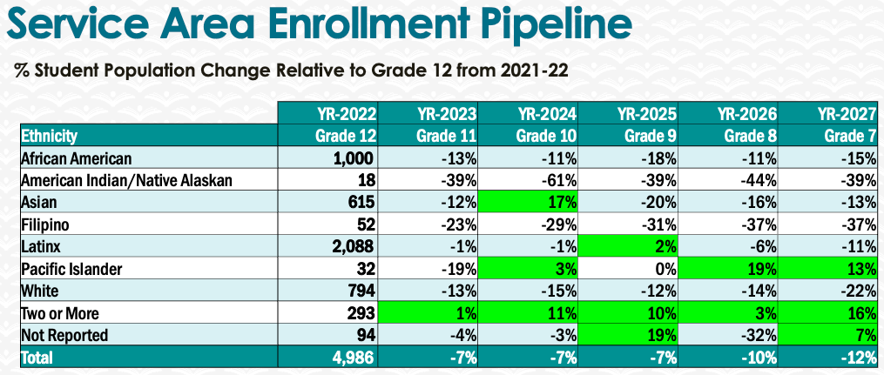
We would need to work together to create a smooth process for our enrollment strategies. Many of these young students do not have any knowledge about college or process. It will be great if our enrollment coordinator and outreach staff could work together with A&R office and other stakeholder that involve in the enrollment process to create a steps by steps instruction or guideline that could help the students to understand. Not only that, we could also work together with our partners school to prepare the students for the enrollment. Many times the students could not enroll due to not having priority registration, the classes are not CCAP, and by the time of the open enrollment, the courses are full. The Enrollment team could work collaboratively with office of instruction for the CCAP courses that open for the high school groups or middle school so that they do not have any problem with enrollment availability.

5. Facility Utilization Needs
Assess your facility utilization for next year and indicate if the space is sufficient or not. If not, what are the needs and why? Work with your manager to check on your needs prior to responding this section.
Our Admissions and Records office have limited office space. Additional space may be needed in the future to support staff growth in this department; as well as, more staffing to support the enrollment.

6. Assessment
Berkeley City College is committed to a culture of assessment to improve instruction, services, and institutional planning. Findings from SLO, PLO, ALO assessments, and program review data are used to direct resources for institutional priorities that are articulated in the Educational Master Plan and BCC Strategic Plan. Due to the critical role that course and program assessments play in our institutional planning and to be in compliance with the Accreditation requirements, assessments must be completed to qualify for APU resource allocation requests.
What action plans did your Program identify upon the assessment of each Service Area Outcomes (SAOs)? Please be as detailed as possible.
The A&R office has been providing service to the student via Chat feature ever since we worked remotely. Though the process has changed lightly when we returned to campus partially in Spring 21 term. We have tested our new ConexEd program (similar to the chat system) where the students can drop-in online for services as well as providing services in person. The students that we serve understand the process. We have recently received lot of positive feedback from the student that we served in –person as well as remotely, mostly through our email system.

Describe the Program’s progress on the Action Plans identified for Service Area Outcomes (SAOs). Please be specific. Identify percentages towards completion of Action Plans. What Action Plans are priorities?
N/A
Describe the status of SAO completion in Rounds 4 and 5 of the Assessment Cycle. Identify the percentages of completion. Briefly describe what needs to be done to reach 100% completion? Identify issues or concerns that may prevent your area from completing assessments of SAOs.

To assist you with this area/prompt, please review your Program’s Round 5 Tentative Plan available on One Drive, search Curricunet for assessment proposals of courses (or SAOs) that should be assessed this past year, and consult the Program’s SAO lead) and/or faculty (or staff) who were scheduled for assessments this past year.
N/A

How does your department, program, or unit ensure that students are aware of Service Area Outcomes?
N/A

Where are the Service Area Outcomes published? If on a website, please specify the URL.
N/A

7. Engagement
Discuss how faculty and classified staff have engaged in institutional efforts such as committees, presentations, and departmental activities. Please list the committees that full-time faculty/staff/admin participate in.
A&R staff has join the classified committee, participate in the district and campus meeting, as well as the campus activities that has been provided from the student services and the campus life department.
Discuss how faculty and staff have engaged in community activities, partnerships and/or collaborations.
We participate in the Student Success Day and sSudent Welcome Week. Additionally, we aslo attended the flex day for any updates or development.
Discuss how part-time staff members are included in program trainings, discussions, and decision-making.
Part-time staff members are included in the team meetings and receive updates regarding the office.
- Discuss the relationship and engagement with other support services, programs, departments, or administrative units and how these relationships/collaboration support meeting your program goals.
Admissions and records staff are working closely with other student services departments, counseling, financial aid, learning community, etc. to make sure our students receive the support that they need.
Are there areas you feel that your department can benefit more by increasing collaboration and partnership? How?
We could work more closely with financial aid office to learn about their process that could benefit the students. To have an understanding about FAFSA or financial aid will help students a lot. Many students are often struggling with financial issues and could not pay full attention to accomplish their goals.

8. Prioritized Resource Requests
During the 2021-22 Comprehensive Program Review process, you have provided your resource requests which went through the IPAR process. In this section, include resource requests from last year that are still needed and/or new resources that have emerged. Provide justifications. If there are no resource requested, leave the boxes blank.

Resource Category | Description/Justification | Estimated Cost
Personnel
Classified Staff | Admissions & Records Clerk (Regular & Non-Credit) | $70,000
Student Worker | Student Worker | $20,000
Part Time Faculty
Professional Development
Department wide PD needed
Personal/Individual PD needed
Supplies
Software (for whom or role?)
Books, Magazines, and/or Periodicals
Instructional Supplies
Non-Instructional Supplies
Technology & Equipment
Description/Justification (Before you list your technology request, click here to view the latest Technology Refresh Plan to verify whether it has already included.)
New
Replacement
Facilities
Classrooms
Offices
Labs
Other
Library
Library materials (including streamline media needs)
Library collections
OER
Other
OTHER Description

Thank you for your time and effort in completing the Annual Program Update!
Please email the completed Program Review to your Dean by November 30, 2022.

