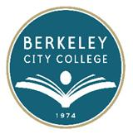
HEALTH & SAFETY COMMITEE

AGENDA
Tuesday, November 18, 2014

12:15 pm – 1:30 pm

Room: 451

- Call to Order
- Agenda Review
- Review of Minutes from October 28, 2014
- Follow-up Discussion (Drill)
- Develop Committee Goals 2014-15
- Additional Safety Training
- Adjourn
Berkeley City College’s Institutional Goals:
Goal 1: Preserve and nourish resources to ensure access, equity and success for all students.
Goal 2: Increase certificate/degree completion and transfers to 4-year colleges or universities by inspiring and supporting students.
Goal 3: Improve career and college-preparation progress and success rates.
Goal 4: Ensure BCC programs and services reach sustainable, continuous quality improvement level.
Goal 5: Collaborate to ensure fiscal stability.

