Berkeley City College – Facilities Committee
April 9, 2021
12:30-1:30 PM
Zoom Meeting
Membership (X=Present); (A=Absent); (E=Excused)
Name
X | Ava Lee-Pang, Co-Chair, Administrator Rep | X | Thomas Kies, Faculty Rep
X | Michael Alvillar, Classified Rep | A | Vincent Koo, Classified Rep
X | Scott Barringer, Classified Rep | X | Joanna Louie, Classified Rep and Recorder
X | Bobby Birks, Classified Rep | A | Jasmine Martinez, Classified Rep
X | Joshua Boatright, Faculty Rep | X | Sergio Mazariegos, ASBCC Rep
X | Johnny Dong, Classified Rep | X | John Nguyen, Co-Chair, Administrator Rep
X | Natalia Fedorova, Classified Rep | A | Roger Toliver, Classified Rep
X | Charlotte Lee, Faculty Rep

Guests
X | Bob Parks, Kitchell | X | Azul Lewis, Classified Staff
X | Brenda Johnson, Dean of Student Support Services | X | Dr. Ronald McKinley, Acting VC of Human Resources & Employee Relations
X | Keith Kajiya, AECOM | X | Natalia Newman, Faculty

Agenda Item | Discussion | Follow-Up Action
1. Standing Items
- Call to Order | 12:31pm
- Adoption of the Agenda | Motion: Sergio Mazariegos moved to approve the agenda.  Second by: Ava Lee-Pang  Votes in favor: 8  Opposed: None  Abstentions: None  Motion passed.
- Approval of 3/12/21 Minutes | Motion: Sergio Mazariegos moved to approve the minutes.  Second by: Bobby Birks  Votes in favor: 9  Opposed: None  Abstentions: None  Motion passed.
2. Bond Program Update & Milvia Street Project Update – Bob Parks (Kitchell) & Keith Kajiya (AECOM) | Capital Program Bond Update (Keith Kajiya)  Last May, the District sold $115M of bonds from the previous general obligation bonds that were passed for Measure A & Measure G. From the total allocation of $115M for the District and Colleges, $65M was sold from Measure A and $50M was sold from Measure G. This is the last issuance for Measure A from the additional $390M bond measure that passed some years ago. The $50M of Measure G was the first bond sale of $800M so there’s still $750M left to sell moving forward. Out of BCC’s $9.5M budget in Measure A, we have spent about $500K. Out of BCC’s $3.2M budget in Measure G, we have spent a mere $33K.  Cost Status  BCC Project Name Measure G Budgeted Measure A Budgeted  2118 Milvia St. (New Building) $2,366,039 $8,793,900  2050 Center Reconfiguration $0 $0  Berkeley ADA Modernization $0 $748,941  Infrastructure $579,097 $0  Information Technology $274,205 $0  BCC Subtotal $3,210,341 $9,542,841  Bond Spending Plan- Costs & Funding as of March 31, 2021  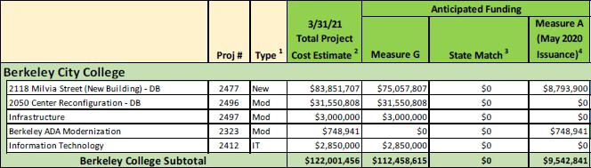  BCC Milvia Street Expansion (Bob Parks)  Bond Spending Plan- Active Major Capital Projects (Costs & Funding as of February 28, 2021)  2118 MIlvia Street (New Building) - DB - 2/28/21 Total Project Cost Estimate $83,851,707  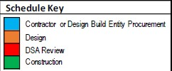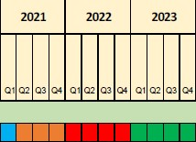  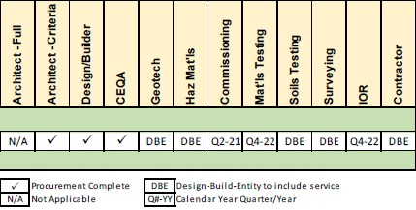  Back in October 2020, we had just released the RFQ (Request For Qualifications) right before that meeting with this committee. We went through about six weeks of weeks of qualification period where we received six Design Build Team submissions. We met as a selection committee with the College and we shortlisted down to three highest qualified teams. Those teams received request for proposal in early December. From there, we went through three rounds of interviews with each of the three teams. The selection committee put together a scoring matrix for those three teams. We have a recommendation on the Design Build Team. We’ve issued a notice of intent to award to the XL Construction and Ratcliff Architects team. We’re in the final stages of bringing this to the Board of Trustees for contract award. The signed contract has been received back from the Chancellor yesterday so it’ll be moving forward this month for the contract award.  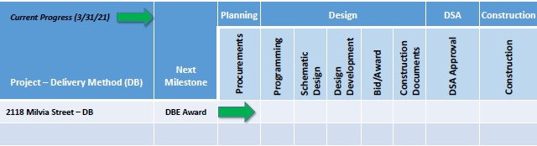  Milvia Total Project Cost Estimate (TPCE) - $83.9M  78% Design/Construction/Escalation Costs goes to the Design Build Team  8% District Soft Costs (project management fees/GSA fees/inspection services)  6% Owner’s Construction Contingency  5% Owner’s Project Contingency  3% Owner’s Design Contingency  Milvia Soft Costs/Contingencies - $18.5M  26% Owner’s Construction Contingency  23% Owner’s Project Contingency  20% Project Management, Commissioning, & Inspection Services  13% Owner’s Design Contingency  7% Information Technology  5% Site/Existing Conditions (i.e. CEQA)  4% Regulatory  2% Miscellaneous Project Costs (PLS, Move Management)  Milvia D/B Budget - $65.4M  79% Hard Construction Costs, Escalation, DBE Markups & Contingencies  10% General Conditions (LSUM- During Construction)  9% Design and Preconstruction (LSUM)  2% Furniture and Equipment  Milvia Tentative Lookahead  Activity Target Dates TBD  Design-Build BOT Approval & Contract Award February 2021 - March 2021  Collaboration and Project Validation Phase^{1,3} May 2021 - June 2021  Design Phase^{2,3,4} August 2021 - May 2022  Division of the State Architect (DSA) Review^{3,4} May 2022 - February 2023  Construction Phase December 2022 - September 2024  Closeout and Project Occupancy October 2024-December 2024  - Building User Group Committee Participation Weekly  - Building User Group Committee Participation Bi-Weekly -> Monthly  - Project Design Milestone Acceptance (Due at Collab, DD’s, SD’s, 50% CD’s, 95% CD’s, & DSA Approval)  - Project Design Status – Board Approval (Due at Preliminary Design and after DSA Approval)  2118 Milvia Programming Phase  First 30 Days- We will conduct the following activities to ensure the Milvia Street project gets off on the right foot and on track to an on-time or early delivery.  - Alignment session  - Finalize plan for stakeholder engagement and reporting  - Vet out Unified and Welcoming campus approach  - Complete first estimate on concept plan  - Validate Building Code approach with DSA  - Prepare demolition permit set  - Begin SLBE outreach  - Initiate PG&E and East Bay MUD new service applications  Infrastructure – Priority Projects (2050 Center Street)  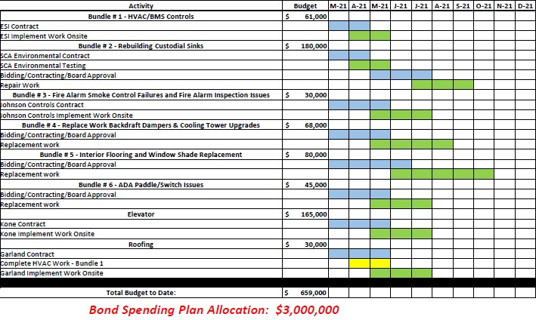  Q&A  John Nguyen’s Question: Is there any additional input you need from this committee?  Keith Kajiya’s Response: Nope. However, we do need to create a routine cycle with this committee to continue providing updates.  Bob Parks’ Response: We should meet each meeting when the Design Build Team comes on board for Milvia Street because they have requirements they have to go through on the Milestone Acceptance Form at each phase so we want to regularly communicate with this committee so everyone can be aware of exactly where the progress of the design is.  Thomas Kies’ Question: A lot of work has been done with Town Halls with the last design. Are we using that as the starting base and then building form that or are we starting from scratch?  Bob Parks’s Response: We continued to work with Noll & Tam Architects who developed the initial design concepts, programming, and layouts as our basis of design. In meeting with President Dr. Garcia, she does not want to start from scratch so once the design team comes on board, we’ll start exactly where Noll & Tam left off.
3. Return to Campus District Proposal – Acting VC, Atheria Smith | Acting VC, Atheria Smith was not able to attend today’s meeting.  Acting VC, Dr. Ronald McKinley’s Update  The EOC met yesterday and we have vetted a vaccine plan. It will be sent out to the shared governance groups soon to get input. We have also vetted a COVID-19 Prevention Plan. DGS and HR will be working on the final Return to Campus Plan which will also be going through the shared governance groups for input. The EOC will be meeting weekly now.  Ava Lee-Pang’s Recommendation: We should combine the Health & Safety Committee and Facilities Committee to start a Return to Campus task force. We need a plan in place.  Scott Barringer’s Concern: Have we started compiling lists for specific challenges that we’re going to have so that we can start trying to resolve some things.  John Nguyen’s Question: Can you please share the vaccine plan with us?  Dr. McKinley’s Response: We’ll develop an approach where you’ll be able to tell us when you got the vaccine and how many doses depending on the company vaccine you have received and HR will manage that. We’re looking to do a self-assessment before you come to work every day and that’s done on your phone/computer/iPad, etc. If you pass, you’ll have a green screen and you’ll be able to come right through screening. No one is required to take the vaccine right now because categorized for emergency use. But once that changes and it becomes for regular use, then the District will require folks to get it unless they can decline it under sincerely held religious beliefs or medical reasons. We were going to require N95 masks. However, we’re not qualified to do fit testing. We will still have N95 masks available to everyone. This plan will be presented to everyone this week and our goal is to have it on the April 27th Board meeting for their approval.  John Nguyen’s Question: Are students required to get vaccinations?  Dr. McKinley’s Response: We’re going to strongly encourage students to get it. However, no one is required to get it right now because it’s under emergency use. But we’ll be tracking student vaccinations in addition to staff.
4. Combining the Facilities and Health & Safety Committee – John Nguyen | Combining the Facilities and Health & Safety Committee Discussion  Brenda Johnson, Ava Lee-Pang, and John Nguyen met to discuss the possibility of combining both the Facilities and Health & Safety Committee together for now, as needed due to the overlapping topics/discussions especially during this pandemic. The frequency and duration of meetings will be determined by the needs of our college.  Narrative Context  - Why do we have Facilities and Health & Safety Committee?  - Facilities and Health & Safety are interconnected with each other.  - Facilities look at the stability and integrity of the building. Due to COVID-19, there has been a push to combine Facilities and Health & Safety to ensure the safety of our staff and students when we return to campus.  - Scope of Facilities and Health & Safety Committee: Make recommendations to College Roundtable  - How (closing the loop) – goes to Roundtable and recommendations get routed to the College President.  - Tri-chair model:  - Shared leadership: Rationale for Tri-chair model to lead the work of the committee.  - Chairs would share and communicate the needs of the college to the District and the three Senates.  - Facilities and Health & Safety Committee make recommendation to the College Roundtable to change chair model from co- to tri-chair model to ensure efficiency and widespread sharing of information.  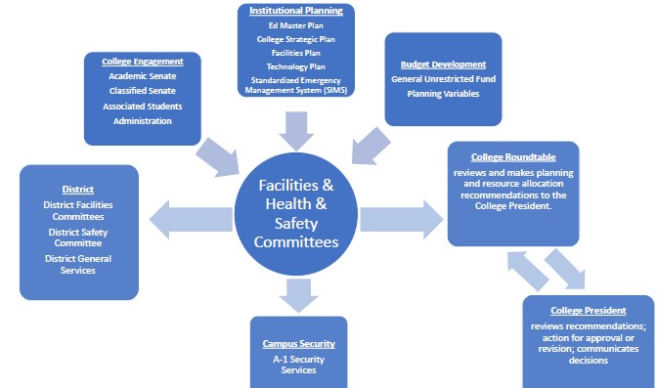  Sergio Mazariegos’ Question: Will this be a temporary change?  Brenda Johnson’s Response: No, it’ll be permanent.  Motion: Ava moved to combine the Facilities and Health & Safety Committee.  Second by: Michael Alvillar  Votes in favor: 7  Opposed: None  Abstentions: 4 – Natalia Fedorova, Thomas Kies, Scott Barringer, & Charlotte Lee  Motion passed.
5. Reopening Readiness – Natalia Fedorova | Berkeley High School has a dashboard with updates and checklists to prepare for in-person learning. It may be beneficial to do something similar and customize it to BCC’s needs. We should get a team together to start on this list because Science Labs plan to start in the Summer and Fall. It will be critical to address student, faculty, and staff concerns on returning to campus. This can also be created by a task force when we combine the two committees. We should have something in writing by the end of the semester. John Nguyen will bring this up to Roundtable on Monday and hopefully we can move forward with this at our next meeting.
6. Adjourn | 1:29pm

