Berkeley City College – Facilities Town Hall
New Building Update & Feedback
October 9, 2020
Zoom Meeting
Participants
1 | Shirley Slaughter (Host) | 24 | Kuni Hay
2 | Joe Bay, AV (Co-Host) | 25 | Lev Komraz
3 | Aidan Carter | 26 | Lisa Cook
4 | Andrea Williams | 27 | Lisa Cralle
5 | BCC Bookstore | 28 | Loan Nguyen
6 | Bobby Birks | 29 | Mang-Ling Cho
7 | Brenda Johnson | 30 | Marilyn Montague
8 | Cynthia Reese | 31 | Martin De Mucha Flores
9 | Charlotte Lee | 32 | Mary Clarke-Miller
10 | Elinor Chin | 33 | Midhun Joseph
11 | Felicia Bridges | 34 | Nancy Cayton
12 | Iva Ikeda | 35 | Nghi Dong
13 | Jasmine Martinez | 36 | Ramona Butler
14 | Jennie O’ Shaughnessy DeLeon, ASL Interpreter | 37 | Roberto Gonzalez
15 | Johnny Dong | 38 | Roger Toliver
16 | Jennie Braman | 39 | Sam Gillette
17 | Joanna Louie | 40 | Sharon Serrano
18 | John Pang | 41 | Stacey Shears
19 | Joseph Bielanski | 42 | Thomas Kies
20 | Joshua Boatright | 43 | Vanessa Phillip, ASL Interpreter
21 | Joya Chavarin | 44 | Vincent Koo
22 | Joyce Van Valkenburgh | 45 | Yolanda Young
23 | Karen Croley
Guest Speakers
1 | Keith Kajiya, Bond Program Manager, AECOM | 3 | Ned Reifenstein, Noll & Tam Architects
2 | Bob Parks, Project Director, Kitchell CEM | 4 | Merideth Marschak, Noll & Tam Architects

Agenda Item | Discussion
Call to Order | 12:30pm
Topic | Planning for Design/Build Request For Proposal (RFP)  New Building: 6 Floors  Added Area: 60,000 Gross Square Feet (GSF)  Future Renovation at 2050 Center Street
Overview | Meeting Goals:  - Project Update  - Schedule  - Cost  - Design/Build Procurement  - Reconfirm Project Goals  - Information for the Design Criteria documents provided to the D/B (Design Build) Teams
Project Update- Schedule | 30 -> 60 -> 90 Day Look Ahead  The design build procurement processes an active phased delivery procurement. Noll & Tam issued a Request For Qualifications (RFQ) out to the industry where they ask design build teams to submit their qualifications for this project. The Statement of Qualifications are currently due November 6, 2020. They will be scoring those statement of qualifications and shortlisting to the top three pre-qualified highest-scoring design build teams. From there, they’ll be getting into the RFP phase. Bob Parks will be working with the college on the selection committee where they’ll be developing a panel of panelists that will be participating in the interviews for December 15th and into late January 2021.  Long Range Look Ahead  Activity Target Dates TBD  Design-Build BOT Approval & Contract Award February-March 2021  Collaboration and Project Validation Phase¹ April-June 2021  Design Phase² June-February 2022  Division of the State Architect (DSA) Review February-December 2022  Construction Phase December 2022-October 2024  Closeout and Project Occupancy October 2024-December 2024

Project Update- Cost | 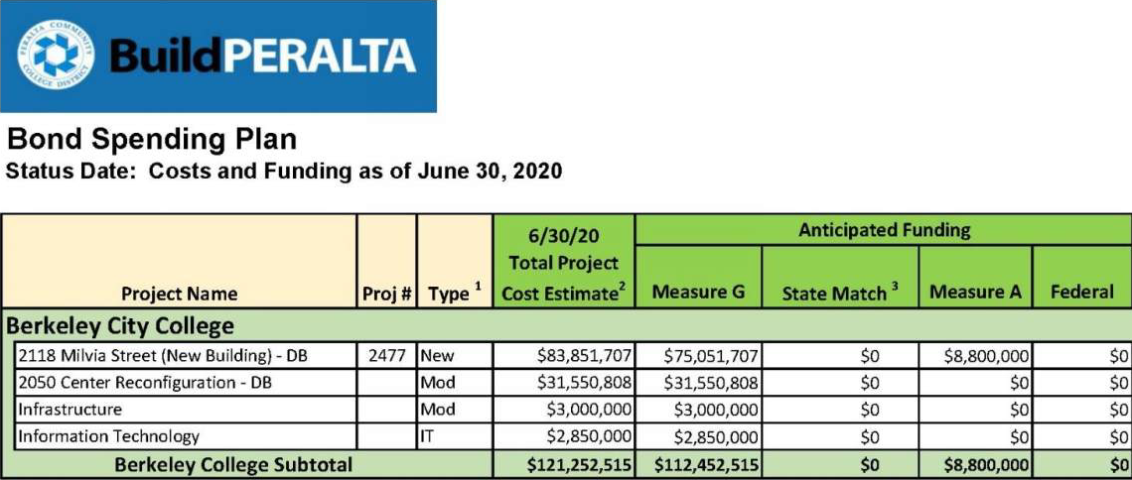  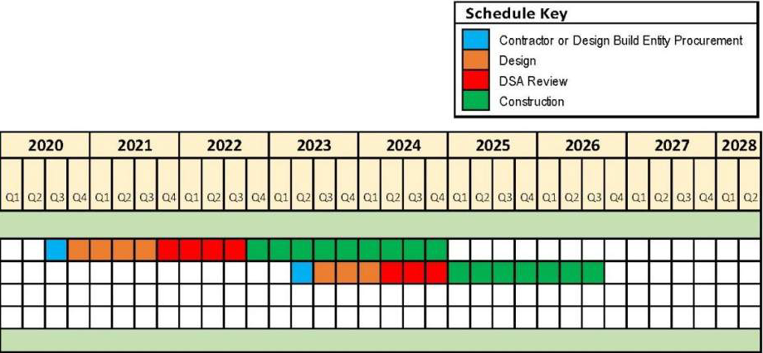
Project Update- Design/Build Procurement | We are going with the Design-Build Project Delivery method because it is a collaborative team approach where we’re able to, as the District and the College, to bring on a single team of the contractor and architect together as the same time. It creates the collaborative team approach where we’re able to work with both the contractor and designer from the start versus the traditional method of where we would design the building and then go out for bid.  Design-Build Considerations  - Benefits: single point of responsibility, fastest delivery, most cost effective, construction input during design, reduced management oversight.  - Limitations: requires up-front program design criteria, District must make timely decisions, less control by District on design details.
Reconfirm Project Goals/ Space Program | - Two buildings to create a single campus (not to have an annex or outpost)  - Increase general classroom space (quantity and size)  - Increase library & learning resource center spaces  - To be unified, welcoming, active, flexible, healthy, sustainable  - Increase office space for Full- and Part-Time Faculty & Administrative Offices  - Art Studios  - Outdoor Roof Space  - Support student success  - Health Center  - Veterans  - Bookstore  - Multi-Center/Learning Communities  - Student Lounge/Study Space  - Future project – 2050 Center Street (Targeted Remodel) Renovation Footprint- Approx. 27,700 GSF  - Expand STEM labs  - Classrooms  - Expand library  - Improve faculty offices  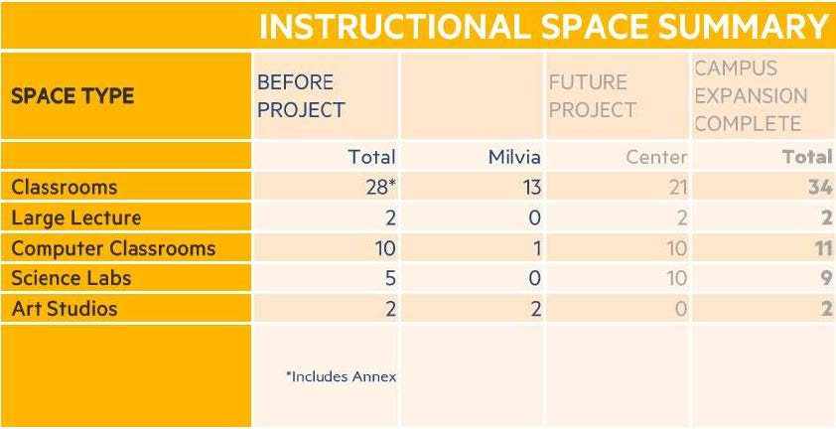
Information for the Design Criteria documents provided to the D/B (Design Build) Teams | Noll & Tam has gathered what they’ve learned over the years into materials they can give to the teams so they have some idea of what they can produce for us. These documents include the Program Summary and Room Data Sheets. The Program Summary document lists all the space, quantity, and some basic requirements for them. Each of those spaces will have a room data sheet which provides more detail about what those spaces will be.  First Floor Plan  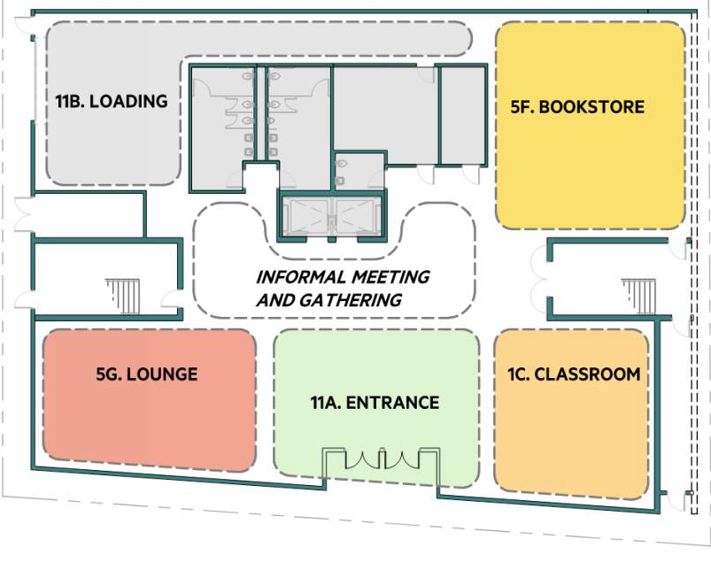  Second Floor Plan  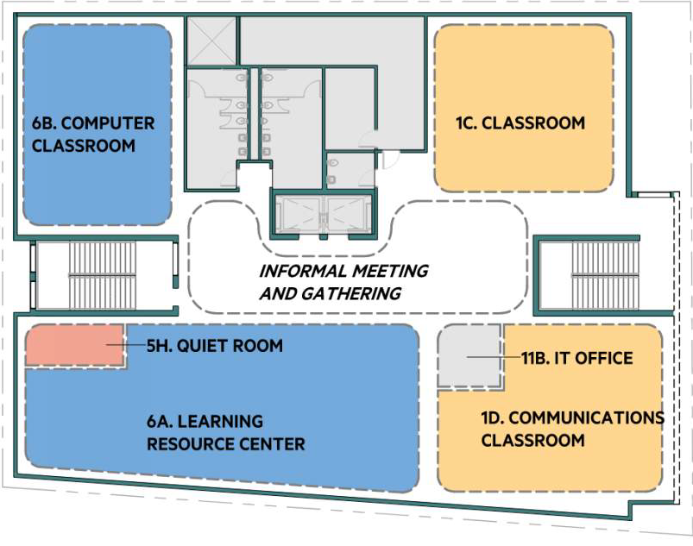  Third Floor Plan  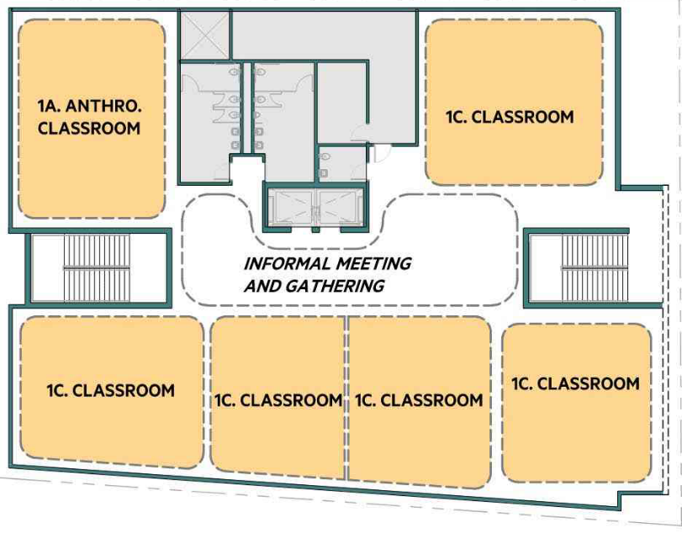  Fourth Floor Plan  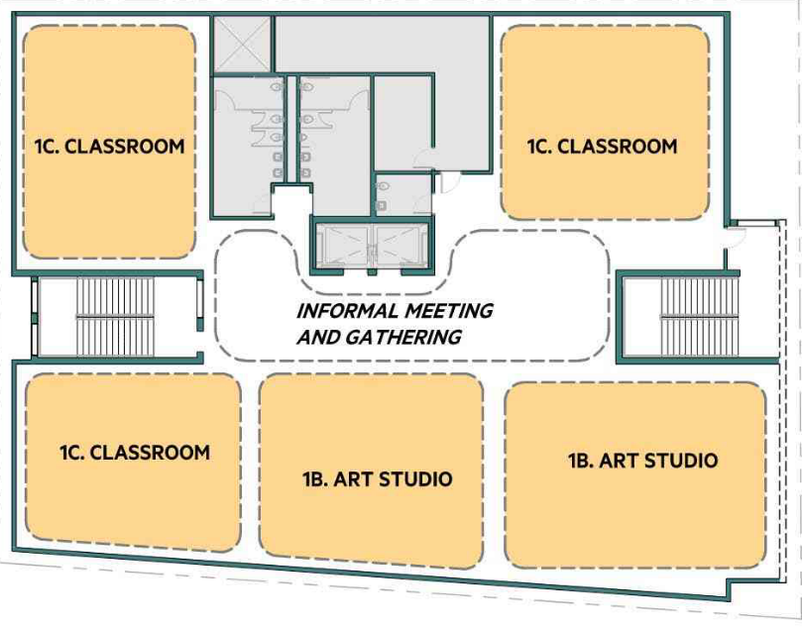  Fifth Floor Plan  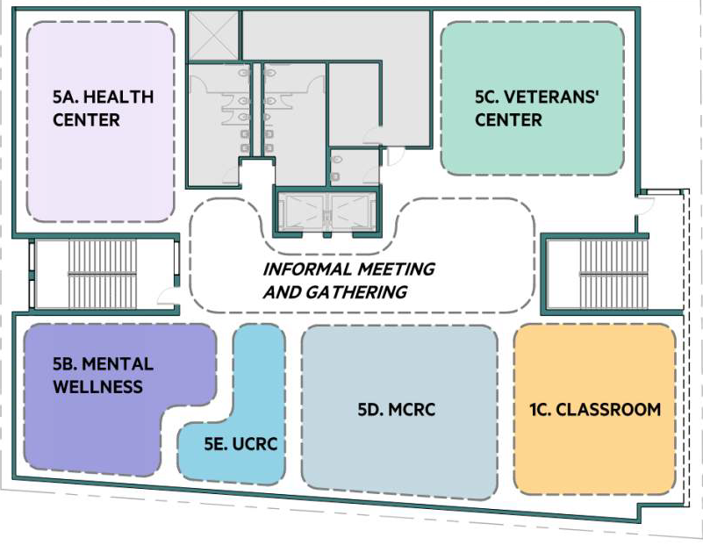  Sixth Floor Plan  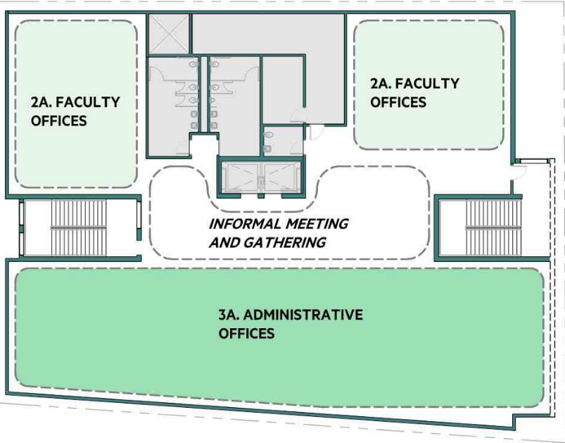  Seventh Floor Plan  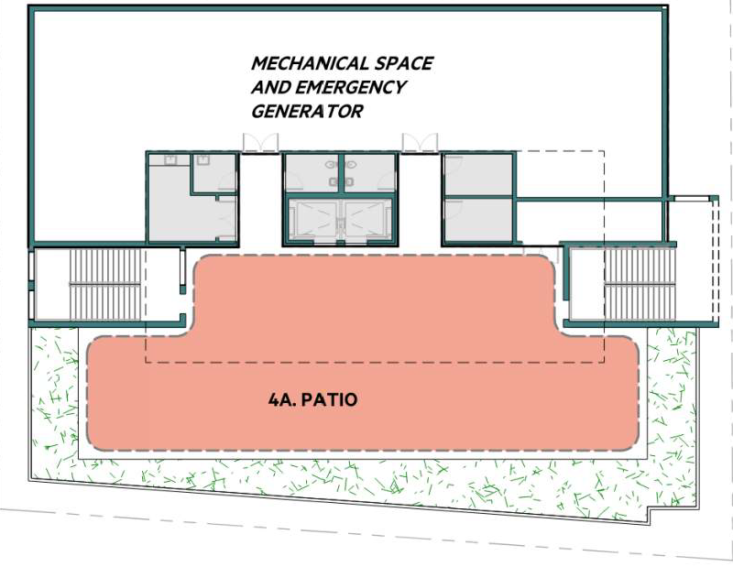
Q&A/Comments | Vincent Koo: Does the approx. $84M include all IT / network infrastructure & equipment, AV infrastructure & equipment, security infrastructure & equipment, user computer equipment, phones, HVAC control workstation, and other computer and technology related resources for admin and instructional purposes? And medical equipment for the Health Center?  Bob Parks: Yes, within the $84M total project budget, we have broken down into what the design build entity or design build teams budget would be. About 6% of the $84M is for furniture, equipment, and IT infrastructure items.  Nancy Cayton: I see classroom 1C next to the entrance and informal meeting area. Will that be too noisy?  Merideth Marschak: Noise is going to be an issue on every floor because that center area linking the elevators and stairs will be heavily used by students. It is a potential source of noise so one of the design criteria is going to be a specific discussion on what should the construction of walls and doors be for classrooms and adjoining public areas.  Aidan Carter: Nancy, that depends on the noise-dampening quality of the walls and how effective the ventilation is. If the classroom can be kept at a decent temp with good airflow, then the door can stay closed, which cuts the noise by a lot. If not, then yes, it would get too noisy at certain times of the day.  Joe Bay: Distance Education would like to propose a testing center/Proctoring location for online classes and a MINI Video Studio for creating content for online education production.  Merideth Marschak: It is not included in our current design. However, we could consider details programming in the computer lab area. That could at least potentially meet some of these desires.  Joe Bay: Yes, for B, that would be a great opportunity to put some lecture capture and more state of the art equipment. The need is particularly acute with all our online learning and if online classes continue, we can be part of a network of proctoring.  Vincent Koo: Each instructional space (classroom/ science lab/ computer lab) requires an instructor station for computer, doc cam, AV, assistive listening equipment, etc. With reference to 2050 Center, this station gets power, data, and AV via the floor.  Merideth Marschak: We typically would anticipate there being a location where there would be an audio visual type box for an instructor station.  Martín De Mucha Flores: I really think the first floor needs to be more welcoming. We want to create a more welcoming and inclusive space, just having a classroom with security and a bookstore really misses that mark.  Shirley Slaughter: We talked about putting the security around the corner and not in the front.  Merideth Marschak: Yes, formal security would be to the side with an office and the first view would be the area that student ambassadors occupy.  Iva Ikeda: 1. I am curious about lighting system… is it Deaf-friendly? Some people (students or teachers) have interpreters in a classroom or meeting room— they need good lighting so to see interpreters clearly without reducing screen visibility (slides, movies, etc.). Need good light switch system, too.  2. Light switches near teacher’s platform so s/he can turn it on/off instead of walking to entrance/exit doors.  3. Podiums or AV table sometimes block students’ view from teachers, other students, or screens. Will they be adjustable?  Shirley Slaughter: We want to make sure we have the infrastructure that will allow us to press a button and say lockdown or that there’s something that our vision or hearing impaired instructors will be able to see if there’s a fire alarm going off.  Merideth Marschak: This is an area where more detailed programming with everyone would be valuable to make it work. Going to fire alarms, modern ones have a visual component in the building like this. The fire alarm would have a strobe in addition to the audible alarm. But we should talk about the other type of alarm systems that make an announcement. These are great topics and we will include them in our write-up for the proposers.  Martín De Mucha Flores: There should be services and resources that students can get program support or immediate resources.  Joe Bay: Put the IT office next to the window please 11B  Lisa Crallé: Can Studio Art classes use the roof space for classes?  Shirley Slaughter: We can discuss this at a later date.  Aidan Carter: will there be backups available for access upper floors when the elevators go out?  Merideth Marschak: We’re aware that BCC has elevator issues in the 2050 Center Street building. We will have two elevators serving a smaller building and in an event of a power outage, these elevators will have emergency operations so they will be able to go up and down even if the power is out, due to the height of the building, which is a code requirement. As far as service, these two elevators are large in size where it’s gurney accessible.  Jennie Braman: I'm wondering about natural light for the studios, given the orientation and proximity to other buildings.  Lisa Crallé: If it’s possible to have skylights or transom windows for the Art Studios, that would be ideal so we can have good natural light as well as wall-space for students to display their artwork during critiques.  Shirley Slaughter: This concern is being expressed and we will ask about this during the build.  Vincent Koo: Is the IT Office for IT/AV staff? Where are IT closets (MDF/IDF) for IT/data infrastructure, data cabling (vertical/ horizontal), network equipment, backup power, etc.? Where are the electrical closets/ panels?  Shirley Slaughter: You may recall in our last year’s discussion, we talked about moving the IT and AV offices to the classrooms located in the basement of 2050 Center Street. There would be one IT person at the new building.  Merideth Marschak: We do have an IT office located on the same floor as the Learning Resources Center and the computer lab classroom. That would be a good space for IT personnel.  Stacey Shears: @Martin maybe a café type thing on the 1st floor without the food services...like bistro feel?  Martín De Mucha Flores: Yes, open like how you get support at apple, someone walks in you get greeted and asked what they can help you with or answer questions  Lisa Cook: I recall a COMM lab was part of the COMM classroom before but now there is an IT closet there. The COMM lab is really important.  Merideth Marschak: We have been debating about the level of detail as we develop these diagrams on what to show and not show. The lab is intended to remain and we have identified it in the space program but not showing in the diagrams. That’s something we should more clearly reflect on this diagrammatic plan.  Martín De Mucha Flores: Include an internal public announcement system  Joe Bay: Public announcement can be integrated into the clocks  Martín De Mucha Flores: That includes audio and visual messages  Vincent Koo: In addition, each projector location requires power & data at ceiling for the projector and AV system.  John Pang: Will there be a key card system to minimize the use of metal keys?  Merideth Marschak: Yes, we need to have a detailed conversation on this. We have to decide which rooms get the extensive key cards and which ones will get a metal key. If we can gather that information, we can include it in our write-up.  Vincent Koo: What is MCRC?  Merideth Marschak: Multi-Cultural Resource Center.  Vincent Koo: Art studios seem to need spot lighting as well.  Joya Chavarin: Can the science labs have windows that open?  Lisa Crallé: Thanks @Vincent, it would be great if we had a flexible lighting system in the art studios, since Painting classes require different lighting than Figure Drawing or 3D Design. It would be great if the Studio Art instructors could adjust the lighting (making it directional as needed).  Ramona Butler: What is a multi-cultural resource center?  Merideth Marschak: We created that space to gather up the many programs.

