Present: Carlos Cortez (Co-Chair), Johnny Dong, Joe Doyle, Windy Franklin, Sam Gillette, Vincent Koo, Ralph Smeester, Colette Cussary for John Pang, Cynthia Reese

Guests: Nancy Cayton

Absent: Joshua Boatright, Jennie Braman, Ramona Butler, Willard Cheng, Pieter DeHaan, Mostafa Ghous, Roberto Gonzalez, Richard Lee (ASBCC),
Lynn Massey, Kelly Pernell, Shirley Slaughter (Co-Chair),

Recorder: Joanna Louie
Agenda Item | Discussion | Follow-up Action | Decisions (Shared Agreement/Resolved or Unresolved?)
Call to order | Call to order- 12:23pm  Facilities Committee 2014-2015 Schedule handout distributed- please mark your calendars!  - Friday, October 3, 2014 12:15-1:30pm room 451  - Friday, November 7, 2014 12:15-1:30pm room 451  - Friday, December 5, 2014 12:15-1:30pm room 451  - Friday, February 6, 2015 12:15-1:30pm room 451  - Friday, March 6, 2015 12:15-1:30pm room 451  - Friday, April 3, 2015 12:15-1:30pm room 451  - Friday, May 1, 2015 12:15-1:30pm room 451
Review of Schedule Deferred Maintenance (Ralph Smeester- 5 minutes) | - (Fire) Repair of smoke dampeners- in progress  - (HVAC) Replace two bad Delta controllers- completed  - (HVAC) Replace boiler water feed valve- working fine right now  - (HVAC) Replace Delta computer-installed in 2005, Vincent in process getting us a new one (acquisition in progress)  - (HVAC) Repair VAV controllers (not communicating) and replace bad actuators- completed  - (HVAC) Replace five ABB VFDs face monitors (control screens)- working now  - (Plumbing) Repair leaks on Domestic Water Line- in progress  - (Window) Replace exterior window classroom 216- in progress, will be done during Christmas break  - (Fire System) Replace leaking valve to maintain pressure- in progress  - (Flooring) Replace laminate floor in room 31, 32, 33, and 34- completed  - (Doors) Rebuild front door hinges, and fire control mechanism- in progress  - (Window) Auto shade classroom 212 circuit board replacement- looking for funding  - (HVAC) Replace air compressor- completed  - (Generator) Backup generator annual service, inspection, & load test- in progress  - (Plumbing) Replace bladder tank for domestic water supply- replaced mains ones, in progress  - (Fire) Simplex recommended fire sprinkler repairs- in progress  - (Elevators) Repair bent control panel in freight elevator- completed  - (Plumbing) Repair water filter system- in progress  - (Elevators) Replace flooring- Ralph not sure what is going on w/ this  Carlos would love to see the window cleaned. Ralph says out for bid and he escorted 3 different vendors on campus but no action yet.
Discussion- Facilities Committee 2014 Goals & Activities (Group- 30 minutes) | Packet of slides distributed- came from Town Hall Meeting 9/24/14. Identifies our 2024 vision and Ed. Master Plan: Eliminate the Achievement Gap & Advance Student Access, Equity, and Success.  Slide pg. 16- Big Audacious Goals to Eliminate the Achievement Gap  - Ensure ALL new, first time to college students (approx. 3000 students/year):  - Enter a program of student by their second semester  - Complete 20 transferable units or a stackable certificate by the end of their first year  - Are a part of at least one outside of the classroom learning environment on campus (i.e. learning communities, student life, student support programs, etc.) or working off campus  - Ensure ALL students have at least 70% successful course completion  Slide pg. 17- Planning for action to eliminate the achievement gap  - Shared governance connects all:  - Annual Program Updates and Action Plans & Reports (every year)  - Program Review & Action Plans (every 3 years)  - Accreditation Self-Study and Action Plan (every 6 years)  - Ed Master Plan (every 10 years)  Slide pg. 18- How do all these plans and reports connect to our Big Audacious Goals?  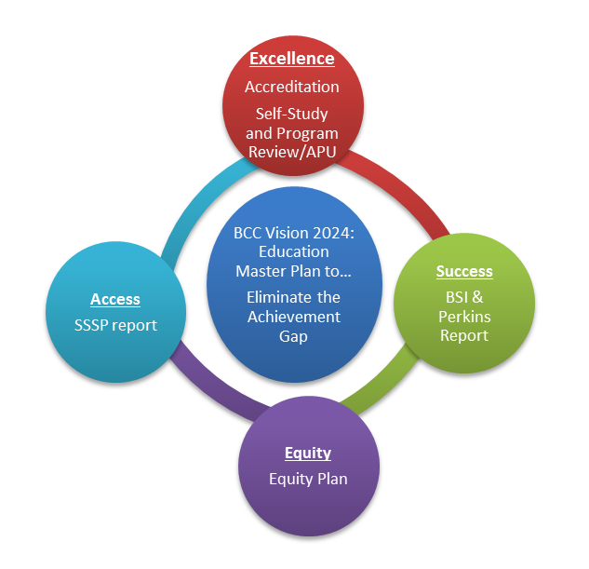  Slide pg. 19- Timeline for Fall 2014 Planning (this illustrates the process of writing these reports)  - Information Gathering & Collaborations Aug/Sept  - Pull previous reports/assessments/reviews  - Facilitated conversations & information gathering  - Writing Sept/Oct  - Compose the report/plan  - Designated writers  - Vetting Oct/Nov/Dec  - To shared governance (October)  - Board (Nov/Dec)  --------------------------------------------------------------------------  2014-2015 Goals & Activities handout distributed-  BCC’s Institutional Goals:  - Goal 1: Preserve and nourish resources to ensure access, equity and success for all students.  - Goal 2: Increase certificate/degree completion and transfers to 4-year colleges or universities by inspiring and supporting students.  - Goal 3: Improve career and college-preparation progress and success rates.  - Goal 4: Ensure BCC programs and services reach sustainable, continuous quality improvement level.  - Goal 5: Collaborate to ensure fiscal stability.  Facilities Committee Proposed Activities:  - Initiate a 5-year rotating campus renovation and repurposing plan that ensures safe, clean, and functional facilities (for Goals 1, 4, and 5)  - Spearhead development and implementation of the transition plan for acquisition and renovation of BCC facilities to ensure student success and close the equity gap (for Goals 2 and 3)
Other |  | Agenda items to add to next meeting:  - Card readers- Lennox? system (replaced Johnson Controls)  - Library cameras  - Check-in regarding fire extinguishers in the chemistry & science labs
Adjourn | Adjourn- 1:10pm

