Chairs Council
Date: March 24, 2023
Location: Zoom
Zoom Link: https://us06web.zoom.us/j/95403090667
Time: 1:30-3:30
Chair: Claudia Abadia
Mission: Berkeley City College’s mission is to promote student success, to provide our diverse community with educational opportunities, and to transform lives. The College achieves its mission through instruction, student support and learning resources, which enable its enrolled students to earn associate degrees and certificates and to attain college competency, careers, transfer, and skills for lifelong success.
Vision: Berkeley City College is a premier, diverse, student-centered learning community, dedicated to academic excellence, collaboration, innovation and transformation.
Charge: Keeping in mind BCC’s mission, vision, values, and learning outcomes the Department Chairs Council will serve as the leadership advisory group for matters related to:
- schedule and program development
- enrollment management
- faculty hiring
- administration of the instructional units including facilities, technology, assessment, and curriculum
- policies, practices, procedures and processes as they pertain to department affairs

Members of Chairs Council

_x_American Sign Language - Jenny Gough  _x_Arts, Humanities, Cultural Studies - Carolyn Martin  __Arts, Humanities, Cultural Studies – Ari Krupnik  __CIS/Business/Econ: Paramsothy Thananjeyan  __Counseling – Catherine Nichols  _x_English - Adán Olmedo  _x_English - Jenny Lowood  _s_ESOL – Sepi Hosseini | _x_Library - Heather Dodge [Jenny Yap sub]  _x_Math – Claudia Abadia  _x_Modern Languages - Fabian Banga  _x_MMART – Justin Hoffman  _x_MMART – Dru Kim  _x_Science/Bio/Chemistry - Pieter de Haan  _x_Science/Bio/Chemistry - Sam Gillette  _x_Social Sciences - Tim Rose  Also in attendance:

Agenda:

Time | Agenda Topics | Facilitators | Minutes/Notes
1:30-1:40 | Welcome – Check In  Approval: Agenda and Minutes from 3/10/23 | Claudia | Minutes from March 10 approved unanimously, except for 1 abstention.  Motion to approve agenda passes unanimously.
1:40-1:55 | Mental Health First Aid Class Discussion | Tim | On behalf of Melina Winterton, Tim proposes mental health first aid training in the fall. This would be an eight-hour training; participants would receive stipends, as would the trainers; there would also be a small cost for materials. Tim is hoping for support from chairs to spread the word about this training. Tim hopes that chairs will contact the members of their departments to offer information about this and will then send names of interested faculty members to Tim and Melina. It would be helpful to have twenty names of interested faculty members; this would make it likelier that the training will happen.
1:55-2:05 | 23-24 Chairs allocation = 3.5 FTE  - Release of department chair allocation  Election process and timeline | Kuni/Lisa/Chris | The overall allocation for department chairs at BCC is roughly the same as it was last year.  Kuni shared the formula by which the chairs’ release time was calculated.  There was discussion about whether the chairs should discuss and possibly make suggestions about changing the formula. It was agreed that the chairs should do this work well as early as possible before the end of March for the next cycle.  The election is to take place between 4/1 and 5/1 this year.  Claudia will send nomination forms out on Monday, April 3.  All nomination forms will be returned to our PFT rep (Justin Hoffman) by 4/12.  Elections will occur between 4/17 and 4/25.  Election results will be validated by 4/26-28 and results announced by 5/1.  We’ll elect the new Chair of Chairs in the Chairs’ Council by 5/12.  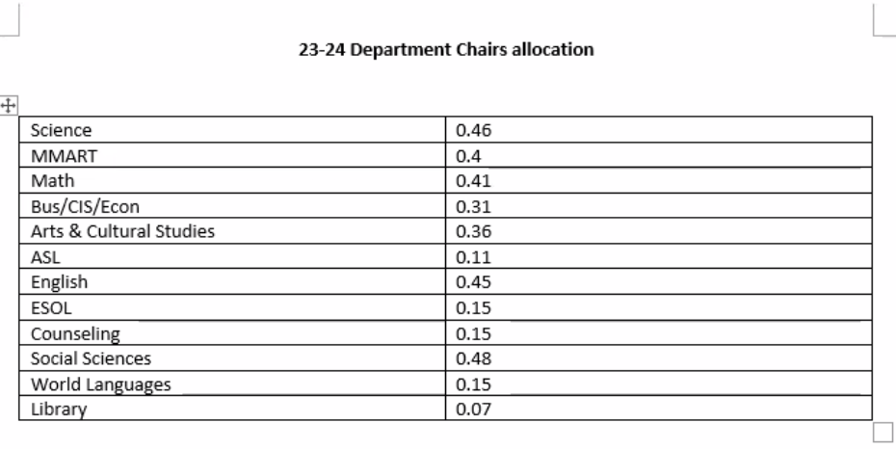
2:05-2:15 | Enrollment update | Kuni | Kuni shared a BCC enrollment update for Spring 2023. She thanked the faculty for their enrollment management work. She also discussed what information we need to research in relation to student success, bearing in mind the increases in online courses over the years since the inception of the pandemic.
2:15 | Announcements  Next Meeting: April 14, 2028 | Claudia | There were no announcements.
2:20 | Meeting Adjourned | Claudia | Meeting adjourned 2:52.
Meeting adjourned: 2:52
Minutes taken by: Jenny Lowood

