Proposal
Faculty use CurriQunet to create new course outlines and update course outlines. We should revise the textbooks area in CurriQunet to bring more attention to Open Educational Resources and Zero Textbook Cost options.
This is the field in CurriQunet where faculty input examples of textbooks used for their courses: 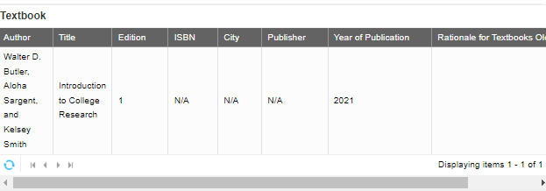
I propose that Zero Cost Textbook(s)/Open Educational Resource(s) is a separate section in the textbooks area. This makes the ZCT/OER options for a course clearer. Below are a few definitions to be added to CurriQunet:
Open Educational Resources (OER) are learning, teaching and research materials in any format that reside in the public domain or are under copyright that have been released under an open license, that permit no-cost access, re-use, re-purpose, adaptation and redistribution by others.
Zero Textbook Costs (ZTC) means that there is no cost for required textbooks, workbooks, lab manuals, readers, or specialized software like online homework systems. There is a state law (SB 1359) that requires California Community Colleges to identify Zero Textbook Costs course sections.
Low Cost are materials (such as, but not limited to, textbook, workbooks, lab manuals, online homework, and required printouts) whose total combined cost does not exceed $40 for a course.
The fields can be:
Zero Cost Textbook(s)/Open Educational Resources
Author | Title | Ed. | ISBN | City | Publisher | URL | Repository | Year | Rationale for Textbooks Older than 5 years | CC License type

Borrowing language from Chaffey College, the textbook section could include these required questions:
Is there a Zero Cost textbook listed for this course? Yes/No | Is there a Zero Cost textbook listed for this course? Yes/No
Yes | No
 | Comment on why a Zero Cost textbook option is not included in the resource list.
Describe any additional strategies the department is using to lower the cost of resources students need when they enroll in this course. | Describe any additional strategies the department is using to lower the cost of resources students need when they enroll on this course.
Would you like to be contacted by a librarian at BCC who can help you find additional low-cost or free textbook options? Yes/No | Would you like to be contacted by a librarian at BCC who can help you find low-cost or free textbook options? Yes/No

Low-cost consideration
The BCC Curriculum Committee and Affordable Educational Materials Committee also supports the addition of a place to indicate that there is a low-cost option and to include a low-cost icon in the class schedule along with the ZTC icon. We must decide as a district what the threshold will be for a low-cost icon. Many colleges consider low cost to be under $40. Laney is currently drafting a resolution for their Academic Senate where they want to set their threshold at $50. The CCCCO is putting out a survey soon about low-cost thresholds and creating a low-cost icon. Our science department's home-grown lab manuals cost around $35 to buy at the bookstore so they can be under the low-cost threshold. The bookstore manager, Kiara Allen, tries to keep home-grown materials and readers under $40.

