**Access**

1. **ACCESS.** Working Collaboratively and Intentionally to Increase Equitable Access at Berkeley City College

As summarized in the Executive Summary, Berkeley City College (BCC) is utilizing an action research approach to both preparing and implementing the Equity Program. Members of the Equity Committee created five sub groups, each of them focusing on each indicator of equitable access. The Equitable Access Team (as members of this team labeled their group), met weekly from September till presently to discuss how can this college provide equitable access to all students, especially to student from underserved communities in higher education and close any inequitable access. This team was comprised of faculty, classified professionals, students, administrators and also a coordinator from Berkeley High School which is one of the major feeder schools for Berkeley City College. Members of this group, represent a wide array of skills and expertise, starting from counseling, financial aid, specialized work with foster youth, high school counseling, and direct experience with learning communities, veterans, and other student success programs.

From the onset of its work, the Equitable Access Team struggled to collect valid data and realized that the intersectionality of race, ethnicity, income, socioeconomic status, legal status in the Unites States, ability/disability, and other factors, warrant a thorough examination of data and possibly multiple data sources and methods to more reliably and validly reflect access at Berkeley City College (“Harris_The_Equity_Scorecard.pdf,” n.d., “Harris_The_Equity_Scorecard.pdf,” n.d.; Hayes & Juárez, 2012; Kozol, 2006; Tatum, 1992).

Given the critical role that community colleges have in increasing educational attainment in the United States, and provided that community colleges are the first entry to higher education for underserved higher education, the team felt that there was an urgency to dig deeper into a more meaningful data that would ensure equitable access.

More precisely, according to the 2014 Fact Sheet generated by the AACC (2014), 45% of all undergraduate students in the United States attend community colleges and 12.8 million students nationwide select one of the 1,132 community colleges to meet their educational goals, either earning a certificate or degree or transferring to a 4-year institution. In addition, according to this report, respectively 59%, 56%, and 48% of all Native American, Latino, and African American undergraduate students select community colleges as the point of entry to pursue their higher education (AACC, 2014).

Yet again, while community colleges have been recognized for their vital role in providing open access to higher education to a diverse student body, this open access warrants further examination to safeguard that community colleges, and especially BCC, provides equitable access to students who would never be able to attain a higher education if it was not for the community college (Kantor & Lowe, 2011).

Based on the crucial importance of equitable access, Berkeley City College and specifically the Equitable Access Team used the ethnicity of students in feeder high schools in the service area to the ethnicity of incoming college students at this college as a more reliable and valid measurement of the access at Berkeley City College. This analysis was utilized to better reveal the underserved groups in our community. In addition, to provide a more longitudinal approach to our research and data, BCC focused on longitudinal data to capture the current success and highlight areas for improvements.

**CAMPUS-BASED RESEARCH: ACCESS**

Table 1

Proportionality of ethnicity of students in **top 10 feeder high schools** **(AY 2012-2013)** to students enrolled at Berkeley



Table 1 reveals that during the 2013-2014 academic years, there was a disproportionate impact for Asian, African American, Filipino, Pacific Islanders, and Hispanic population. This table also reiterates the complexity of finding valid data especially when one considers the fluid definition of race and the major increase of the two or more race category and the unknown category. Based on last year’s intentional efforts to increase equitable success, one can clearly see from Table 2 that there has been a significant improvement in the area of increasing access for African American, Asian, and Hispanic students.

Table **2**

**First time students from top 10 feeder high schools at Berkeley (AY 2014-2015)**



Table 3

Percentage Change in the Proportionality Index by Race/Ethnicity

|  |  |  |  |
| --- | --- | --- | --- |
| **Target Population(s)** | **Prop. Index 13/14** | **Prop. Index 14/15** | **Gain or loss in proportion (%)** |
| Asian | 0.63 | 0.91 | 44.50 |
| Black/African-American | 0.64 | 0.85 | 33.77 |
| Filipino | 0.37 | 0.69 | 86.39 |
| Hawaiian/Pacific Islander | 0.36 | 0.24 | -32.82 |
| Hispanic | 0.42 | 0.61 | 45.37 |
| Native American | 0.00 | 0.59 |  |
| Two or More Races | 4.98 | 5.15 | 3.40 |
| Unknown | 3.85 | 4.22 | 9.63 |
| White | .74 | 1.05 | 42.14 |

Despite, major improvements in increasing the access for all the disproportionately impacted groups, there is still clear a need for more intentional efforts to increase the access for African American, Native American, Hispanic, Filipino and Hawaiian/Pacific Islander students at BCC.

To measure the inequitable access for the purpose of developing goals, activities and evaluate future progress, BCC decided to measure the gap by comparing all racial/ethnic groups to the White population. Measuring the access of the White population as a point of reference, Table 4 displays the gap.

Table 4

*Point Gap in Equitable Access for Race/Ethnicity Participation at BCC*

|  |  |
| --- | --- |
| **Race/Ethnicity** | Gap 2014-2015 |
| Asian | -0.14 |
| Black/African-American | -0.2 |
| Filipino | -0.36 |
| Hawaiian/Pacific Islander | -0.81 |
| Hispanic | -0.44 |
| Native American | -0.46 |
| Two or More Races | 4.1 |
| Unknown | 3.17 |
| White | 0 |
| Total |  |

**GOALS, ACTIVITIES, FUNDING AND EVALUATION: ACCESS**

**GOAL A**

The goal is to improve access for the following target populations identified in the college research as experiencing a disproportionate impact:

|  |  |  |  |  |
| --- | --- | --- | --- | --- |
| **Target Population(s)** | **Current gap, year** | **Goal\*** | **Goal for 2018** | **Goal Year**  **2024** |
| Asian | ***-.14*** | ***0*** | ***-. 07*** |  |
| Black/African-American | -.2 | 0 | _.1 |  |
| Filipino | -0.36 | 0 | _. 18 |  |
| Hawaiian/Pacific Islander | -0.81 | 0 | _. 4 |  |
| Hispanic | -0.44 | 0 | _. 22 |  |
| Native American | -0.46 | 0 | _. 23 |  |
| Two or More Races | 4.1 | 0 |  |  |
| Unknown | 3.17 | 0 |  |  |
| White | 0 |  |  |  |

**ACTIVITIES: A. ACCESS**

**A.1**

* ***Activity Type(s)***

|  |  |  |  |  |  |
| --- | --- | --- | --- | --- | --- |
| X | Outreach | X | Student Equity Coordination/Planning | X | Instructional Support Activities |
| X | Student Services or other Categorical Program | X | Curriculum/Course Development or Adaptation | X | Direct Student Support |
| X | Research and Evaluation | X | Professional Development |  |  |

* ***Target Student Group(s)*** & # of Each Affected*:

|  |  |  |  |
| --- | --- | --- | --- |
| **ID** | **Target Group** | **# of Students Affected** |  |
| A.1 | African American / Hispanic/ Filipino/ Native Americans/Hispanics/Hawaiian and Pacific Islanders |  |  |

The Equitable Access team engaged in an intentional inquiry and assessment to understand some of the data, and reasons why students of color would have more limited access to Berkeley City College. The discussion contributed to an action plan that would be both preventive and empowering. The President of Berkeley City College facilitated some of the discussions and created the bigger vision of establishing seamless pathways from high school to college. An outcome of these discussions was that a variety of activities intentionally designed to increase equitable access will be needed, and community partners, parents, high schools and other community organizations will be the key to us reaching out goal. To that end, we designed a series of activities listed below. In the process, BCC reviewed and assessed current efforts, such as the Persist to College program and designed new programs and activities that would expand the success and scale up initial efforts.

High School to College Initiative- Increasing Equitable Success

1. Presentation of educational opportunities that BCC has to offer for Oakland International HS -Sep. 25, 2015.
2. Panel Presentation for FACES in Oakland -Sep. 30, 2015
3. Presentation for BHS Counseling Department and Student Support Faculty – Concurrent Enrollment opportunities and updates- October 5, 2015
4. Classroom presentations promoting concurrent enrollment opportunities and registration for BCC – October 8, 2015
5. Multiple application workshops for BUSD _ October 2015
6. Presentation to Berkeley Independent Studies parents and faculty – Back to School Night _October 8, 2015
7. Panel Presentation for BHS parents – College Night _ October 8, 2015
8. McClymonds High School – College Fair – Empower Students to Attend College by creating Seamless Pathways
9. Oakland High School – College Fair – October 13, 2015
10. Berkeley High School – BCC Info Event, presentation for parents and students – October 21, 2015 (almost 150 parents/students in attendance)/
11. Fremont High School – College Fair _ October 22, 2015
12. Albany High School – College Night Presentation to parents and students _October 28, 2015
13. Castlemont High School – College Fair _ October 29, 2015

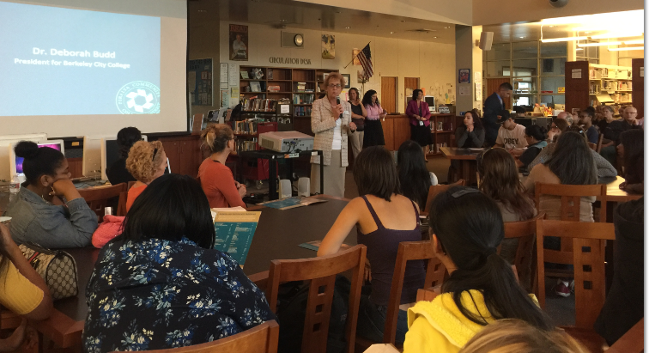

*Figure 1*: Berkeley City College Students/Parents Night at Berkeley High School, October 21, 2015

While the activities listed above are the most current activities, Berkeley City College has been intentionally designing programs and activities that will ease and equalize the access to college for all students, especially for students from underserved communities in higher education. Part of these efforts was the design of the Berkeley Scholars Summer Program that addresses the opportunity gap in higher education, and reaches out to high school students in their early years in high school to demystify college and unveil opportunities and potentials that a higher education degree can offer.

An ongoing evaluation and assessment of these efforts is happening during weekly meetings of the High School to College Initiative that intentionally is designing programs and services to increase access. A lot of thoughts and research is going into these meetings, from designing college classes offered in high schools, such as counseling and math classes, to an entire Summer Program devoted to high school students.

These efforts are aided by the voices of high school students that are captured by different student surveys, and that indicate a need of a curriculum that is enticing and empowering to high school students. Ongoing professional development is highlighted as a necessary component of scaling up efforts to provide equitable access. Issues such as race, racism, economic inequality, discrimination and poverty need to be discussed in open and culturally competent pedagogy and services are needed to shift the needle of equitable access.

Counselors as agent of change are needed in all feeder high schools to inform students of the endless opportunities that a college degree or a certificate has to offer. The most powerful guest speakers during these events have been alumni of these high schools that despite challenges were able to now attend UC Berkeley, and other universities and be successful. Peer Support is a major component of our equitable access efforts, and our Student Ambassadors and BCC Alumni are an integral part of the plan to increase access to BCC.

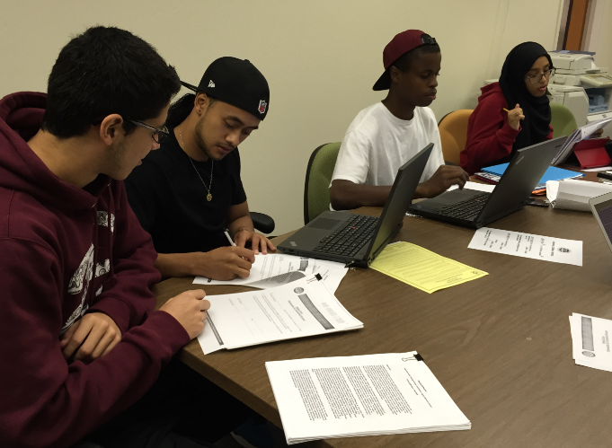

*Figure 2*: Persist to College Study Group – Fall 2015

* ***Activity Implementation Plan***

|  |  |  |  |
| --- | --- | --- | --- |
| **ID** | **Planned Start and End Date(s)** | **Student Equity Funds** | **Other Funds\*\*** |
|  | Counselor (1 FT) | $ 100, 000 |  |
|  | Counselors at High Schools | $ 20, 000 | SSSP |
| A.1 | Peer  Mentors/Alumni/Student Ambassadors |  | SSSp |
|  | Counselors Breakfast  (High School Counselors, BCC Counselors, faculty Advisers0 |  | SSSP |
|  | Research/Institutional effective Practices  (.1 FTE) VP IE  (.1 FTE) Researcher | $ 20, 000  10, 000 | SSSP  SSSP |

* ***Link to Goal***

All these activities together and ongoing will increase awareness about the community college, services offered and eased the transition of students from high school to college.

* ***Evaluation***

There is going to be ongoing evaluation of these efforts, and the Program Review and the Annual Program Units (APUs) will reflect the changes in access. These planning documents as well as ongoing meetings and assessment will guide budgetary decisions and future actions.

* A timeline of / frequency of data collection and review.

At the beginning of each semester, and annually as documented in Annual Program Updates (APUs) and Program Reviews (3 years).

**A.2 Increase Equitable Access for Foster Youth**

* ***Activity Type(s)***

|  |  |  |  |  |  |
| --- | --- | --- | --- | --- | --- |
| X | Outreach | X | Student Equity Coordination/Planning | X | Instructional Support Activities |
| X | Student Services or other Categorical Program | X | Curriculum/Course Development or Adaptation | X | Direct Student Support |
| X | Research and Evaluation | X | Professional Development |  |  |

* ***Target Student Group(s)*** & # of Each Affected*:

|  |  |  |  |
| --- | --- | --- | --- |
| **ID** | **Target Group** | **# of Students Affected** |  |
| A.2 | Foster Youth |  |  |

**Activities**

* Connected with Berkeley High’s McKinney Vento Program Director and Counselor to develop partnership and pipeline for students attending BHS to BCC
* Academic and Financial Assistance Workshop offered to self-identified Foster and Homeless Youth on October 27th. This was an excellent presentation with representation of EOPS, DSP&S, Counseling Department, Records and Admissions Department, Faculty Advisers, Interim Vice President of Student Services, Financial Aid, Learning Resource Center, and Assessment Center. Workshops such as this one will continue in an ongoing basis in collaboration with high schools.
* Connected with Dawn Moultrie at Alameda County’s Independent Living Skills Program (ILSP). BCC will have a representative at the ILSP Education Committee Meeting to learn about ILSP services and also share BCC services.
* Financial Aid Office has developed a process to flag and review Foster Youth Financial Aid files when they are submitted and expedite the processing to ensure quick disbursement to foster youth students.
* Financial Aid created a direct link on BCC’s Financial Aid site for Foster Youth to list all resources to this student population. Also uploaded Alameda County TAY Resource Guide- (Foster Youth Education and Housing Guide)
* ***Activity Implementation Plan***

.

|  |  |  |  |
| --- | --- | --- | --- |
| **ID** | **Timeline(s)** | **Student Equity Funds** | **Other Funds\*\*** |
| A.3 | Foster Youth Peer Mentors |  | Foster Youth Grant |
|  | Foster Youth ( see Foster Youth Grant) |  |  |

* ***Link to Goal***
* ***Evaluation***

**A.3 …, etc.**

|  |  |  |
| --- | --- | --- |
| **ID** | **Target Group** | **# of Students Affected** |
| A.4 | Veterans |  |
|  |  |  |

* Set up on base access to Coast Guard Island beginning in January to discuss enrolling at BCC while still on active duty and as a veteran. This will be monthly presentation.
* Connecting with outside agencies to come to Veteran's Resource Center on a monthly basis, i.e., Haven for Heroes, Operation Dignity, Oakland Vet Center, etc.
* Develop a job board for veterans
* Housing/Roommate referral program
* Online and In-class Orientation for veterans
* Develop a "social support" network
* Mentoring program - pair one current veteran with a new incoming veteran student
* Develop early alert program
* Create a "recognition program" for Faculty, Administrators and Staff who have been identified by veteran students who have shown sensitivity and provided a safe learning environment for their special population.
* Develop a veteran specific student handbook - outlining the best practices within the college and community to aid in their educational success

**A.4 Undocumented Students/Dreamers.**

|  |  |  |
| --- | --- | --- |
| **ID** | **Target Group** | **# of Students Affected** |
| A.5 | Undocumented Students/Dreamers |  |
|  |  |  |

* Provide community with workshops
  + Mental health
  + Legal
  + Applications (Dream Act, CCC Apply, AB540 forms)
* Build alliances with UCB, Berkeley Adult School, Berkeley High School and other local feeder schools
* Outreach to local community
* Establish a more permanent and visible center (not in the South Campus basement)
* Institutionalize the center with general funds; not dependent on grant monies
* Identify and train student leaders for the 16-17 year
* Develop a comprehensive website for info for Undocumented students.
* Organize a Berkeley wide conference for Undocumented peoples with UCB, BHS and BAS
* Provide more professional development activities for BCC faculty, staff, admin, students

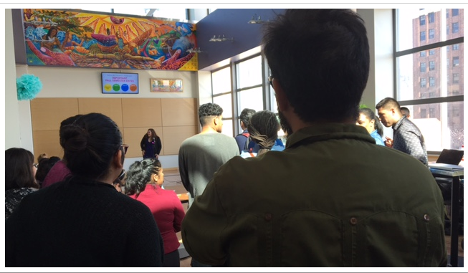*Figure 4*: BCC Undocumented Community Resource Center Grand Opening, October 22, 2015

|  |  |  |
| --- | --- | --- |
| **ID** | **Target Group** | **# of Students Affected** |
| A.5 | Student with Disabilities |  |
|  |  |  |

When one considers the issue of equitable access for students with disabilities, the access issue presents new nuances and meanings.

References

American Association of Community Colleges (AACC). (2014). 2014 fact sheet. Retrieved from http://www.aacc.nche.edu/AboutCC/Documents/Facts14_Data_R3.pdf

Alexander, M. (2012). *The New Jim Crow* (Reprint). New Press, The.

Darling-Hammond, L. (2010). *The Flat World and Education: How America’s Commitment to Equity Will Determine Our Future*. Teachers College Press.

Harris_The_Equity_Scorecard.pdf. (n.d.). Retrieved from http://www.californiacommunitycolleges.cccco.edu/Portals/0/Executive/StudentSuccessTaskForce/Harris_The_Equity_Scorecard.pdf

Hayes, C., & Juárez, B. (2012). There Is No Culturally Responsive Teaching Spoken Here: A Critical Race Perspective. *Democracy & Education*, *20*(1), 1–14.

Kozol, J. (2006). *The Shame of the Nation: The Restoration of Apartheid Schooling in America* (Reprint). Broadway.

Tatum, B. D. (1992). Talking about race, learning about racism: The application of racial identity development theory... *Harvard Educational Review*, *62*(1), 1.