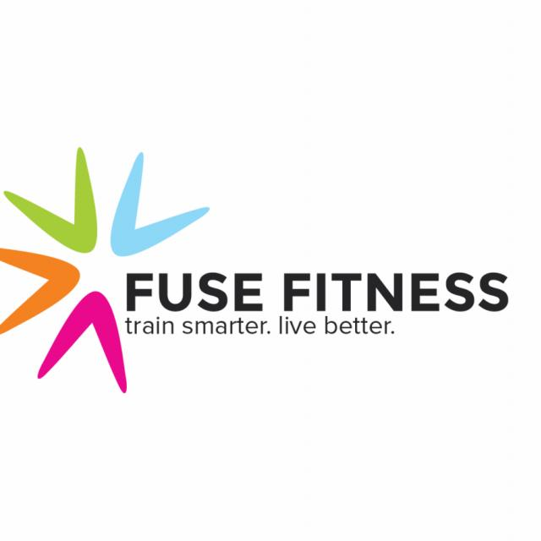
First of all, thanks for taking the time to visit this page. It's our hope that you have precisely what we need in a trainer so we can stop looking immediately and put you to work in the fun and rewarding coaching position.

The Fuse Fitness is looking for enthusiastic, motivated, well educated, and experienced trainers to coach Group Training sessions and work with clients one-on-one. We are a small boutique fitness studio located in Kensington, near North Berkeley, Albany and El Cerrito.

We currently offer training programs which educate, motivate and support men, women and teens to improve their health and fitness. We focus on reaching goals through physical exercise and sound nutrition. With your help we plan to expand the programs and services Fuse Fitness offers. Oh yeah, we're also very fair, respectful and appreciative.

We like having fun by providing highly valuable fitness services and products. You will be compensated well and treated great! We want someone who enjoys working with people and making a difference in the lives of others... because that's what we do at Fuse Fitness.

Specifically in regards to group training- we are looking for an amazing, enthusiastic morning person! This job is perfect for early-birds and college students who really love coaching/training but has a day time job and looking for some extra fun work! We need someone who is available Tuesday and Friday at 6am, Thursday at 6:30pm and Sunday at 9:30am. All of our classes and private training sessions are 1 hour.

Please respond with your resume and call us with times to interview and provide a short 30 minute demo.

We look forward to you joining our team!

The Fuse Fitness
377 Colusa Ave
Kensington CA 94707
thefusefitness@gmail.com
(510)558-8638

