Student Services Meeting
Tuesday, June 12, 2012
2:00 p.m. -3:30 p.m. Conference Room 451A
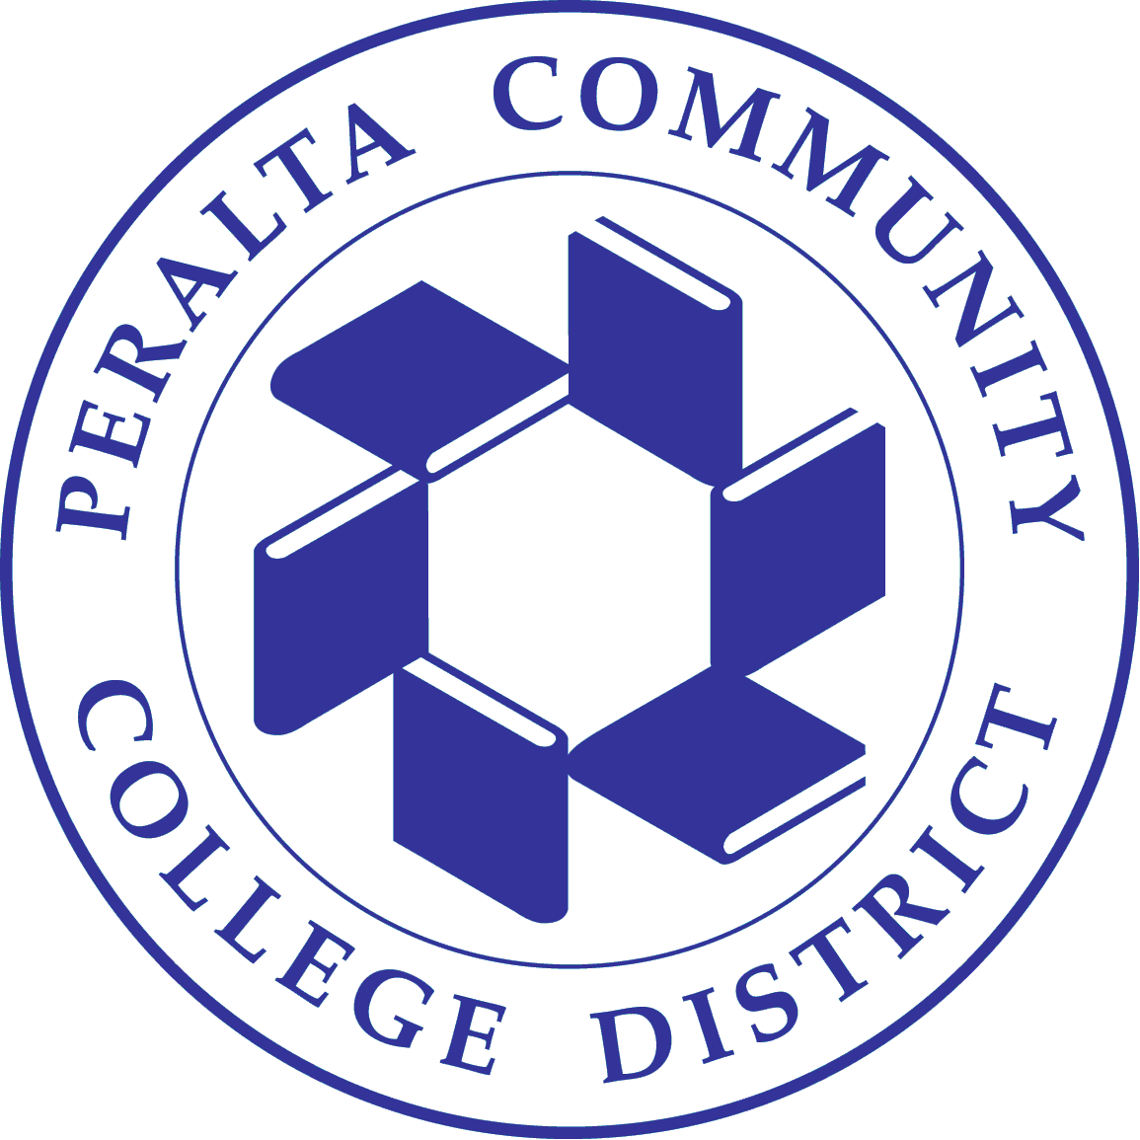
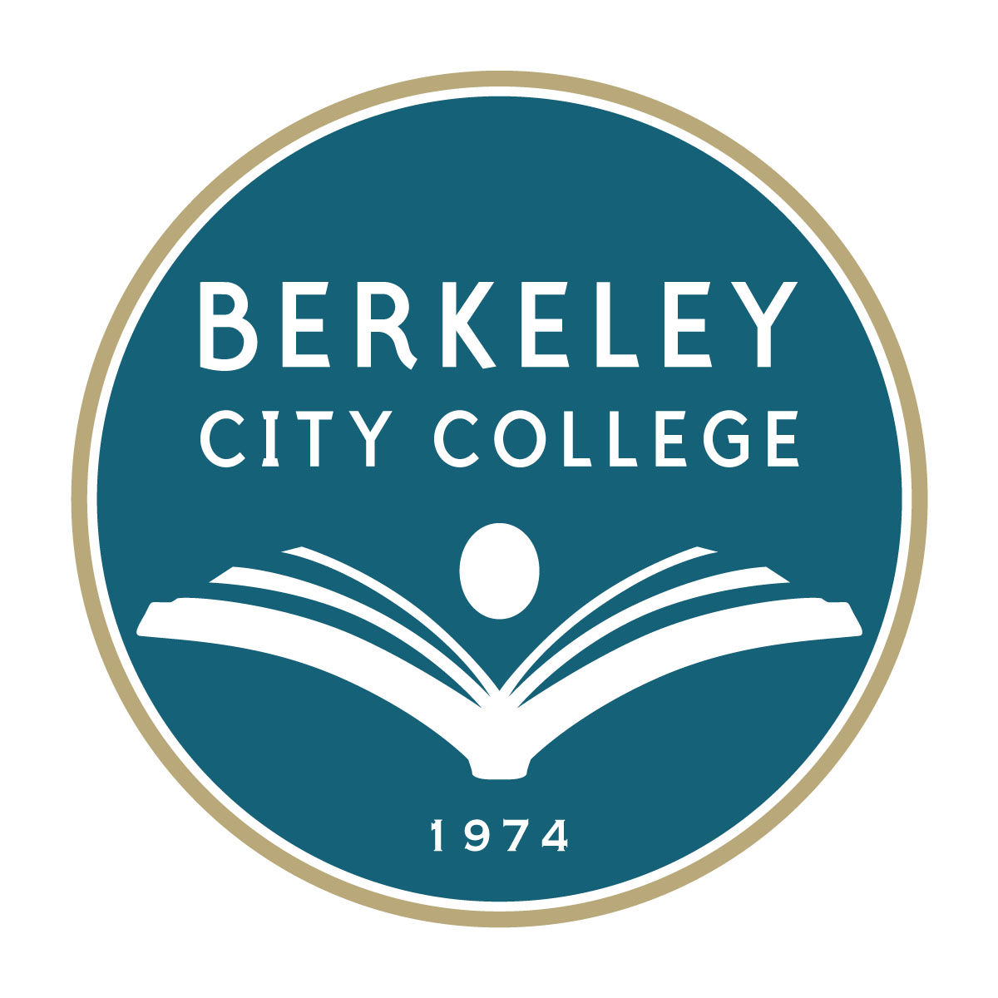
ATTENDEES: Jasmine Martinez, Ramona Butler, Gail Pendleton, Jennifer Lenahan, Ayele Lemma, Paula
Coil, Fatima Shah, Kristophe Green (Student), Dean of Instruction Harry Singh, Loan Nguyen,
and Loretta Newsome.
CHAIR: Dr. May Chen
AGENDA
- Facilitation Preparation for the upcoming Summer & Fall semesters
- SLO Assessments
- Team Building
- Area report.
- Items from the floor
Dr. Chen announced that we would be going back to bi-monthly meetings beginning next month.

Facilitation Preparation for the upcoming Summer & Fall semesters
Dr. Chen passed out a handout “BCC Enrollment Facilitation Strategies”. We were behind in enrollment last summer. Laney’s course offering this summer was less; they only scheduled half of their FTES. BCC is also behind in enrollment so we recently added 10-15 more classes. May will email everyone the current enrollment information. There will be a list-updated regularly of the summer courses placed on the first floor. We will ask our Ambassadors to encourage student to enroll in the newly added courses. We also want our cohort groups to call their students and encourage them to enroll. Let’s all spend at least 30 minutes to returning calls.
PASSPORT has been having issues for new students that are still not fixed. Please refer these students to A&R since they can only enroll in person through them. Please also refer students to our website for questions and resources. May has added two drop-in times a week to her calendar to assist students with issues; Mondays 10-12pm and Thursdays 2-5pm. If you encounter any student behavior issues please let May know immediately.
Financial Aid office encouraged to communicate with students about our programs such as TRIO, EOPS, PACE, etc., when helping students on the computers with FAFSA or other issues.
Earlier on we told the High School students that there was no more English and Math courses due to the classes being closed. However, they are still eligible to enroll in these courses, so please encourage them.
SLO Assessments
70% of us all completed our SLO assessments; some still need to input data and do calculations. We have run out of time therefore, for those that were working with May on more details requested, let’s hold off since we are now ready to complete most surveys. Use the results as a foundation for upcoming needs for the following year. After sending out last years program review summary, make sure you have your staffing and needs requests included. We are going to look into how we want to revise our timeline. It also depends on our economy. One example is the parcel tax and what our budget is for that year. It is necessary for us to complete the full SLO assessment cycle. It’s essential for our accreditation.

Team Building
This is the end of 3rd year for May, and ever since it’s been budget cut after cut and workload increased for us all. May thanked everyone for all their efforts and hard work. We have applied for grants in the past and we did get a mental health grant but did not receive VA grant desired. Due to some laid off positions those tasks have been added to other staff. May appreciates all the efforts we have done and happy to see that our new President Debbie Budd has already been working on improvements. Instruction has already identified funds to give to Student Services to help us out.
The budget has been very uneven for some time now among all four colleges. Laney just spent $95k for online orientation. BCC over the last two years gave over $150k from our DSPS to Laney’s because they have overspent as well as the other colleges. May recently found out that BCC has been under spending and our funds get moved to those campuses that are overspending.
May has noticed that a lot of us are doing things that are not in our job descriptions. Over time we have all
inherited more tasks. Many of you inherited an old job description and May will try to work with HR to update
your job description and update your level. This is also happening to our faculty counseling staff. May is
thinking about us having a retreat for team building and have a facilitator.
Area report

A&O: Added two more assessments; one of them is already fully booked. So please encourage students to hurry up and sign up for assessment.
Transfer Center: Last semester wrapped up well also the with graduation and scholarship ceremony. Paula recently attended the FELI (faculty experience learning institute) week and highly recommends other staff to attend in the future. Humboldt State contracted with us to hold an event here (Lab 126) offering support to students enrolling online to their college (students in the bay area). Paula was ale to hire a 20 hour/week assistant through the Perkins grant/funds.
A&R: Hours for evening here at BCC are Wednesday evenings until 6:30pm. The office hours are: Monday, Tues., Thurs & Fri 8-4:30pm and Wed. 8-6:30pm. They have been working with this passport issue to get students enrolled. The enrollment fees have gone up from $36 to $46 per unit, effective this summer. High School students have to pay the heath fee & student center fee.
Counseling: Summer Hours are Mon& Tues 9-5pm, Wed 9-6:30pm & Thurs. 9-4:30pm. No appointments for summer.
Ambassadors: Funding for the program has come from various budgets. Victor asks that since this is an all college service that funds for this program should always be stable and available.
EOPS: They are in the process of closing out this FY budget. Applications for Fall are still being given out; no deadline yet. There is a book loan program for summer students. Kim Blackwell will be working this summer. The cut to the CalWORKs program has been reversed. EOPS is currently supporting 300 EOPS student even though the budget only allows for 105 students.
Dean/TRIO: There are currently 115 students in the TRIO Program. It has been challenging getting them to keep their counseling appointments. Overall the program is doing fine. TRIO will soon have a Counselor for the program. Working with summer campus tours and workshops; two grads and 2 transfers from the program.

Financial Aid: Will be paying summer Pell on the 26th of June. Next fall will change how students sign up for the Loan Workshops; students file must be complete before they attend the workshop. Dates for loan workshops TBD, but will still have sign up list. Working on the work-study budget closing out this year and trying to spend most of funds. May be able to carry over $10k. Next years budget may have a cut of $30k in the work-study budget. The Specialists here will not be working at front counter here, other campuses may, but Loan decided not to follow that due to file interruptions and files need to be accurate.
Items from the floor
None

NEXT MEETING: TUESDAY, JULY 3, 2012
PLEASE SEND AGENDA ITEMS NO LATER THAN THE FRIDAY BEFORE THE MEETING ONCE IT IS ANNOUNCED.

Adjourned at 3:43pm
J.Martinez

