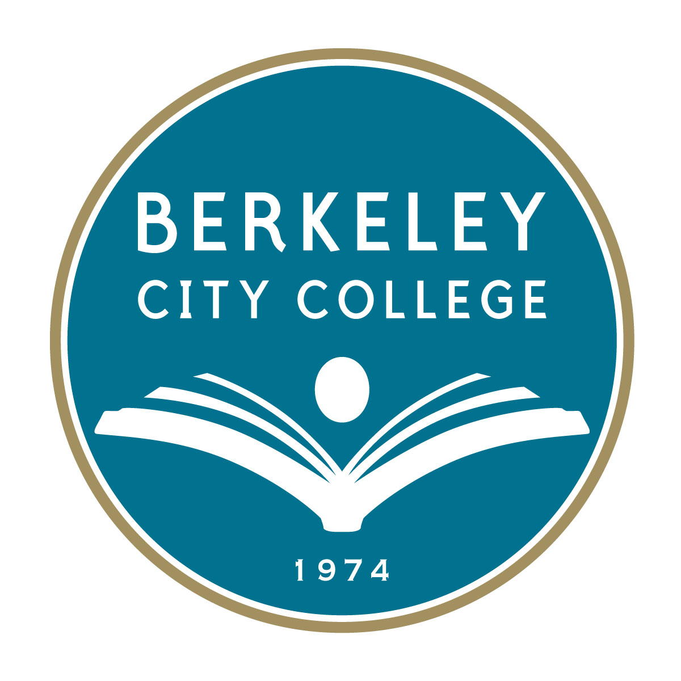 Berkeley City College
Institutional Goals, Strategic Activities, and
Measurable Outcome Indicators

2015-2016

Berkeley City College’s Roundtable for Planning and Budgeting approved a set of college goals for FY 2015-16.

The goals, which integrate directly with the college’s mission, vision and values, The 2024 Vision: BCC Education Master Plan , statewide Student Success Initiatives (SSSP) and Equity Plan, guide BCC as faculty, staff, administrators and students work together to develop annual priorities and strategic activities to ensure equitable college access and student success to be measured by Outcome Indicators.

PCCD/BCC Strategic Goals | BCC Strategic Activities | Measurable Outcome Indicators
PCCD Goal A  Advance Student Access, Equity, and Success  BCC Goal 1. Increase Equitable Access  1.a Meet BCC FTES targets:  Resident: 4,212  Total: 4,732  1.b Achieve and surpass productivity target of 17.5.  (PCCD FTES Goal:  Resident: 20,609  Total: 22,126)  BCC Goal 2. Improve Equitable Success  2.a Equitable course completion  2.b Equitable degree/certificate completion  2.c Equitable transfer |  | BCC Goal 1.  Outcome Measure Indicators:  1.a Meet BCC’s 2015-16 FTES targets for both Residents and Total FTES.  Increase the number of new students through high school to BCC pathways by ____ .  Increase the number of CTE pathways and Adult Learner Pathways by _____.  1.b Achieve the minimum productivity target of 17.5  BCC Goal 2.  Outcome Measure Indicators:  2.a To reach the Education Master Plan 10-year goal of 70% for course success, BCC will increase its annual course success rate by at least 0.53% based upon Fall 2014 baseline of 64.7%.  2.b. Increase the  (i) total number of degree/certificate award numbers by at least 5%.  (ii) number of graduates with honors by _________ , and  (iii) the representations of male, African-American, American Indian/Alaskan, Hispanic, and white using 2015-16 Equity Plan baseline data by _______#/%__________.  2.c. Increase the  (i) total number of transfers to USs and CSUs, and  (ii) the representations of male, African-American, American Indian/Alaskan, Filipino, Hispanic, and Pacific Islander using 2015-16 Equity Plan baseline data by ___#/%__________________.
PCCD Goal B. Engage and Leverage Partners.  BCC Goal 3. Increase the number of new partners and enhance and leverage resources with existing partners. |  | BCC Goal 3.  Outcome Measure Indicators:  Increase the number of new partners by __#____.  Leverage resources with new and/or existing partners through grant applications of X__ numbers or other resources generating $_______.
PCCD Goal C. Build Program of Distinction  BCC Goal 4. Reduce education and achievement gap through building and implementing programs of distinction through SSSP, Equity, BSI and other college-wide plans. |  | BCC Goal 4.  Outcome Measure Indicators:  Summarize a list of programs of distinctions,  Same as BCC Goal 2.  Outcome Measure Indicators above
PCCD Goal D.  Strengthen Accountability Innovation and Collaboration  BCC Goal 5. Resolve the 2 ACCJC Recommendations and BCC’s self-identified Actionable Improvement Plans |  | BCC Goal 5.  Outcome Measure Indicators:  By June 30, 2016, complete the draft of ACCJC Follow-up Report by: (i) fully addressing and resolving the 2 ACCJC Recommendations, and (ii) making measurable and significant progress addressing BCC’s Actionable Improvement Plans with evidence documented and published online.  BCC will go through shared governance, complete and submit the final Follow-Up Report by October 1, 2016.
PCCD Goal E.  Develop resources to advance and sustain our Mission.  BCC Goal 6. Increase BCC additional and alternative funding sources through materializing BAM, funding raising, non-RES tuition, grants, etc. |  | BCC Goal 6.  Outcome Measure Indicators:  Fully implement BAM.  Increase additional funds from grants, fund raising, non-RES tuition, and other sources by __$/%____ using 2014-15 Budget as baseline.

VISION 2024: EDUCATION MASTER PLAN GOAL Eliminate the education gap and advance student access, equity and success with exemplary programs. VISION 2024: EDUCATION MASTER PLAN INITIAL INDICATORS Student Success Indicators Core Indicators - Increase successful course completion to 70% for all students - Increase the number of students who receive a certificate, degree and/or transfer by 5% Milestone Indicators for certificate, degree and transfer seeking students. Increase the number of students who: - Enter a program of study & complete a comprehensive Student Ed. Plan (SEP) by end of the 2nd semester. - Complete a stackable certificate or 20 transferable units by end of the 1st year, including summer - Complete college-level math by end of 3rd semester - Participate in work-based learning opportunities on and off-campus Exemplary Program Indicators - Program and Course Learning Outcomes - Program and Course Success - Demand vs. capacity - Student program progression - Certificate/Degree Awards - Out of the classroom learning opportunities Institutional Performance Indicators Accreditation Status Fiscal Indicators - FTES - Fund Balance - Audit Findings
Actual Goals for Annual Increment* Baseline 2008 Fall 2009 Fall 2010 Fall 2011 Fall 2012 Fall 2013 Fall 2014 Fall Fall 2015** Fall 2016 Fall 2017 Fall 2018 Fall 2019 Fall 2020 Fall 2021 Fall 2012 Fall 2013 Fall 2014 Grand Total 13,382 15,116 14,479 14,123 13,313 14,791 16,339 16,585 Course Success Rate 63.30% 65.10% 68.00% 65.90% 65.80% 64.90% 64.70% 65.2% 65.8% 66.3% 66.8% 67.4% 67.9% 68.4% 68.9% 69.5% 70% 10-year increment based upon 6-year average increment, BCC will only reach to 67.03% in Fall 2024 *Use Fall 2014 rate as the baseline reaching 70% in fall 2024 of 70%, the average annual increment is 0.530% **Fall 2015 enrollment is projected using 9.2.15 Fall 2015 Enrollment Report
Year Total Graduates Honor Students AA Degrees AS Degrees AA-T Degrees AS-T Degrees Certificates TOTAL Degrees/Certs 2013/14 280 111 173 4 34 12 254 477 2014/15 352 158 122 4 80 28 376 610 1-Yr Increase 25.7% 42.3% -29.5% 0.0% 135.3% 133.3% 48.0% 27.9%

