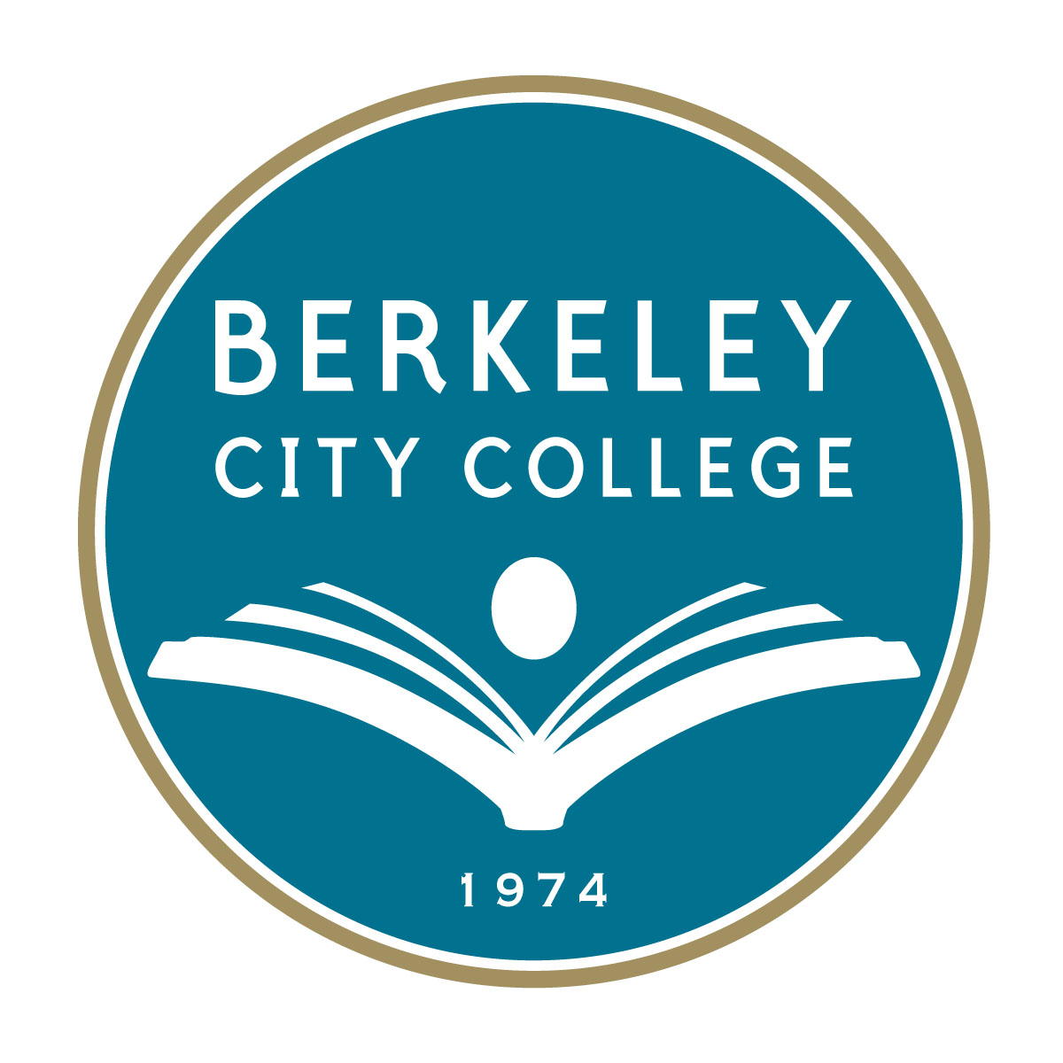
Berkeley City College
2015-2016 Institutional Goals, Strategic Activities, and Accomplishments
With Measurable Outcome Indicators

Berkeley City College’s Roundtable for Planning and Budgeting approved a set of college goals for FY 2015-16.

The goals integrate with the college’s mission, vision, and values, and with the BCC Education Master Plan (2015-2020), Student Success Initiatives (SSSP), and Equity Plan. They guide BCC as faculty, staff, administrators, and students work together to develop annual priorities and strategic activities to ensure equitable college access and student success to be measured by Outcome Indicators.

PCCD/BCC Strategic Goals | BCC Strategic Activities | Accomplishments – Measurable Outcome Indicators
PCCD Goal A  Advance Student Access, Equity, and Success  BCC Goal 1. Increase Equitable Access  1.a Meet BCC FTES targets:  Resident: 4,212  Total: 4,732  1.b Achieve and surpass productivity target of 17.5.  (PCCD FTES Goal:  Resident: 20,609  Total: 22,126)  BCC Goal 2. Improve Equitable Success  2.an Equitable course completion  2.b Equitable degree/certificate completion  2.c Equitable transfer | BCC Goals 1 and 2  Enrollment: Increase enrollment for programs and course offerings in the essential areas for students of all enrollment status.  Resources: Preserve and nourish resources to ensure access, equity, and success for all students  Equity: Address the achievement gap through fully implementing the student success and equity plans at BCC.  Integrated Planning: Links student success with college-wide institutional effectiveness indicators; plans, measures, reports, and assesses college-wide student success and institutional effectiveness processes and outcomes.  Accountability: Through shared governance participatory processes, BCC develops, updates, and establishes benchmarks for outcome measurements, evaluates program and outcomes indicators, and reports plans according to timelines.  Course Completion: Improve career and college preparation progress and success rates.  Degree/Certificate Completion: Increase certificate/degree completion and transfers to 4-year colleges or universities by inspiring and supporting students and maintaining high quality educational programs.  Transfer: Increase certificate/degree completion and transfers to four-year colleges or universities by inspiring and supporting students and maintaining high quality educational programs.  Quality: Ensure BCC programs and services reach sustainable, continuous quality improvement levels. | BCC Goal 1.  1.a Meet BCC’s 2015-16 FTES targets for both Residents and Total FTES.  Overall 11% increase in BCC’s student headcount (6,311 in fall 2014 vs. 7,010 in fall 2015)  - 23% increase in first-time students  - 13% increase in first-time transfer students  - 46% increase in continuing student enrollment  - 12% increase in total credit course enrollment (duplicated counts) increased from 14,763 to 16,526  - CTE enrollment (duplicated counts) increased from 2,749 to 3,090, while success rate grew from 62.355 to 64.37%.  - 11% increase in total degree/certificate awards (from 788 in 2015 to 875 in 2016)  *Data Source: CCCCO Datamart  1.b. Productivity. BCC achieved an annual productivity of 16.9, exceeding the district average of 16 by .9.  BCC Goal 2: Equitable Success  2.a, 2.b, 2.c. BCC has successfully completed and begun to implement both its 2015-16 Equity Plan and the 5-year Education Master Plan aiming at accomplishing these goals. Although the annual or 5-year data tracking are not ready to be used as measurements, the preliminary data shown below suggest that between Fall 2014 and Fall 2015:  - Basic Skills enrollment (duplicated counts) decreased from 584 to 556, while course success rate declined from 51.4% to 44.6%.  - Total credit course enrollment (duplicated counts) significantly increased from 14,763 to 16,526 or 12%, while course success rate increased slightly from 62.0% to 62.6%.  - CTE enrollment (duplicated counts) increased from 2,749 to 3,090, while success rate grew from 62.355 to 64.37%.  - BCC’s total degree/certificate awards increased from 788 in 2015 to 875 in 2016; among the types of awards, the growth of AA and AAT topped others. A noteworthy fact: Both the total numbers of graduate and honor student increased from 397 to 445, and 122 to 136, respectively.  *Data Source: CCCCO Datamart  - DSPS increased its 2015-2016 program enrollment by over 5% from the previous year.  - EOPS outreach was able to serve 255 students and increased book voucher program from $42, 968 to$48,587  - Equity funding supported additional books for our book lending library and provide additional book loans to program participants.  - CalWORKs increased the number of participants to 35. Partnerships with employment counselors and students improved county support in a timelier manner.  - Assessment & Orientation: Working together with Counseling, Financial Aid to provide special populations such as Foster Youth, At Risk, Undocumented, and Homeless students with an innovative student success plan  Resources  - Faculty Advising Program: Comprised of 14 dedicated instructors and one counselor liaison. Each instructor represents an academic discipline offered at BCC. Faculty advisors would be responsible for providing discipline specific information, assist with career exploration, act as mentors and provide resources.  - Admission & Records staff continue to participate in BCC staff development offered through Classified Senate and through our union President and the Chancellor at different locations throughout the District.  - As part of Student Service, Admission & Records has to continually work on customer service in our area because of the demands of a diverse student population that wants to continue their education process. Continue to act as a support system in the Student Service area that will allow us to put our student first as they go through the learning process.  - Facilities: Opening of 3 new classrooms (net gain of 1 classroom) and program spaces in 2000 Center St.
PCCD Goal B. Engage and Leverage Partners | BCC Goal 3: Partners | BCC Goal 3: Outcome Measure Indicators
BCC Goal 3. Increase the number of new partners and enhance and leverage resources with existing partners. | Partnerships. Expand and document domestic and international partnerships with K-12 institutions, community-based organizations, four-year institutions, local governments, and regional industries and businesses. | - BCC-Unified School District Leadership Group established (Emeryville, Albany, Piedmont and Berkeley Unified)  - Irvine Foundation – Bridging the Gap Planning Grant– BCC, BUSD, OUSD, CSUEB partnership around math pathways  - CalWORKs increased the number of participants to 35. Partnerships with employment counselors and students improved county support in a timelier manner.  - The Financial Aid Office reached out to high schools to assist high school seniors with their FAFSA applications
PCCD Goal C. Build Program of Distinction | BCC Goal 4: Reduce Education and Achievement Gap | BCC Goal 4: Outcome Measure Indicators
BCC Goal 4. Reduce education and achievement gap through building and implementing programs of distinction through SSSP, Equity, BSI and other college-wide plans. | SSSP, Equity, BSI, and CTE Plans and Implementations. Develop and fully implement an integrated, innovative student success plan, including first-year experience and learning communities. | - To close the education and achievement gap, BCC provided an increasing number of student success related services to its prospective and enrolled students by 31%. This means, the number of services increased from 37,302 in 2014-15 to 48,880 in 2015-16.  - EOPS/CalWORKs/CARE/ DSPS/Learning Communities: Providing students with tools for success by coordinating, developing and implementing the BCC Online Orientation in spring 2016. All students will receive updated information regarding the requirements of the programs and service benefits available.  - Financial Aid Office: Added a feature to send notifications in the “To Do List” section of students’ Passport accounts has improved communication between staff and students. This feature allows students to ask questions and request documents from staff members  - Student Activities and Campus Life: Improve robust student ambassador program to support the student body. Coordinate Orientation Week to promote services and resources. During the spring 2016 semester, there were over 80 student activities held on campus. During the spring 2016 semester, there were approximately 30 chartered and active student clubs.  - Transfer/Career Center: 142 BCC students accepted to UC Berkeley. First job fair coming to BCC this year  - Veterans Affairs: Developed a “job board” with collaborations with outside resources for veteran students  - Beginning in the fall 2016, a College Success course (Counseling 24) for new veteran students was established to be taught by the VA Counselor and Program Coordinator. The course is designed to help student veterans make an easier transition from military to civilian and academic life.  More related accomplishments under BCC Goal 2.
PCCD Goal D.  Strengthen Accountability Innovation and Collaboration | BCC Goal 5: Resolve Two ACCJC Accreditation Recommendations | BCC Goal 5: Outcome Measure Indicators
BCC Goal 5. Resolve the 2 ACCJC Recommendations and BCC’s self-identified Actionable Improvement Plans | Data Integrity. With the support of PCCD Institutional Research, through coordination and collaboration, BCC conducts college-wide efforts and projects relating to data submissions, validates data before final submission by coordinating with college and district members, including but not limited to general enrollment, categorical program records of participation, annual degree and certificate awards, SSSP, and the Equity Plan.  Integrated Planning. Through shared governance participatory processes, BCC plans, collects, integrates, and publishes major college-wide plans and planning process; creates and publishes an annual timeline for all plans on the BCC homepage; develops annual goals; and collects and publishes annual accomplishments.  ACCJC Accreditation Recommendations. Through district-wide and college-wide coordination, BCC carries out and follows through all necessary efforts preparing for the follow-up reports, including resolving the two ACCJC recommendations, and incorporating progress made to resolve district recommendations into the college report. Prepares and submits BCC Follow-up Report by October 2016.  BCC Education Master Plan (BCCEMP). Working with the college team and major constituent groups, contributes to information regarding internal and external scan data review and development, summarizes data interpretations and potential implications, communicates with stakeholders, receives feedbacks, and completes BCCEMP. | Date Integrity. Validated data for BCC degrees/certificate, EOPS/DSPS/CalWORKs data prior to the submission to the State of California; reviewed and validated 2014-15 SSSP data recording prior to the submission; reviewed and verified 2014-15 SSSP and Equity year-end data prior to completing 2015-16 Equity and SSSP Plans; reviewed and verified 2014-15 SSSP and Equity year-end expenditure data prior to the submission; reviewed and finalized BCC’s internal scan data generated for Education Master Plan; reviewed and validated both qualitative and quantitative data for the 2016 ACCJC Annual Report and IEPI Report prior to the submission.  Integrated Planning. Initiated and began to implement college-wide major plans through an integrated, seamless, and collaborative fashion by identifying silos and breaking barriers. Created BCC integrated plans website; collected and published existing BCC plans; completed BCC’s IEPI Plan and placed online at http://www.berkeleycitycollege.edu/wp/prm/iepi/; developed and published Framework of IE Indicators and Collegewide Goal Establishment, 2016 online at http://www.berkeleycitycollege.edu/wp/ierpe/files/2016/01/IE-indicator-establishment2016.pdf .  ACCJC Accreditation Recommendations. Completed the draft of ACCJC Follow-Up Report by: (1) fully addressing and resolving the 2 ACCJC Recommendations, and (2) making measurable and significant progress addressing BCC’s Actionable Improvement Plans with evidence documented and published online. BCC will proceed through shared governance, and will complete and submit the final Follow-Up Report by October 1, 2016.  BCCEMP. Completed BCC’s 5-year Education Master Plan by (1) exercising innovation and designing PowerPoints to present various complicated concepts of success indicators and performance measure development in a simple, general-public-friendly manner to stimulate conversation at the Senate meetings, collect feedbacks and receive supports for implementations; (2) summarizing data interpretations and potential implications; and (3) communicating with stakeholders, receiving feedback, and offering suggestions for revisions and completions.
PCCD Goal E. Develop resources to advance and sustain our Mission. | BCC Goal 6: Increase BCC Alternative Funding | BCC Goal 6: Outcome Measure Indicators
BCC Goal 6. Increase BCC additional and alternative funding sources through materializing BAM, fund raising, non-RES tuition, grants, etc. | Resources. Preserve and nourish resources to ensure access, equity and success for all students.  Fiscal Stability. Collaborate to maintain high-quality educational programs and ensure fiscal stability.  Institutional Effectiveness Partnership Institute (IEPI) Resources. Develops IEPI proposal, secures the $150,000 seed budget, assesses progress, updates outcomes, and summarizes accomplishment to be shared with the internal and external team members.  Budget Augmentation. Applies and secures additional $150,000 SSSP and $160,000 equity funds from the State of California to augment the implementation of BCC’s 2015-16 SSSP and Equity Plans. | - Developed IEPI proposal and secured the $150,000 seed budget.  - Applied and secured additional $150,000 SSSP and $160,000 Equity funds from the State.  - Received Basic Skills Transformation grant – $1.5 million over 3 years  - Received Basic Skills Partnership grant - $140,000 over 2 years

