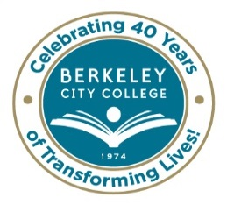

Draft Alphabetized Classified Position Requests from APU Planning Process
As of March 9, 2015

Admissions and Records Clerical Assistant
Assessment Student Personnel Services Specialist
Campus and Student Life Staff Assistant
Chemistry Lab Technician
Counseling Clerical Assistant
Custodian
Distance Ed Analyst
DSPS Staff Assistant
DSPS Instructional Assistant (2)
Duplicating Technician\
Financial Aid Clerical Assistant (2)
Instructional Assistant English
Instructional Assistant Math
IT Staff Member
Library Technician
Outreach Specialist
Public Information Officer
Staff Assistant to Department Chairs
Transfer Career Services Specialist
Trio Staff Assistant

**********
Our Mission: Berkeley City College’s mission is to promote student success, to provide our diverse community with educational opportunities, and to transform lives.

Our Vision: Berkeley City College is a premier, diverse, student-centered learning community, dedicated to academic excellence, collaboration, innovation and transformation.

