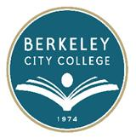
AGENDA
ROUNDTABLE MEETING
Monday, October 22, 2012
12:10 p.m. – 1:30 p.m.
Teaching and Learning Center (TLC), Room 341

Chair: Debbie Budd, Interim President

Topic

- Agenda Review Debbie Budd

- Accreditation Linda Berry

- 2012-2013 Goals – Rubric All

- Program Review Debbie Budd

- Reports from Committees Technology, Facilities, Education Committee

- Other

- Adjournment

For your calendar:

- Brown Bag/Knowledge Café Thursday, October 25, 2012 – 12:00-1:00 pm 451A/B
***********

~ Roundtable meetings are open to the college community ~

